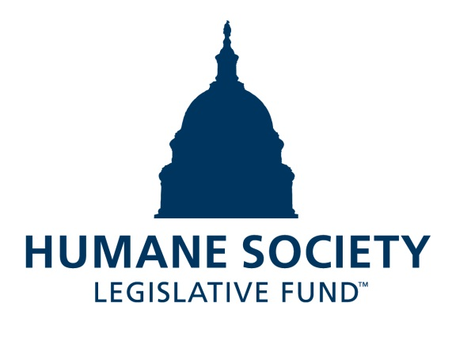

**2024 STATE LEGISLATIVE CANDIDATE QUESTIONNAIRE: NEW YORK**

Candidate Name: _________________________________________________________________________________

Candidate Address: _______________________________________________________________________________

Office Sought: ___________________________________ District: _____________________________________

Staff Contact Name: ______________________________ Phone: ______________________________________

Email: _________________________________________ Website: _____________________________________

Animals play an important role in the lives of many Americans. Countless citizens look to their state government to protect animals from cruel treatment and exploitation. Humane-minded individuals care deeply about the positions their elected officials take on animal protection issues.

For information on the range and details of our issue areas, please visit the websites of the Humane Society Legislative Fund (hslf.org) or the Humane Society of the United States (humanesociety.org).

**BACKGROUND INFORMATION:**

What actions have you taken to promote the welfare of animals in the past? (Please include any action taken in an official or unofficial context.)

Are there any animal welfare programs or issues of importance to you that you would take the initiative on after you are elected?

Will you post information in your campaign materials stating your positions on animal protection issues?

Do you have, or have you had in the past, any pets that have made an impact on you personally?

**STATE ISSUES:**

Members of state legislatures influence animal protection policy by sponsoring or cosponsoring humane legislation, opposing government programs that use taxpayer funds to harm animals, supporting funding for government programs to protect animals and for adequate enforcement of animal welfare laws, and opposing inhumane laws or those which weaken current protections. We would like to know your position on the following important animal welfare issues, which are subject to debate in your state.

***PETS AND CRUELTY***

**Breed-Specific Legislation:** Across the United States, entire communities ban or restrict dogs because of their breed, or, more commonly, what is perceived to be their breed. Breed-based policies aren't founded on science or credible data, but on myths and misinformation surrounding different breeds and their natures. The impact of these policies on dogs, families, and animal shelters, though, is heartbreakingly real. Breed bans and restrictions force dogs out of homes and into shelters, taking up kennel space and resources that could be used for animals who are in need.

In 2022, a state law was enacted to prohibit insurance companies from refusing to provide insurance to homeowners based on dog breeds. Will you support efforts to prohibit discriminatory breed-based policies in the issuance of renter’s insurance policies to New Yorkers?

_____ Yes _____ No _____ Not Sure

**Support for Animal Shelters:** New York’s network of animal shelters provides essential services aimed at preventing pet homelessness and animal abuse in our communities. The Companion Animal Capital Fund (CACF), launched in 2017, is the nation’s first funding stream that provides matching state grants for capital improvement projects to strengthen and improve our shelters. To date, the CACF has channeled over $33 million into enhancing shelter facilities across the state.

Additionally, the Humane Society of the United States, ASPCA, and New York State Animal Protection Federation have proposed that the legislature establish a “New York State Animal Crimes Fund.” By allocating $2.5 million to the fiscal year budget, New York can help shelters burdened by the enormous costs of caring for animals held as live-evidence, while law enforcement agencies pursue animal cruelty cases. The process of holding animals, where routine care must be administered, is vastly different than storing other types of seized property—an animal, and particularly an animal mistreated in a cruelty case, cannot be packed and stored away.

Will you support New York’s animal shelters by advocating for allocations to the CACF?

_____ Yes _____ No _____ Not Sure

Will you support the creation of an Animal Crimes Fund, to help bolster humane law enforcement in the state of New York?

_____ Yes _____ No _____ Not Sure

***WILDLIFE***

**Traveling Wildlife Acts:** Decades of documented animal mistreatment have greatly reduced the popularity of traveling exhibitions that use wild animals in their acts—Ringling Bros. and Barnum and Bailey closed for good in 2017 after the truth was exposed of almost 150 years of cruel practices. Wild animals used in circus acts are routinely beaten and shocked with electric prods to force them to perform unnatural, potentially dangerous tricks. The Animal Welfare Act creates only minimum standards for animals in traveling exhibits, and it is poorly enforced. Persistent violators are rarely prosecuted, and those who are usually only face fines. These acts have also resulted in dangerous encounters with the public in New York and elsewhere. Municipalities across the state, including New York City, Suffolk County, and Westchester County, prohibit such acts in their communities.

In 2017, the legislature prohibited the issuance of permits for the use of elephants in travelling acts. Will you support legislation such as [A.4005-A](https://nyassembly.gov/leg/?default_fld=%0D%0At&leg_video=&bn=A04005&term=&Summary=Y)/[S.4363-A](https://www.nysenate.gov/legislation/bills/2023/S4363), to prohibit the participation of big cats, bears, non-human primates, and kangaroos in cruel travelling wildlife acts?

_____ Yes _____ No _____ Not Sure

***FARM ANIMAL PROTECTION AND FOOD SAFETY***

**Factory Farming:** On factory farms, egg-laying hens are packed into battery cages where they can't even spread their wings. Baby calves are taken from their mothers and confined in pens so small they can barely move, and pigs are locked in gestation crates the width and length of their bodies, unable to even turn around.

Will you support efforts to protect New York’s family farmers by prohibiting cruel industry practices on factory farms?

_____ Yes _____ No _____ Not Sure

**Fashion:** Animals used in the fur industry suffer immensely. On fur factory farms in the U.S. and around the world, millions of rabbits, foxes, mink, and other wild animals spend their entire lives in cramped cages, deprived of the ability to engage in natural behaviors—only to be crudely gassed or electrocuted at the end. These farms are also the ideal setting for pathogens to circulate, as the animals are susceptible to infection with a host of zoonotic diseases. Prohibiting the sales of new fur products will support efforts to end this cruel industry, while still allowing businesses to sell vintage or used fur products, and continue services caring for fur products, such as storage and cleaning.

Will you support efforts to prohibit the sale of new products containing fur from animals?

_____ Yes _____ No _____ Not Sure

**Thank you for your time! Please return the completed questionnaire to:**

**Humane Society Legislative Fund**

**1255 23rd St NW, Suite 455**

**Washington, D.C. 20037**

**Phone: (202) 676-2314**

**Email: info@hslf.org**

Rev 3/4/24