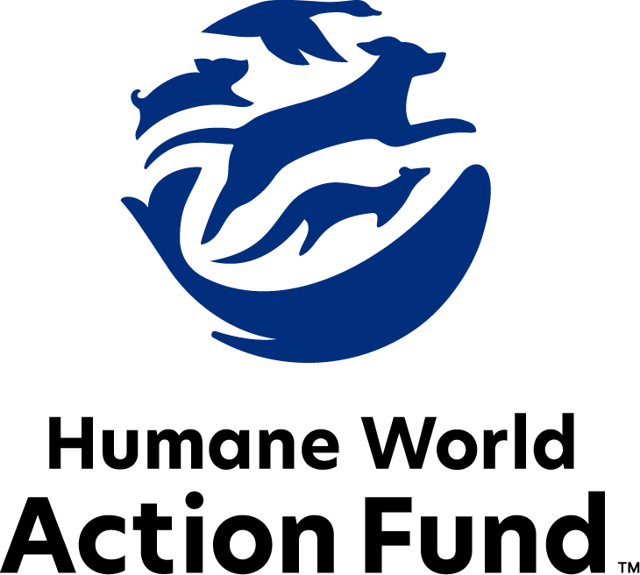

Formerly called  
Humane Society Legislative Fund

CANDIDATE QUESTIONNAIRE

local & municipal office

# 2025 local and municipal candidate questionnaire

Candidate Name: _____________________________________________________________________

Candidate Address: ___________________________________________________________________

Office Sought: ______________________________ Locality: ________________________________

Staff Contact Name: _________________________ Phone: _________________________________

Email: ____________________________________ Website: ________________________________

Animals play an important role in the lives of many Americans. Countless citizens look to their local government to protect animals from cruel treatment and exploitation. Humane-minded individuals care deeply about the positions their elected officials take on animal protection issues.

For information on the range and details of our issue areas, please visit the websites of Humane World Action Fund (humaneaction.org) or Humane World for Animals (humaneworld.org).

### Background information

What actions have you taken affecting the welfare of animals in the past? Please include actions taken at the local, state, or federal levels.

What actions have you taken affecting the habitats of animals in the past? Please include actions taken at the local, state, or federal levels. Examples may include efforts to address the impacts of natural disasters such as wildfires and hurricanes on ecosystems.

Are there any animal welfare programs or issues of importance to you that you would take the initiative on after you are elected? Examples might include municipal animal welfare standards; cracking down on large-scale commercial breeding facilities known as puppy mills; or local tethering and weather-related laws where pets are concerned.

Will you post information on your campaign website outlining your positions on animal protection issues?

Do you have, or have you had in the past, any pets that have made an impact on you personally?

Puppy mills: Internet sales, flea markets, face-to-face sales and the majority of pet stores that sell puppies are getting those dogs from puppy mills. A puppy mill is an inhumane high-volume dog breeding facility that churns out puppies for profit, ignoring the needs of the pups and their mothers. Dogs from puppy mills are often sick and unsocialized. Pet retailers often falsely assure consumers that the puppies they offer for sale are raised in reputable or humane breeding facilities, even when they come from inhumane facilities like mass production puppy mills. Our family of organizations hears from thousands of devastated consumers every year who bring home a dog only to have the animal fall sick and, in some cases, even die.

Will you support efforts to end the sale of puppies sourced from puppy mills in pet stores?

_____ Yes _____ No _____ Not Sure

Fashion: Animals need their fur coats more than we do. But on fur factory farms around the world, millions of rabbits, foxes, mink and other wild animals spend their entire lives in cramped cages, deprived of the ability to engage in natural behaviors—only to be crudely gassed or electrocuted at the end. In the wild, animals are caught in crippling leghold traps for days without food or water. These archaic traps are indiscriminate, often maiming and killing non-target animals, like threatened species and even pets—all this in the name of fashion.

Will you support efforts to prohibit the sale of new products containing fur from animals?

_____ Yes _____ No _____ Not Sure

Breed-specific legislation: Throughout the United States, entire communities ban or restrict dogs because of their breed, or, more commonly, what is perceived to be their breed. Breed-based policies aren't founded on science or credible data, but on myths and misinformation surrounding different breeds and their natures. The impact of these policies on dogs, families, and animal shelters, though, is heartbreakingly real. Breed bans and restrictions force dogs out of homes and into shelters, taking up kennel space and resources that could be used for animals in need.

Will you support efforts to prohibit discriminatory breed-based policies?

_____ Yes _____ No _____ Not Sure

Public contact: While exciting to see up close, wild animals are altogether unfit for public contact. Substandard wildlife attractions like roadside zoos and cub petting operations exploit these animals to turn a quick profit, often with such neglect that horror stories have been recorded through undercover investigations. Not only do wild animals suffer cruelly when captured, transported, and placed in close proximity to humans—the risks they then pose to human health and safety are enormous. Cases of aggression may prove life-threatening, as may a host of zoonotic diseases. In recognition of these dangers, the federal government now prohibits the private ownership, breeding, import, or export of big cats acquired, or maintained and unregistered with the USDA, after June 18th, 2023. All big cats, even those owned and registered prior to the law’s enactment, are now banned from use in public contact.

Will you support efforts to prohibit direct public contact with wild animal species?

_____ Yes _____ No _____ Not Sure

Factory farming: On factory farms, egg-laying hens are packed into battery cages where they can't even spread their wings. Baby calves are taken from their mothers and confined in pens so small they can barely move, and pigs are locked in gestation crates the width and length of their bodies, unable to even turn around.

Will you support efforts to prohibit the extreme confinement of breeding pigs, egg-laying hens, and calves raised for veal in restrictive, inadequate, and painful conditions?

_____ Yes _____ No _____ Not Sure

Local control: Across the country, bills are often filed aiming to overturn hundreds of local ordinances related to animals. These overly broad bills seek to eliminate commonsense restrictions on matters of animal protection and public safety, alike, by undoing local ordinances prohibiting the sale of dogs from puppy mills; outlawing roadside zoos and similar cruel, unsafe operations; regulating livestock management; or even requiring safety standards for ingredients in our food or health products.

Will you oppose any efforts to prohibit municipal or county ordinances related to animals?

_____ Yes _____ No _____ Not Sure

### Thank you for your time! Please return the completed questionnaire to:

Humane World Action Fund

1255 23rd St NW, Suite 455

Washington, D.C. 20037

Phone: (202) 676-2314

Email: info@humaneaction.org

Rev. 2/15/2025

# 

© 2025 Humane World Action Fund

# About us

**We fight for political and policy change to tackle the root causes of animal cruelty and suffering.**

We work to advance our mission by  
passing animal protection laws at the state and federal levels, educating the public about animal protection issues and supporting humane candidates for office. Together, we act to end animal cruelty.

**humaneaction.org**