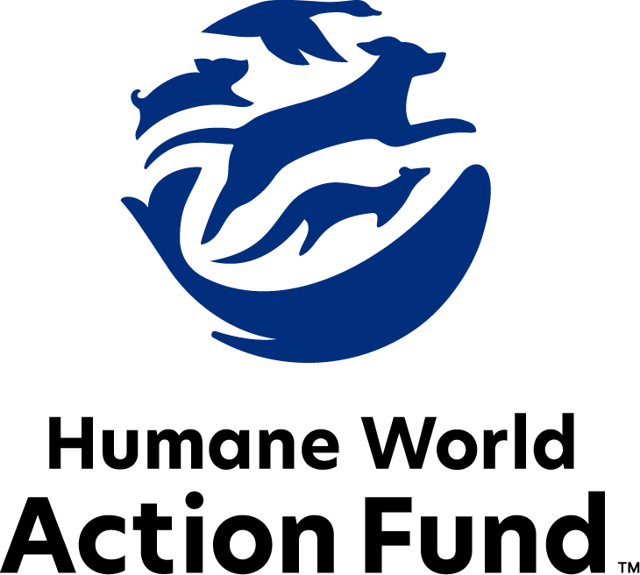

Formerly called  
Humane Society Legislative Fund

CANDIDATE QUESTIONNAIRE

New Jersey state-level offices

# 2025 New Jersey state

# candidate questionnaire

Candidate Name: _____________________________________________________________________

Candidate Address: ___________________________________________________________________

Office Sought: ______________________________ Locality: ________________________________

Staff Contact Name: _________________________ Phone: _________________________________

Email: ____________________________________ Website: ________________________________

Animals play an important role in the lives of many Americans. Countless citizens look to their local government to protect animals from cruel treatment and exploitation. Humane-minded individuals care deeply about the positions their elected officials take on animal protection issues.

For information on the range and details of our issue areas, please visit the websites of Humane World Action Fund (humaneaction.org) or Humane World for Animals (humaneworld.org).

### Background information

What actions have you taken affecting the welfare of animals in the past? Please include actions taken at the local, state, or federal levels.

What actions have you taken affecting the habitats of animals in the past? Please include actions taken at the local, state, or federal levels. Examples may include efforts to address the impacts of natural disasters such as wildfires and hurricanes on ecosystems.

Are there any animal welfare programs or issues of importance to you that you would take the initiative on after you are elected? Examples might include municipal animal welfare standards; cracking down on large-scale commercial breeding facilities known as puppy mills; or local tethering and weather-related laws where pets are concerned.

Will you post information on your campaign website outlining your positions on animal protection issues?

Do you have, or have you had in the past, any pets that have made an impact on you personally?

**STATE ISSUES:**

Statewide office holders and members of state legislatures influence animal protection policy by supporting humane legislation, opposing government programs that use taxpayer funds to harm animals, supporting funding for government programs to protect animals and for adequate enforcement of animal welfare laws, and opposing inhumane laws or those which weaken current protections. We’d like to know your position on the following important animal welfare issues, which are subject to debate in your state.

PETS AND CRUELTY

Puppy Mills: Internet sales, flea markets, face-to-face sales and many pet stores that sell puppies and kittens are getting those animals from large scale breeding operations, often known as puppy mills. A puppy mill is an inhumane, high-volume commercial dog breeding facility which churns out puppies for profit, ignoring the needs of the pups and their mothers. Dogs from puppy mills are often sick and unsocialized. Pet retailers often falsely assure consumers that the puppies they offer for sale are raised in reputable or humane breeding facilities, when really, they are coming from mass production puppy mills.

Will you support legislation such as S2511/A4051, which establishes a prohibition on the sale of cats, dogs, and rabbits by pet stores?

_____ Yes _____ No _____ Not Sure

Cat Declawing: Many countries and hundreds of cities in the U.S. have banned cat declawing because the procedure frequently results in pain in the paw, infection, tissue necrosis (tissue death), lameness, and back pain. Removing claws changes the way a cat's foot meets the ground and can cause pain like wearing an uncomfortable pair of shoes. There can also be a regrowth of improperly removed claws, nerve damage, and bone spurs. Further, cat declawing has been associated with drastic changes in a cat’s behavior, increasing biting and other negative behaviors. Humane World Action Fund opposes declawing except for the rare cases when it is necessary for medical purposes to the feline, such as the removal of cancerous nail bed tumors.

Will you support legislation such as S1406/A1180, which prohibits the surgical declawing of cats and other animals?

_____ Yes _____ No _____ Not Sure

Cross Reporting: In recent years, a growing body of research, including studies published in the Journal of Emotional Abuse, the Journal of Interpersonal Violence, and the Journal of Violence Against Women, has explored the co-occurrence of animal abuse and domestic violence. In the wake of these studies, state legislatures have introduced and adopted bills mandating the cross-reporting of animal and child abuse between humane law enforcement agencies and child protective agencies.

Will you support legislation such as A310, which allows employees of the New Jersey Division of Child Protection and Permanency to report cases of animal abuse to humane law enforcement officers?

_____ Yes _____ No _____ Not Sure

Trap-Neuter-Return: In at least 240 cities and counties in the U.S., a free-roaming cat with an “ear-tip” indicator is one you can trust has been vaccinated against rabies; spayed or neutered; and subsequently marked as a “community cat.” These services promote public health and safety by preventing illness in community cat populations, and by reducing aggressive or nuisance behavior exhibited by unsterilized cats. As a result of humane population control, public resources are preserved, and fewer free-roaming cats are admitted to overcrowded shelters.

Will you support legislation such as S261/A3635, which establishes the Department of Health’s "Compassion for Community Cats Fund," providing grants to municipalities and counties for programs to humanely trap, sterilize, ear-tip, vaccinate, and return community cats to the location where they were trapped?

_____ Yes _____ No _____ Not Sure

Hot Cars: On a 72-degree day, a car’s internal temperature can heat up to 116 degrees within an hour. On an 80-degree day, a car’s internal temperature can shoot up to a sweltering 99 degrees in just 10 minutes. Cracking the windows has been shown to have very little impact on the temperature. Yet, it is still illegal for citizens or for law enforcement to perform a lifesaving rescue of an animal when the vehicle is locked.

Will you support “Good Samaritan” legislation such as A3637/S80, which provides immunity from civil and criminal liability for rescue of an animal from a motor vehicle under inhumane conditions?

_____ Yes _____ No _____ Not Sure

FARM ANIMAL PROTECTION AND FOOD SAFETY

Fashion: Animals used in the fur industry suffer immensely. On fur factory farms in the U.S. and around the world, millions of rabbits, foxes, mink, and other wild animals spend their entire lives in cramped cages, deprived of the ability to engage in natural behaviors—only to be crudely gassed or electrocuted at the end. These farms are also the ideal setting for pathogens to circulate, as the animals are susceptible to infection with a host of zoonotic diseases. Prohibiting the sales of new fur products will support efforts to end this cruel industry, while still allowing businesses to sell vintage or used fur products, and continue services caring for fur products, such as storage and cleaning.

Will you support efforts to prohibit the sale of new products containing fur from animals?

_____ Yes _____ No _____ Not Sure

Factory Farming: On factory farms, egg-laying hens are packed into battery cages where they can't even spread their wings. As consumers more frequently demand animal products from humane sources, and entire states enact humane sourcing standards—as New Jersey did in 2023, when it enacted a ban on the crates used to cruelly confine mother pigs and calves raised for veal—egg producers around the world are responding by investing millions of dollars into cage-free farms.

Will you support legislation to require that eggs produced or sold in New Jersey come from hens raised in accordance with the United Egg Producers' cage-free standards?

_____ Yes _____ No _____ Not Sure

ANIMALS IN RESEARCH

Animal Testing: Countries with a collective 1.7 billion consumers prohibit the sale of cosmetics tested on animals—and 11 states, including New Jersey, now prohibit new animal testing for cosmetics safety substantiation. The vast majority of animal testing is for drugs, vaccines, medical devices, and to assess the risk of chemicals. However, 95% of drugs tested on animals fail in human trials. Non-animal alternatives not only save countless animal lives, but can be cheaper, faster, and more relevant to human biology, therefore more reliable at predicting safety.

Will you support a budget resolution to direct state funding to laboratories that promote the research and development of modern technologies based on human biology, without the use of animals?

_____ Yes _____ No _____ Not Sure

WILDLIFE

Killing Contests: Wildlife killing contests are organized events in which participants compete for prizes to see who can kill the most or the largest animals within a certain time. Most Americans are shocked to learn that thousands of animals—including coyotes, foxes, bobcats, prairie dogs, rabbits, and squirrels—are killed in these events every year across the United States.

Will you support legislation such as S2754/A1142, which addresses killing contests by making it unlawful for any person to organize, sponsor, promote, conduct, or participate in a competitive event at which the participants harass or take covered wildlife?

_____ Yes _____ No _____ Not Sure

Bear Hunting: In New Jersey, the annual bear hunting season is extended if only 20% of bears tagged for hunting are “harvested”—this extension allows hunters to shoot and kill up to 30% of the tagged bear population. Any bear killed has a tremendous negative impact on the population and its ecosystems—and to meet harvest quotas, trophy hunters shoot and kill vulnerable black bears on both private and public property. People value bears for their considerable aesthetic and ecological purposes, as crucial members of their forest habitats and iconic animal species.

Will you support legislation that would put an end to bear hunting in the state of New Jersey?

_____ Yes _____ No _____ Not Sure

Appointments to State Agencies: New Jersey state agencies are responsible for a wide range of policymaking, with immeasurable effects on the state’s animal populations and wildlife habitats. For example, the Department of Environmental Protection’s councils decide a range of matters concerning habitat conservation, hunting, and fishing regulations, and the classification of endangered species. When the department’s Fish and Game Council was established, the law required that two of its members be commercial fishermen, three be farmers, and six be sportsmen recommended to the Governor by the New Jersey State Federation of Sportsmen’s Clubs—to this day, the makeup of the council remains the same. With much to gain, special interests may profit greatly from the councils their representatives serve on—where there should instead be a diverse group of perspectives, representing the broad interests of the public.

Will you encourage the appointment of a diverse range of experts committed to preserving New Jersey’s natural beauty and wildlife, backed by science and not by special interests?

_____ Yes _____ No _____ Not Sure

### Thank you for your time! Please return the completed questionnaire to:

Humane World Action Fund

1255 23rd St NW, Suite 455

Washington, D.C. 20037

Phone: (202) 676-2314

Email: info@humaneaction.org

Rev. 3/7/2025

# 

© 2025 Humane World Action Fund

# About us

**We fight for political and policy change to tackle the root causes of animal cruelty and suffering.**

We work to advance our mission by  
passing animal protection laws at the state and federal levels, educating the public about animal protection issues and supporting humane candidates for office. Together, we act to end animal cruelty.

**humaneaction.org**