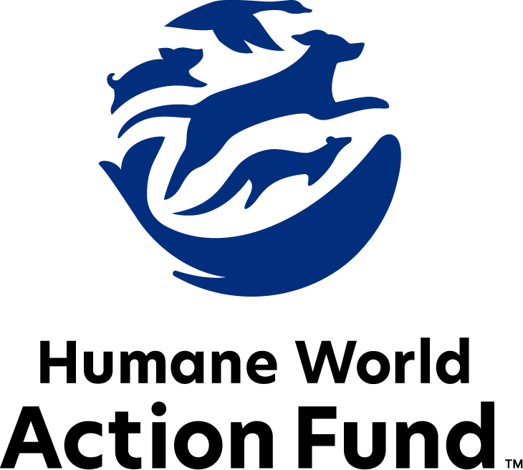

Formerly called  
Humane Society Legislative Fund

CANDIDATE QUESTIONNAIRE

Virginia State Office

# 2025 Virginia state office candidate questionnaire

Candidate Name: _____________________________________________________________________

Candidate Address: ___________________________________________________________________

Office Sought: ______________________________ Locality: ________________________________

Staff Contact Name: _________________________ Phone: _________________________________

Email: ____________________________________ Website: ________________________________

Animals play an important role in the lives of many Americans. Countless citizens look to their local government to protect animals from cruel treatment and exploitation. Humane-minded individuals care deeply about the positions their elected officials take on animal protection issues.

For information on the range and details of our issue areas, please visit the websites of Humane World Action Fund (humaneaction.org) or Humane World for Animals (humaneworld.org).

### Background information

What actions have you taken to promote the welfare of animals in the past? (Please include any action taken in an official or unofficial context.)

Are there any animal welfare programs or issues of importance to you that you would take the initiative on after you are elected?

Will you post information in your campaign materials stating your positions on animal protection issues?

Do you have, or have you had in the past, any pets that have made an impact on you personally?

**STATE ISSUES:**

Statewide office holders and members of state legislatures influence animal protection policy by supporting humane legislation, opposing government programs that use taxpayer funds to harm animals, supporting funding for government programs to protect animals and for adequate enforcement of animal welfare laws, and opposing inhumane laws or those which weaken current protections. We’d like to know your position on the following important animal welfare issues, which are subject to debate in your state.

***PETS AND CRUELTY***

**Puppy Mills:** Internet sales, flea markets, face-to-face sales, and the majority of pet stores that sell puppies are getting those dogs from puppy mills. A puppy mill is an inhumane, high-volume dog breeding facility that churns out puppies for profit, ignoring the needs of the pups and their mothers. Dogs from puppy mills are often sick and unsocialized. Pet retailers often falsely assure consumers that the puppies they offer for sale are raised in reputable or humane breeding facilities, even when they come from inhumane facilities like mass production puppy mills. Humane World for Animals – formerly called Humane Society of the United States – hears from thousands of devastated consumers every year who bring home a dog only to have the animal fall sick and, in some cases, even die.

Will you support efforts to end the sale of puppies sourced from puppy mills in pet stores, which would authorize a locality to regulate or restrict by ordinance the acquisition, marketing, and sale of animals in a pet shop?

_____ Yes _____ No _____ Not Sure

**Pets in Housing:** 72% of Americans reported that pet-friendly rental housing was difficult to find, and 59% agreed that where it was available, excessive fees made it too pricey to afford. Housing agencies also frequently ban or restrict dogs because of their breed, or, more commonly, what is perceived to be their breed. Founded on myths and misinformation, breed-based policies and high, non-refundable pet fees and pet rents force dogs away from their families and into shelters, a devastating scenario that also increases the burden on struggling shelter operations. Recent research found that 24% of nationally-surveyed pet owners have had to move homes strictly because of their companion animals—many driven to rent poorer-quality housing. Altogether, pet ownership can be a mechanism for housing and financial insecurity among renters—particularly those who qualify for subsidized affordable housing—as families with pets often feel powerless and discriminated against while seeking a home.

It is already illegal to broadly prohibit ownership of any breed of dog in Virginia—this does not, however, apply to rules set forth by some housing agencies. Will you support efforts to ban breed- or weight-based pet policies, as well as pet fees, from Virginia’s subsidized affordable housing?

_____ Yes _____ No _____ Not Sure

**Breed-Inclusive Insurance:** Breed-based policies are also employed by many insurance companies, which often discriminate against owners of pit bulls, rottweilers, Doberman pinschers, or other breeds perceived to be uncontrollable. If the insured party owns a dog on an insurance company’s restricted breed list, the company may increase the user’s rates, may exclude liability coverage for any damage the dog causes, may decline to offer a new policy, or may even cancel the user’s existing policy, leaving them vulnerable to all manner of possible expenses.Meanwhile, experts have found that no breed is more likely to bite than another. The AVMA, the National Animal Control Association, and the U.S. Centers for Disease Control and Prevention oppose breed-specific policies, along with leading animal protection organizations.

Will you support efforts to prohibit insurance companies from denying coverage to Virginia homeowners based on their breed, or perceived breed, of dog?

_____ Yes _____ No _____ Not Sure

***FARM ANIMAL PROTECTION AND FOOD SAFETY***

**Fashion:** Animals need their fur coats more than we do. But on fur factory farms around the world, millions of rabbits, foxes, mink, and other wild animals spend their entire lives in cramped cages, deprived of the ability to engage in natural behaviors — only to be crudely gassed or electrocuted at the end. In the wild, animals are caught in crippling leghold traps for days without food or water. These archaic traps are indiscriminate, often maiming and killing non-target animals, like threatened species and even pets — all this in the name of fashion. Mink in fur farms have tested positive for coronavirus, prompting the Netherlands to move up its deadline for ending all mink fur production, and France to announce a ban on mink fur production.

Will you support efforts to prohibit the sale of new products containing fur from animals?

_____ Yes _____ No _____ Not Sure

**Factory Farming:** On factory farms, egg-laying hens are packed into battery cages where they can't even spread their wings. Baby calves are taken from their mothers and confined in pens so small they can barely move, and pigs are locked in gestation crates the width and length of their bodies, unable to even turn around.

Will you support efforts to end cruel industry practices on factory farms?

_____ Yes _____ No _____ Not Sure

***WILDLIFE***

**Killing Contests:** Wildlife killing contests are organized events in which participants compete for prizes to see who can kill the most or the largest animals within a certain time period. Most Americans are shocked to learn that thousands of animals – including coyotes, foxes, bobcats, prairie dogs, rabbits and squirrels – are killed in these events every year across the United States.

Will you support legislation to address killing contests by making it unlawful for any person to organize, sponsor, promote,

conduct, or participate in a competitive event at which the participants kill wildlife?

_____ Yes _____ No _____ Not Sure

**Hound Hunting of Bears:** While Virginia is phasing out canned fox hunting, hound hunting of bears continues. Chasing bears with packs of dogs is inhumane and unsportsmanlike, and an animal fighting situation ensues when bears are overtaken by dogs or stand their ground.

Will you support legislation to ban this outdated practice, which voters have outlawed in many states?

_____ Yes _____ No _____ Not Sure

**Roadside Zoos:** A 2014 Humane World for Animals undercover investigation of the Natural Bridge Zoo in Virginia documented shocking abuses, including mother monkeys fiercely protecting their young as staff separated them, tiger cubs deprived of food so they would be hungry for bottle-feeding photo sessions, and a pregnant giraffe who was found dead in her cage**.** Roadside zoo operators across the country promote themselves as animal experts and conservationists, and often list accreditations by various zoological associations. But the Association of Zoos & Aquariums (AZA), a professional accreditation organization that requires the highest standards of care, does not authorize such activity. Other associations allow members to make their own rules and police themselves. Because of limited oversight, animals kept at roadside zoos are often confined in their cages alone, fed inadequate food, and denied medical care.

Will you oppose efforts to weaken protections for animals kept in roadside zoo facilities?

_____ Yes _____ No _____ Not Sure

**Appointments to State Agencies:** Virginia state agencies are responsible for awide range of policymaking with immeasurable effects on the Commonwealth’s animal populations and wildlife habitats.For example, the Department of Agriculture and Consumer Services decides a range of matters concerning pet store regulations; the inspection of animal shelters; animal control methods; veterinary care mandates; and livestock inspections. The Department of Wildlife Resources regulates hunting, fishing, wildlife watching, the use of public lands, and outdoor recreation. With much to gain, special interests often fill state commission seats—where there should instead be a diverse group of perspectives, representing the broad interests of the public.

Will you encourage the appointment of a diverse range of experts committed to preserving Virginia’s natural beauty and wildlife, backed by science and not by special interests?

_____ Yes _____ No _____ Not Sure

### Thank you for your time! Please return the completed questionnaire to:

Humane World Action Fund

1255 23rd St NW, Suite 455

Washington, D.C. 20037

Phone: (202) 676-2314

Email: info@humaneaction.org

Rev. 3/12/2025

# 

© 2025 Humane World Action Fund

# About us

**We fight for political and policy change to tackle the root causes of animal cruelty and suffering.**

We work to advance our mission by  
passing animal protection laws at the state and federal levels, educating the public about animal protection issues and supporting humane candidates for office. Together, we act to end animal cruelty.

**humaneaction.org**