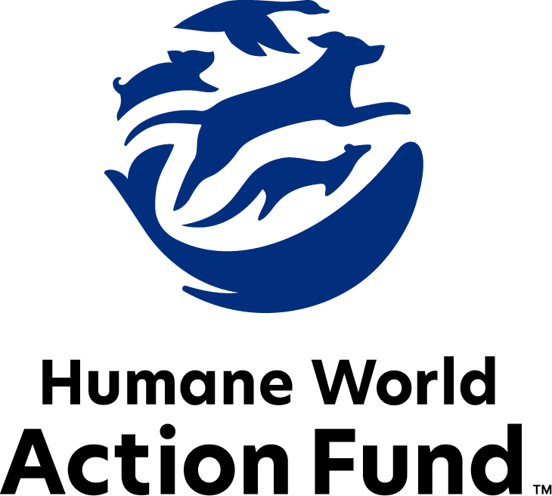

Formerly called  
Humane Society Legislative Fund

CANDIDATE QUESTIONNAIRE

Massachusetts state-level offices

# 2025 Massachusetts state candidate questionnaire

Candidate Name: _____________________________________________________________________

Candidate Address: ___________________________________________________________________

Office Sought: ______________________________ Locality: ________________________________

Staff Contact Name: _________________________ Phone: _________________________________

Email: ____________________________________ Website: ________________________________

Animals play an important role in the lives of many Americans. Countless citizens look to their local government to protect animals from cruel treatment and exploitation. Humane-minded individuals care deeply about the positions their elected officials take on animal protection issues.

For information on the range and details of our issue areas, please visit the websites of Humane World Action Fund (humaneaction.org) or Humane World for Animals (humaneworld.org).

### Background information

What actions have you taken affecting the welfare of animals in the past? Please include actions taken at the local, state, or federal levels.

What actions have you taken affecting the habitats of animals in the past? Please include actions taken at the local, state, or federal levels. Examples may include efforts to address the impacts of natural disasters such as wildfires and hurricanes on ecosystems.

Are there any animal welfare programs or issues of importance to you that you would take the initiative on after you are elected? Examples might include municipal animal welfare standards; cracking down on large-scale commercial breeding facilities known as puppy mills; or local tethering and weather-related laws where pets are concerned.

Will you post information on your campaign website outlining your positions on animal protection issues?

Do you have, or have you had in the past, any pets that have made an impact on you personally?

PETS AND CRUELTY

Puppy Mills: Internet sales, flea markets, face-to-face sales and many pet stores that sell puppies and kittens are getting those animals from large scale breeding operations, often known as puppy mills. A puppy mill is an inhumane, high-volume commercial dog breeding facility which churns out puppies for profit, ignoring the needs of the pups and their mothers. Dogs from puppy mills are often sick and unsocialized. Pet retailers may falsely assure consumers that the puppies they offer for sale are raised in reputable or humane breeding facilities, when really, they are coming from mass production puppy mills.

Will you support efforts to end the retail sale of puppies and kittens sourced from large scale breeding operations in pet stores?

_____ Yes _____ No _____ Not Sure

Spay-Neuter Services: Since 2014, the Massachusetts Animal Fund has made possible its Spay-Neuter Voucher Program through the allocation of over 2.5 million dollars, providing free spay-neuter services for more than 18,500 cats and dogs in the state. For residential pet owners, these services don’t just keep the headcount from growing at home—they also curb unwanted animal behaviors and promote a proven longer lifespan in both dogs and cats. For feral cat caregivers, these humane population control methods promote public health and safety by preventing illness in community cats, and by reducing aggressive or nuisance tendencies exhibited by cats who are unsterilized. Animal control officers also rely on the program to request vouchers for animals in need. The financial support granted to the clinics that participate makes a big difference to a veterinary field currently facing staff and resource shortages nationwide.

Will you support continued funding for the Massachusetts Animal Fund’s Spay-Neuter Voucher Program?

_____ Yes _____ No _____ Not Sure

Breed-Specific Legislation: Some homeownership or rental insurance companies ban or restrict dogs because of their breed, or, more commonly, what is perceived to be their breed. Breed-based policies aren't founded on science or credible data, but on myths and misinformation surrounding different breeds and their natures. The impact of these policies on dogs, families and animal shelters, though, is heartbreakingly real. Breed bans and restrictions force dogs out of homes and into shelters, taking up kennel space and resources that could be used for other animals.

Will you support efforts to prohibit breed-based provisions in homeowner or rental insurance policies?

_____ Yes _____ No _____ Not Sure

FARM ANIMAL PROTECTION AND FOOD SAFETY

Fashion: Animals need their fur coats more than we do, and whether trapped in the wild or raised on farms, animals used in the fur industry suffer immensely. On fur factory farms in the U.S. and around the world, millions of rabbits, foxes, mink, and other wild animals spend their entire lives in cramped cages, deprived of the ability to engage in natural behaviors — only to be crudely gassed or electrocuted at the end. These farms have also proven to be dangerous breeding grounds for various diseases transmissible to humans, such as avian influenza. Prohibiting the sales of new fur products will support efforts to end this cruel industry, while still allowing businesses to sell vintage or used fur products and to continue services caring for fur products, such as storage and cleaning.

Will you support legislation to prohibit the sale of new products containing fur from animals?

_____ Yes _____ No _____ Not Sure

Plant-Based Options: Americans eat more meat per person than any other country. Our habit is leading to poor health. environmental degradation, and the suffering of billions of animals every year. Each of us can make a difference by actively choosing to reduce our consumption of inhumanely produced animal products, refine the items in our shopping cart, and replace animal products with plant-based alternatives. “Clean meat” like the “Beyond” and “Impossible Burger” is becoming increasingly common on menus across the country due to consumer demand. Plant-based meat continues to emerge as the highly competitive, humane option of the future.

Will you support funding for research and innovation in alternative proteins?

_____ Yes _____ No _____ Not Sure

ANIMALS IN RESEARCH

Product Testing: Humane and safe products can be made using the thousands of existing ingredients that have already been approved, and several non-animal safety tests are already available for new ingredients. These non-animal alternatives not only save countless animals, but can be cheaper, faster, and more relevant to human biology, and therefore more reliable at predicting safety. Countries with a collective 1.7 billion consumers, including India and those in the European Union, already prohibit the sale of cosmetics tested on animals, and global companies are meeting this demand with cruelty-free products. California, Hawaii, Illinois, Louisiana, Maine, Maryland, Nevada, New Jersey, New York, Oregon, and Virginia prohibit new animal testing for cosmetics safety substantiation, and it’s expected more states will consider legislation.

Will you support legislation such as [S.640](https://malegislature.gov/Bills/194/S640), which would require that when testing a product, product formulation, chemical, or ingredient in the Commonwealth, no manufacturer or contract testing facility may use a traditional animal test method for which a valid alternative test method exists?

_____ Yes _____ No _____ Not Sure

Rodenticides: Chemical rodenticides are commonly used in commercial rodent control in Massachusetts. These include Second Generation Anticoagulant Rodenticides (SGARs), which induce a particularly insidious death due to excessive bleeding. Not only is this control method highly inhumane—it has also proven to rapidly enter the bodies of predators up the food chain, from owls to big cats and beyond, who ingest the poison and often succumb to it, themselves. Once these compounds enter the environment, they rapidly move across it, virtually unstoppably except at the source. The number of animals who are either compromised or die from the poison is enormous.

Will you support legislation such as the 193rd Legislature’s [H.825](https://malegislature.gov/Bills/193/HD577)/[S.487](https://malegislature.gov/Bills/193/S487), which would monitor and reduce the use of Second Generation Anticoagulant Rodenticides (SGARs) in Massachusetts to protect our wildlife and pets?

_____ Yes _____ No _____ Not Sure

WILDLIFE

Ivory: The United States is among the world’s largest markets for illegal wildlife goods, including elephant ivory and rhinoceros horn. The illegal wildlife trade is a lucrative, multi-billion-dollar enterprise, fueling transnational crime and incentivizing the cruel killing of animals for their parts. Legal ivory marketplaces provide an opportunity for illegal ivory to flourish, because of the ease of mixing the two. Enforcement efforts are often hampered by a lack of resources or the difficulty of visually distinguishing illegal ivory from legally acquired ivory.

Will you support legislation such as [H.3935](https://malegislature.gov/Bills/194/H3935)/[S.616](https://malegislature.gov/Bills/194/S616), which establishes state-level penalties for the sale of ivory and rhinoceros horn in Massachusetts?

_____ Yes _____ No _____ Not Sure

Wildlife Trapping: The steel-jawed leg-hold trap is like a crude landmine for wildlife—when a wild animal, family pet, or even a human steps into the trap, it slams shut, causing severe pain and suffering. The trap’s design has not changed since its invention in 1823, and the number of maimed animals it has left to slowly die in anguish is incalculable. In 1997, public outcry against this cruelty was solidified through a vote—the Wildlife Protection Act “Question One” ballot measure outlawed both steel-jawed and padded leghold traps, in defense of both land and sea animals alike. However, special interests are now trying to lift the ban, reintroducing these cruel, indiscriminate devices.

Will you oppose efforts to repeal the Wildlife Protection Act “Question One” ballot measure, reintroducing barbaric steel-jawed and padded leghold traps to the Commonwealth?

_____ Yes _____ No _____ Not Sure

Appointments to State Agencies: Massachusetts state agencies are responsible for a wide range of policymaking, with immeasurable effects on the state’s animal populations and wildlife habitats. For example, the Massachusetts Department of Agricultural Resources—within the state’s Executive Office of Energy and Environmental Affairs—maintains an Environmental Justice Program, which aids in developing broad environmental policy and responds to the loss of forest land, open spaces, and other crucial habitat land in Massachusetts. The department influences the agricultural policy that determines the lives of countless farmed animals in the state. With much to gain, special interests often fill state commission seats—where there should instead be a diverse group of perspectives, representing the broad interests of the public.

Will you encourage the appointment of a diverse range of experts committed to preserving Massachusetts’s natural beauty and wildlife, backed by science and not by special interests?

_____ Yes _____ No _____ Not Sure

### Thank you for your time! Please return the completed questionnaire to:

Humane World Action Fund

1255 23rd St NW, Suite 455

Washington, D.C. 20037

Phone: (202) 676-2314

Email: info@humaneaction.org

Rev. 3/28/2025

# 

© 2025 Humane World Action Fund

# About us

**We fight for political and policy change to tackle the root causes of animal cruelty and suffering.**

We work to advance our mission by  
passing animal protection laws at the state and federal levels, educating the public about animal protection issues and supporting humane candidates for office. Together, we act to end animal cruelty.

**humaneaction.org**