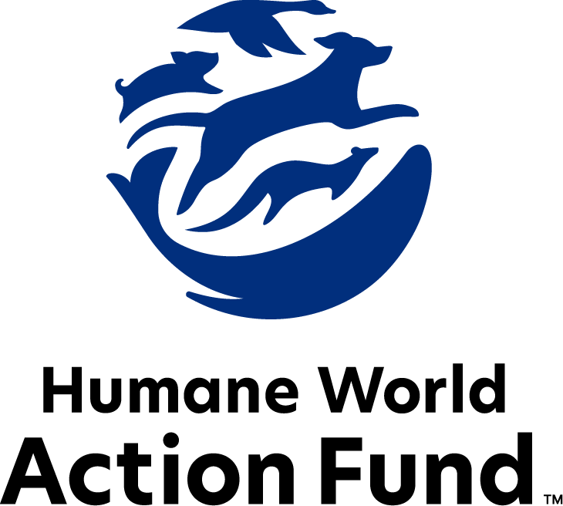

Formerly called
Humane Society Legislative Fund

CONGRESSIONAL CANDIDATE QUESTIONNAIRE
2026 election

2026 congressional candidate questionnaire
Candidate Name: _____________________________________________________________________
Candidate Address: ___________________________________________________________________
Office Sought: ______________________________ Locality: ________________________________
Staff Contact Name: _________________________ Phone: _________________________________
Email: ____________________________________ Website: ________________________________

Animals play an important role in the lives of many Americans. Countless citizens look to their local government to protect animals from cruel treatment and exploitation. Humane-minded individuals care deeply about the positions their elected officials take on animal protection issues.
For information on the range and details of our issue areas, please visit the websites of Humane World Action Fund (humaneaction.org) or Humane World for Animals (humaneworld.org).

Background information

What actions have you taken affecting the welfare of animals in the past? Please include actions taken at the local, state, or federal levels.

What actions have you taken affecting the habitats of animals in the past? Please include actions taken at the local, state, or federal levels. Examples may include efforts to address the impacts of natural disasters such as wildfires and hurricanes on ecosystems.

Are there any animal welfare programs or issues of importance to you that you would take the initiative on after you are elected?

Will you post information on your campaign website outlining your positions on animal protection issues?

Do you have, or have you had in the past, any pets that have made an impact on you personally?

PETS AND CRUELTY

Strengthening Animal Welfare Act Enforcement: The AWA sets basic care standards for over a million animals in research, exhibition, commercial breeding and other facilities, yet many licensees are getting away with egregious abuses due to inadequate enforcement of the law. While the DOJ may currently ask federal courts to issue injunctions to prevent continued unlawful mistreatment of animals, the Better CARE for Animals Act (H.R. 3112/S. 1538) would authorize the agency to seek license revocations, civil penalties, and forfeiture to seize and remove suffering animals. It would also codify a memorandum of understanding between the USDA and the DOJ to encourage greater collaboration and ensure the DOJ has access to evidence needed to initiate cases, following related report language in prior appropriations measures.

Will you support legislation such as the 119th Congress’s H.R. 3112 and S. 1538, the Better Collaboration, Accountability, and Regulatory Enforcement (CARE) for Animals Act?

_____ Yes _____ No _____ Not Sure

Puppy Mills: Puppy mills are commercial breeding facilities that mass-produce puppies for sale. Under the Animal Welfare Act (AWA), the USDA regulates dog breeders that sell to pet stores or over the internet, but the standards of care outlined under the AWA regulations are very outdated. In 2020, the USDA finalized an important rulemaking that provides some upgrades to dog care standards, such as requiring hands-on veterinary exams and 24-hour access to fresh, clean water. However, in many ways the regulations still allow dogs at puppy mills to be kept in overcrowded, filthy, and inhumane conditions that cause them terrible suffering, and often result in sick puppies being sold to consumers.
Legislation is needed to codify the rule’s upgrades and make other long-overdue reforms – e.g., prohibiting the stacking of cages; no longer allowing gridded or wired flooring for these cages; increasing the size of the cages to reduce behavioral problems that dogs in these facilities often develop; requiring protection from sweltering or frigid temperatures; requiring that all dogs be fed at least twice a day, receive prompt treatment for illness or injury, and receive daily socialization with humans and compatible dogs; prohibiting the overbreeding of dogs or the breeding of dogs that have serious health conditions or inheritable diseases; and requiring that breeders make an effort to find humane placement for retired breeding dogs rather than destroying them.

Will you support legislation like the 119th Congress’s H.R. 2253, the Puppy Protection Act, to upgrade standards of care for dogs in large-scale commercial breeding operations?

_____ Yes _____ No _____ Not Sure

Access to Care: In the U.S., at least 20 million pets live in homes experiencing poverty or in underserved areas where resources are limited or essentially nonexistent. Increased access to care through approaches that employ community outreach, policymaking, training for veterinary and animal welfare professionals, corporate partnerships, and direct care programs that serve and provide supplies to people with companion animals at no cost can improve quality of life for both animals and the people who care about them.

Will you support legislation such as H.R. 3732 and S. 1939, the Bring Animals Relief and Kibble (BARK) Act?

_____ Yes _____ No _____ Not Sure

Animal Protection Enforcement: Over the past fifteen years, Congress has given modest increases in funding for enforcement of the Animal Welfare Act, Horse Protection Act, and other animal welfare laws. Increased funding is needed to enforce basic humane treatment of animals at breeding kennels, research laboratories, roadside zoos, circuses, and other regulated facilities.
Will you support continued funding for adequate enforcement of the Animal Welfare Act, Horse Protection Act, and animal welfare programs?
_____ Yes _____ No _____ Not Sure

EQUINE PROTECTION

Horse “Soring”: Congress enacted the Horse Protection Act in 1970 to prohibit the practice of “soring,” in which caustic chemicals and other painful methods are used to injure the hooves and legs of show horses to exaggerate their high-stepping gait in show competitions. Unfortunately, enforcement of the law is too weak, and this deliberate cruelty persists on a widespread basis in the Tennessee walking horse industry.

Will you support legislation such as H.R. 1684, the Prevent All Soring Tactics (PAST) Act, to fortify existing federal law by ending the failed industry self-policing system, strengthening penalties, banning the use of devices associated with soring, and making the actual soring of a horse for the purpose of showing or selling it illegal?

_____ Yes _____ No _____ Not Sure

Horse Slaughter: The horse slaughter industry is a predatory, inhumane enterprise. They don't "euthanize" old horses, but do precisely the opposite: they buy young and healthy horses, often by misrepresenting their intentions, and kill them to sell the meat to Europe and Japan. Most Americans don’t eat horsemeat; American thoroughbreds, family ponies, and other horses are shipped in long-distance transport over the border to Canada or Mexico for brutal slaughter. In addition to animal welfare concerns, horse slaughter is a human health issue. Because horses are not raised for human consumption, they are often given drugs and medications throughout their lives that should not enter the food supply.

Will you support legislation such as H.R. 1661 and S. 775, the Save America’s Forgotten Equines (SAFE) Act, to ban exports of horses for slaughter in other countries, and prevent horse slaughter plants from re-opening in the U.S.?

_____ Yes _____ No _____ Not Sure

FARM ANIMAL PROTECTION AND FOOD SAFETY

States’ Rights: Some members of Congress have introduced bills that would overturn state laws regulating not only animal protection, including those for farmed animals, but also state laws that regulate the sales of products within their own borders, set standards for disease and quarantine control, toxic materials, and more. The U.S. Supreme Court has long recognized the broad latitude provided by the Tenth Amendment to allow states to enact laws that protect public health, safety, and welfare by regulating the sale of goods and services within state borders. Advancing any measure to rescind states’ rights runs contrary to principles of federalism that have guided our nation since its founding and have long allowed states to create specific guidelines and regulations for the sale of goods within their borders.

Will you oppose legislation like the 119th Congress’s S. 1326, the so-called Food Security and Farm Protection Act, and H.R. 4673, the so-called Save Our Bacon Act?

_____ Yes _____ No _____ Not Sure

Plant-Based Protein: Plant-based technologies hold enormous promise for reducing animal suffering by providing alternatives to traditional animal production for food. Conventional animal meat receives significant financial support from the federal government through subsidies, research grants, and more. We are supporting a shift in existing and new federal funding to prioritize additional research and development of plant-based meat alternatives, critical to expanding choice in the marketplace.

Will you support federal incentives to encourage research and innovation into plant-based protein?

_____ Yes _____ No _____ Not Sure

ANIMALS IN RESEARCH

Alternatives Development: The accelerated federal effort to transition to non-animal scientific approaches began after the passage of the Frank R. Lautenberg Chemical Safety for the 21st Century Act in 2016. This law, reforming the Toxic Substances Control Act, passed with broad bipartisan support and established a mandate to promote the development and implementation of test methods and strategies to reduce animal testing, and provide information of equivalent or better scientific quality and relevance for assessing risks to human health or the environment. Many of these methods are already in use by industry, and multiple federal agencies (including FDA, NIH, and EPA) have made recent announcements that they will phase out animal testing in the coming years. However, greater funding and staffing for development and approval of alternative testing methods are vital to this effort. While these announcements are a great first step, much work needs to be done to reach these goals.

Will you support efforts to ensure the federal agencies have the resources to transform systems and bureaucracy built on outdated animal testing methods and adopt New Alternative Methods?

_____ Yes _____ No _____ Not Sure

WILDLIFE

Wildlife Conservation: Congress has continued funding over recent years for programs that help protect critical wildlife habitats and prevent poaching around the world. Millions of dollars have been appropriated for the Rhinoceros and Tiger Conservation Act, the African Elephant Conservation Act, the Indian Elephant Conservation Act, the Great Ape Conservation Act, the Marine Turtle Conservation Act, and the Neotropical Migratory Bird Conservation Act.

Will you support continued funding for wildlife conservation and habitat protection programs?

_____ Yes _____ No _____ Not Sure

Gray Wolf and Grizzly Bear Conservation: Wolves and grizzlies are still recovering from the historical killing campaigns that brought them to the brink of extinction. The U.S. Fish and Wildlife Service provided both species with Endangered Species Act (ESA) protections in the 1970s, but wolves in particular have faced a series of disastrous delisting attempts. In the early 2010s and again in 2020, wolves were stripped of their ESA protections, and states rushed to open brutal trophy hunting, trapping, snaring, and even hounding seasons on them. Today, wolves face a patchwork of protection under the ESA in the lower 48, and although they still urgently need protection, in November 2025 USFWS canceled a much-anticipated National Recovery Plan for this iconic species.
Similarly, USFWS Director Brian Nesvik has indicated the agency may soon seek to remove ESA protections for grizzlies bears as well. With only around 2,000 grizzlies remaining in the lower 48, a tiny fraction of their historical numbers, this important species still needs comprehensive protection. Grizzly bears reproduce slowly; it may take a female grizzly ten years to replace herself in the population.

Will you support efforts to restore and maintain protections for vulnerable gray wolf and grizzly bear populations in the United States as the science dictates?

_____ Yes _____ No _____ Not Sure

Thank you for your time! Please return the completed questionnaire to:

Humane World Action Fund
1255 23rd St NW, Suite 455
Washington, D.C. 20037
Phone: (202) 676-2314

Email: info@humaneaction.org

Rev. 1/30/2026
© 2025 Humane World Action Fund

About us
We fight for political and policy change to tackle the root causes of animal cruelty and suffering.
We work to advance our mission by
passing animal protection laws at the state and federal levels, educating the public about animal protection issues and supporting humane candidates for office. Together, we act to end animal cruelty.

humaneaction.org

