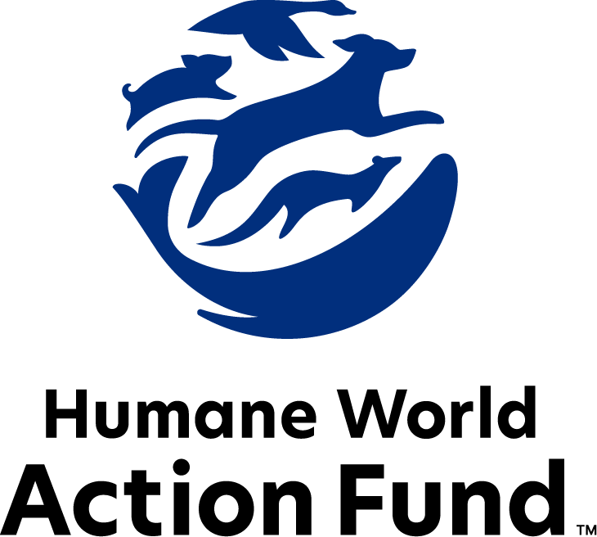

Formerly called
Humane Society Legislative Fund

CANDIDATE QUESTIONNAIRE
Arizona state office

2026 Arizona state office candidate questionnaire
Candidate Name: _____________________________________________________________________
Candidate Address: ___________________________________________________________________
Office Sought: ______________________________ Locality: ________________________________
Staff Contact Name: _________________________ Phone: _________________________________
Email: ____________________________________ Website: ________________________________

Animals play an important role in the lives of many Americans. Countless citizens look to their local government to protect animals from cruel treatment and exploitation. Humane-minded individuals care deeply about the positions their elected officials take on animal protection issues.
For information on the range and details of our issue areas, please visit the websites of Humane World Action Fund (humaneaction.org) or Humane World for Animals (humaneworld.org).

Background information

What actions have you taken to promote the welfare of animals in the past? (Please include any action taken in an official or unofficial context.)

Are there any animal welfare programs or issues of importance to you that you would take initiative on after you are elected?

Will you post information in your campaign materials stating your positions on animal protection issues?

Do you have, or have you had in the past, any pets that have made an impact on you personally?

STATE ISSUES:
Statewide office holders and members of state legislatures influence animal protection policy by supporting humane legislation, opposing government programs that use taxpayer funds to harm animals, supporting funding for government programs to protect animals and for adequate enforcement of animal welfare laws, and opposing inhumane laws or those which weaken current protections. We’d like to know your position on the following important animal welfare issues, which are subject to debate in your state.

PETS AND CRUELTY

Puppy Mills: Internet sales, flea markets, face-to-face sales and many pet stores that sell puppies and kittens are getting those animals from large scale breeding operations, often known as puppy mills. A puppy mill is an inhumane, high-volume commercial dog breeding facility which churns out puppies for profit, ignoring the needs of the pups and their mothers. Dogs from puppy mills are often sick and unsocialized. Pet retailers often falsely assure consumers that the puppies they offer for sale are raised in reputable or humane breeding facilities when really, they are coming from mass production puppy mills.

Will you support efforts to end the sale of puppies sourced from puppy mills in pet stores?

_____ Yes _____ No _____ Not Sure

Preemption: It is well documented that nefarious pet stores have been a front for the puppy mill pipeline for decades. As such, it is essential to protect local communities’ ability to address these bad actors. Individuals who seek to profit off puppies will stop at no cost, even using state level preemption legislation to overturn local ordinances, including puppy mill and pet store reforms. Special interests exhibit a dangerous overreach, coming head-to-head with the core right of local governments to legislate freely on issues impacting their communities. In 2016, the Arizona legislature enacted a law that stripped local governments of their right to regulate puppy-selling pet stores, voiding Phoenix and Tempe ordinances.

Will you support repeal of the 2016 preemption law to support municipal governments in their efforts to raise animal welfare standards within their jurisdiction?

_____ Yes _____ No _____ Not Sure

Cat Declawing: Many countries, two states and more than a dozen cities in the U.S. have banned cat declawing because the procedure frequently results in pain in the paw, infection, tissue necrosis (tissue death), lameness, and back pain. Removing claws changes the way a cat's foot meets the ground and can cause pain like wearing an uncomfortable pair of shoes. There can also be a regrowth of improperly removed claws, nerve damage, and bone spurs. Further, cat declawing has been associated with drastic changes in a cat’s behavior, increasing biting, and other negative behaviors. Humane World Action Fund opposes declawing except for the rare cases when it is necessary for medical purposes to the feline, such as the removal of cancerous nail bed tumors.

Will you support legislation to prohibit the non-therapeutic surgical declawing of cats?

_____ Yes _____ No _____ Not Sure

Pets in Housing: Monthly pet rents, non-refundable pet fees, and a variety of pet deposits are all legal in Arizona rental housing. Rental agencies also frequently ban or restrict dogs because of their breed, or, more commonly, what is perceived to be their breed. Founded on myths and misinformation, breed-based policies and high, non-refundable pet fees and pet rents force dogs away from their families and into shelters, taking up kennel space and resources that could be used for other animals. Recent research suggests that almost 75% of renters with pets have struggled to find affordable, pet-friendly housing, but will go to great lengths to stay with their pets, including renting poorer-quality housing. Altogether, pet ownership can be a mechanism for housing and financial insecurity among renters, as families with pets often feel powerless and discriminated against while seeking a home.

Will you support pet-inclusive rental housing, including efforts to prohibit breed-based and weight-based policies by home rental agencies in Arizona?

_____ Yes _____ No _____ Not Sure

Adequate Food and Water: For dogs who primarily live outdoors, access to shelter from heat and the elements is not just smart—it is crucial to ensuring their safety. And on any pet’s day spent outside, the presence of clean, drinkable water and enough food to support their normal diet is not just a good idea—it is a necessity.

Will you support legislation to require access to adequate food and water for companion animals?

_____ Yes _____ No _____ Not Sure

RESEARCH, TESTING, AND FASHION

Cosmetics: Humane and safe cosmetics can be made using the thousands of existing ingredients that have already been approved, and several non-animal safety tests are already available for new ingredients. These non-animal alternatives not only save countless animals, but can be cheaper, faster, and more relevant to human biology, and therefore more reliable at predicting safety. Countries with a collective 1.7 billion consumers, including India and those in the European Union, already prohibit the sale of cosmetics tested on animals, and global companies are meeting this demand with cruelty-free products. California, Maine, New Jersey, Maryland, Nevada, Virginia, Hawaii, Illinois, Oregon, and Washington prohibit new animal testing for cosmetics safety substantiation, and it’s expected more states will consider legislation.

Will you support legislation which prohibits the manufacture and sale of newly animal-tested cosmetics?

_____ Yes _____ No _____ Not Sure

FARM PROTECTION AND FOOD SAFETY

Factory Farming: As consumers more frequently demand animal products from humane sources, and entire states enact humane sourcing standards, Arizona continues to stand out as a leader in encouraging more humane farming practices. In 2022, Arizona became the tenth state in the U.S. to institute protections for egg-laying hens by prohibiting the production and sale of eggs from caged hens. Hens in Arizona will no longer be confined to brutal battery cages, and by 2032, all eggs laid and sold within the state will be cage-free. This is a massive step forward in ending the cruelest industry practices on factory farms, but now that law is at risk. The proposed Save Our Bacon Act (H.R. 4673) on the federal level aims to prevent states from regulating agricultural practices within their own borders as Arizona has done. If passed, the Save Our Bacon Act, or any legislation like it, would prohibit the passage of crucial animal protection initiatives like the cage-free law across the country.

Will you support efforts to ensure states retain the authority to end the cruelest industry practices on factory farms?

_____ Yes _____ No _____ Not Sure

WILDLIFE

Appointments to State Agencies: Arizona state agencies are responsible for a wide range of policymaking, with immeasurable effects on the state’s animal populations. With much to gain, special interests often fill state commission seats—where there should instead be a diverse group of perspectives, representing the broad interests of the public.

Will you encourage the appointment of a diverse range of experts committed to preserving Arizona’s natural beauty and wildlife, backed by science and not by special interests?

_____ Yes _____ No _____ Not Sure

Thank you for your time! Please return the completed questionnaire to:

Humane World Action Fund
1255 23rd St NW, Suite 455
Washington, D.C. 20037
Phone: (202) 676-2314

Email: info@humaneaction.org

Rev. 1/20/2026
© 2025 Humane World Action Fund

About us
We fight for political and policy change to tackle the root causes of animal cruelty and suffering.
We work to advance our mission by
passing animal protection laws at the state and federal levels, educating the public about animal protection issues and supporting humane candidates for office. Together, we act to end animal cruelty.

humaneaction.org

