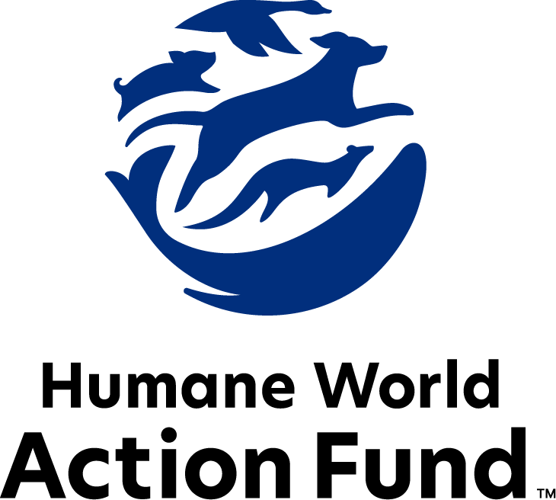

Formerly called
Humane Society Legislative Fund

CANDIDATE QUESTIONNAIRE
California state office

2026 California state office candidate questionnaire
Candidate Name: _____________________________________________________________________
Candidate Address: ___________________________________________________________________
Office Sought: ______________________________ Locality: ________________________________
Staff Contact Name: _________________________ Phone: _________________________________
Email: ____________________________________ Website: ________________________________

Animals play an important role in the lives of many Americans. Countless citizens look to their local government to protect animals from cruel treatment and exploitation. Humane-minded individuals care deeply about the positions their elected officials take on animal protection issues.
For information on the range and details of our issue areas, please visit the websites of Humane World Action Fund (humaneaction.org) or Humane World for Animals (humaneworld.org).

Background information

What actions have you taken to promote the welfare of animals in the past? (Please include any action taken in an official or unofficial context.)

Are there any animal welfare programs or issues of importance to you that you would take the initiative on after you are elected?

Will you post information in your campaign materials stating your positions on animal protection issues?

Do you have, or have you had in the past, any pets that have made an impact on you personally?

STATE ISSUES:
Statewide office holders and members of state legislatures influence animal protection policy by supporting humane legislation, opposing government programs that use taxpayer funds to harm animals, supporting funding for government programs to protect animals and for adequate enforcement of animal welfare laws, and opposing inhumane laws or those which weaken current protections. We’d like to know your position on the following important animal welfare issues, which are subject to debate in your state.

WILDLIFE

Bear Hunting: The Black Bear Take Report for 2021 to 2023 revealed that the average number of black bears killed per year was 27% higher than in 2020. Nearly 4,000 bears were killed over the three year period. The California Department of Fish and Wildlife measures the population solely through the number of bears killed and reported by hunters, which allows for significant error—as such, Humane World for Animals, formerly the Humane Society of the United States, petitioned California's Fish and Game Commission to temporarily halt the practice of bear hunting, allowing time to develop a census capable of returning dependable numbers. This would allow conservation efforts to be adjusted as necessary to protect the vulnerable species.

Will you support efforts to protect California’s iconic species such as the black bear from significant population decline?

_____ Yes _____ No _____ Not Sure

Hounding: Hound hunting is a tactic in which packs of dogs pursue exhausted, frightened animals until they seek refuge in a tree—where they are then shot—or turn to fight to the death. After this gruesome conflict, any babies left orphaned are vulnerable to their natural predators, or to mauling by the same dogs. In turn, the dogs involved can suffer broken bones, punctured lungs or other serious injuries, and are frequently dumped at municipal animal shelters or left in the woods if they do not perform adequately. Hound hunting for bears and bobcats was banned in California in 2012. The California Wildlife Protection Act of 1990, enacted by Proposition 117, designates the mountain lion as a “specially protected mammal under the laws of this state.” The non-lethal hounding of mountain lions is prohibited under Proposition 117.

Despite current California law, bills have been introduced that would allow for the use of hounding to haze bears and mountain lions. Scientific evidence shows that hounding does not reduce human-wildlife conflicts, is cruel to the animals hunted, and endangers the dogs involved. Simply put, hounding is dangerous for people, wildlife, and the hounds themselves.

Will you uphold the current law and oppose efforts to legalize any form of hounding in California?

_____ Yes _____ No _____ Not Sure

Coexistence: Californians derive immense ecological, economic, and recreational value from the state’s diverse wildlife, including its native carnivores. Wolves, bears, mountain lions, and bobcats are critical parts of the state’s natural beauty and ecosystems. However, humans and wildlife do come into contact, and it is critical that nonlethal management practices are used to improve coexistence rather than inhumane and ineffectual ones like trapping, baiting, hunting seasons, and more.

Will you support the use of nonlethal management practices to improve coexistence between Californians and the state’s native carnivores?

_____ Yes _____ No _____ Not Sure

Public Contact: While exciting to see up close, wild animals are altogether unfit for public contact. Substandard wildlife attractions in California, like roadside zoos and exotic animal shows, exploit these animals to turn a quick profit, often with such neglect that horror stories have been recorded through undercover investigations. Not only do wild animals like elephants, bears, and nonhuman primates suffer when captured, transported, or placed in close proximity to humans—the risks they then pose to human health and safety are enormous. Cases of aggression may prove life-threatening, as may a host of zoonotic diseases these animals contract. Public contact with wild animals jeopardizes their welfare as well as the health and safety of the public. In fact, 14 other states have already prohibited public contact with specific animals because of the danger posed by this industry.

Will you support legislation to prohibit direct public contact with wild animals in California?

_____ Yes _____ No _____ Not Sure

Appointments to State Agencies: California state agencies are responsible for a wide range of policymaking with immeasurable effects on the state’s animal populations and wildlife habitats. For example, the Department of Food and Agriculture decides a range of matters concerning animal health; the transfer of companion and farmed animals; and livestock inspections. The Fish and Game Commission sets protections for endangered species but also issues a multitude of hunting and fishing licenses. With much to gain, special interests often fill state commission seats—where there should instead be a diverse group of perspectives, representing the broad interests of the public.

Will you encourage the Governor’s appointment of a diverse range of experts committed to preserving California’s natural beauty and wildlife, backed by science and not by special interests?

_____ Yes _____ No _____ Not Sure

PETS AND CRUELTY

Cost of Animal Care: Animal cruelty cases can involve the seizure of dozens or even hundreds of animals. Providing care for the animals for months or years pending trial can be financially devastating to county animal shelters and to the well-being of these abused animals. Large-scale cases can be a financial burden for shelters, preventing critical resources from reaching other homeless, abused, or at-risk animals.

Will you support efforts to shift this financial burden to those who abused or neglected the animals?

_____ Yes _____ No _____ Not Sure

Roosters: Cockfighting is still a prevalent industry across the country with negative impacts on the birds themselves and on the communities in which cockfighting rings are run. Roosters forced to participate in cockfighting suffer terribly before, during, and after fights—common injuries include punctured lungs, broken bones and pierced eyes, yet there is no escape from the fighting pit. The steel blades tied to the birds' legs are so sharp and dangerous that cockfighters themselves have been killed when accidentally slashed by their own birds. As federal and state law enforcement can attest, cockfighting is often associated with other criminal activities such as illegal gambling, drug trafficking, and illegal weapon sales. Animal cruelty, avian disease, and crime are all consequences of this dangerous industry. One path in combatting California’s illegal cockfighting problem is to institute a rooster limit law modeled after existing rooster ordinances to protect our communities. Limiting the number of tethered or confined roosters a person can own, addresses cockfighting before it becomes a major criminal operation

Will you support a rooster limit bill to prevent individuals from breeding for the purposes of cockfighting?

_____ Yes _____ No _____ Not Sure

COMPANION ANIMALS

Pets in Housing: As California faces an ongoing housing affordability and homelessness crisis, we must do more to keep people with their pets. Pet rent and additional non-refundable pet fees continue to be a key barrier for Californians and their pets. 72% of Americans report that pet-friendly rental housing is difficult to find, and 59% agree that where it is available, it’s too pricey to afford. Pet ownership has proven to be an increasing mechanism for housing and financial insecurity among renters, as families with pets often feel powerless and discriminated against while seeking a home. Additionally, pets provide companionship, warmth, and security to many people experiencing homelessness—but while up to 10 percent of the national homeless population maintains companion animals, they are often not permitted in shelters, motels, or in other assisted housing. Surrendering these animals means losing a critical source of comfort, purpose, and family.

Will you support legislation promoting pet-inclusive, affordable rental practices to keep people and their pets together?

_____ Yes _____ No _____ Not Sure

Access to Veterinary Care: Today, 344,000 California shelter animals do not have adequate access to veterinary care. Roughly 40% of animal shelters in the state cannot provide consistent access to spay and neuter services which are required before shelter animals can be adopted out to new homes. These gaps in care have deadly consequences. A lack of basic veterinary care across the state’s shelters is already leading to higher rates of euthanasia and disease. Shelter staff and pet owners alike are struggling to find veterinary care due to the profession’s snowballing shortage. Without an intervention, more animals will lose access to the medical care they need to live full, healthy lives alongside their human companions.

Will you support efforts to alleviate California’s veterinarian shortage and increase access to veterinary care?

_____ Yes _____ No _____ Not Sure

Supporting Shelters: Across California, animal shelters in both rural and urban areas are overwhelmed by the constant influx of animals in need of their care. These shelters are critical to their communities, reuniting lost pets with their families and adopting out companion animals to loving homes. Overcrowding and lack of funds put a strain on shelters that play a vital role in responding to cruelty cases, offering spay and neuter services, and helping maintain public health. The lifesaving service shelters and rescues provide will become more difficult to maintain if the current crisis is not addressed.

Will you support legislation that increases funding for California’s shelters?

_____ Yes _____ No _____ Not Sure

FARM PROTECTION AND FOOD SAFETY

Proposition 12: In 2018, 63% of California voters said “YES!” to ballot measure “Proposition 12,” the strongest farm animal protection law in the world. The passage of the transformational proposition built on protections first passed by voters in 2008, to ensure that pork, eggs and veal products produced or sold in the California marketplace come from facilities that do not confine animals in tiny, cruel cages their entire lives. Despite legal challenges to the law mounted by special interests, the United States Supreme Court upheld Proposition 12 as constitutional and ruled that California could establish regulations pertaining to animal products sold within its borders. The Court’s decision quashed one challenge to Proposition 12, but threats to similar farm animal protection laws continue to rise. The proposed Save Our Bacon Act (H.R. 4673) and Food Security and Farm Protection Act (S.1326) on the federal level aim to prevent states from regulating agricultural practices within their own borders. If either passed, the bills could prohibit the passage of crucial animal protection initiatives like Proposition 12 across the country.

Will you oppose efforts to further delay or repeal the enforcement of Proposition 12?

_____ Yes _____ No _____ Not Sure

Thank you for your time! Please return the completed questionnaire to:

Humane World Action Fund
1255 23rd St NW, Suite 455
Washington, D.C. 20037
Phone: (202) 676-2314

Email: info@humaneaction.org

Rev. 2/10/2026
© 2025 Humane World Action Fund

About us
We fight for political and policy change to tackle the root causes of animal cruelty and suffering.
We work to advance our mission by
passing animal protection laws at the state and federal levels, educating the public about animal protection issues and supporting humane candidates for office. Together, we act to end animal cruelty.

humaneaction.org

