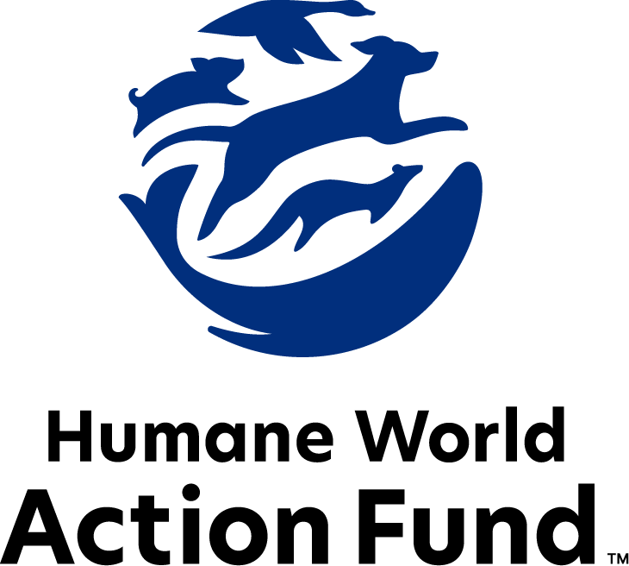

Formerly called
Humane Society Legislative Fund

CANDIDATE QUESTIONNAIRE
Indiana state office

2026 Indiana state office candidate questionnaire
Candidate Name: _____________________________________________________________________
Candidate Address: ___________________________________________________________________
Office Sought: ______________________________ Locality: ________________________________
Staff Contact Name: _________________________ Phone: _________________________________
Email: ____________________________________ Website: ________________________________

Animals play an important role in the lives of many Americans. Countless citizens look to their local government to protect animals from cruel treatment and exploitation. Humane-minded individuals care deeply about the positions their elected officials take on animal protection issues.
For information on the range and details of our issue areas, please visit the websites of Humane World Action Fund (humaneaction.org) or Humane World for Animals (humaneworld.org).

Background information

What actions have you taken to promote the welfare of animals in the past? (Please include any action taken in an official or unofficial context.)

Are there any animal welfare programs or issues of importance to you that you would take initiative on after you are elected?

Will you post information in your campaign materials stating your positions on animal protection issues?

Do you have, or have you had in the past, any pets that have made an impact on you personally?

STATE ISSUES:
Statewide office holders and members of state legislatures influence animal protection policy by supporting humane legislation, opposing government programs that use taxpayer funds to harm animals, supporting funding for government programs to protect animals and for adequate enforcement of animal welfare laws, and opposing inhumane laws or those which weaken current protections. We’d like to know your position on the following important animal welfare issues, which are subject to debate in your state.

PETS AND CRUELTY

Puppy Mills: Internet sales, flea markets, face-to-face sales, and many pet stores that sell puppies are getting those dogs from puppy mills. A puppy mill is an inhumane, high-volume commercial dog breeding facility which churns out puppies for profit, ignoring the needs of the pups and their mothers. Dogs from puppy mills are often sick and unsocialized. Pet retailers often falsely assure consumers that the puppies they offer for sale are raised in reputable or humane breeding facilities, even when they come from inhumane facilities like mass production puppy mills. Humane World for Animals hears from thousands of devastated consumers every year who bring home a dog only to have the animal fall sick and, in some cases, even die.

Will you support legislation to end the retail sale of puppies sourced from puppy mills in pet stores?

_____ Yes _____ No _____ Not Sure

Preemption: It is well documented that some pet stores have been a front for the puppy mill pipeline for decades. As such, it is essential to protect local communities’ ability to address these bad actors. Individuals who seek to profit from puppies will stop at no cost, even using state level preemption legislation to overturn local ordinances, including puppy mill and pet store reforms, as they recently did in Indiana. In 2024, HB 1412 was signed into law, preempting localities from regulating pet stores and thus preserving the puppy mill to pet store pipeline. HB 1412 represents the dangerous overreach of special interests, which violates the core right of local governments to legislate freely on issues impacting their communities.

Will you empower local governments and support the repeal of HB 1412 (2024)?

_____ Yes _____ No _____ Not Sure

Predatory Pet Financing: Pet stores in Indiana that sell puppies and kittens—rather than partner with local rescues and shelters for sourcing adoptable animals—frequently offer financing for the purchase of pets using predatory lending practices with interest rates as high as 188%. The purchase price and financing documents are often not presented to potential buyers until after they interact with a puppy or kitten, and sometimes not until the final moments of a transaction. These practices often put families thousands of dollars in debt, and at risk of repossessing their new animals.

Will you support efforts to end predatory financing practices in Indiana’s pet stores?

_____ Yes _____ No _____ Not Sure

Cat Declawing: Many countries and hundreds of cities in the U.S. have banned cat declawing because the procedure frequently results in pain in the paw, infection, tissue necrosis (tissue death), lameness, and back pain. Removing claws changes the way a cat's foot meets the ground and can cause pain like wearing an uncomfortable pair of shoes. There can also be a regrowth of improperly removed claws, nerve damage, and bone spurs. Further, cat declawing has been associated with drastic changes in a cat’s behavior, increasing biting, and other negative behaviors. Humane World Action Fund opposes declawing except for the rare cases when it is necessary for medical purposes to the feline, such as the removal of cancerous nail bed tumors.

Will you support legislation to prohibit the non-therapeutic surgical declawing of cats?

_____ Yes _____ No _____ Not Sure

FARM PROTECTION AND FOOD SAFETY

Factory Farming: On factory farms, egg-laying hens are packed into battery cages where they can't even spread their wings. Baby calves are taken from their mothers and confined in pens so small they can barely move, and pigs are locked in gestation crates the width and length of their bodies, unable to even turn around.

Will you support efforts to protect Indiana’s family farmers by prohibiting cruel industry practices on factory farms?

_____ Yes _____ No _____ Not Sure

ANIMALS IN RESEARCH

Retirement: It is a bleak life for the tens of thousands of dogs and cats used in testing and research in U.S. laboratories each year. These animals spend almost every hour of their short lives behind bars in cold steel cages, never knowing what it is like to play fetch, lie in the sun, or roll over happily for a belly rub. Those who have adopted former research dogs and cats can attest to the resilience and affection of these animals once they are given the chance to flourish in a home environment.

Will you support legislation that would require institutions of higher education, and related research facilities, to offer cats and dogs no longer used for educational, research, or scientific purposes to animal rescue organizations for adoption prior to euthanizing the animals?

_____ Yes _____ No _____ Not Sure

WILDLIFE

Killing Contests: Wildlife killing contests are organized events in which participants compete for prizes to see who can kill the most or the largest animals within a certain time period. Most Americans are shocked to learn that thousands of animals – including coyotes, foxes, bobcats, prairie dogs, rabbits and squirrels – are killed in these events every year across the United States.

Will you support legislation to address killing contests by making it unlawful for any person to organize, sponsor, promote, conduct, or participate in a competitive event at which the participants harass or take covered wildlife?

_____ Yes _____ No _____ Not Sure

Thank you for your time! Please return the completed questionnaire to:

Humane World Action Fund
1255 23rd St NW, Suite 455
Washington, D.C. 20037
Phone: (202) 676-2314

Email: info@humaneaction.org

Rev. 1/20/2026
© 2025 Humane World Action Fund

About us
We fight for political and policy change to tackle the root causes of animal cruelty and suffering.
We work to advance our mission by
passing animal protection laws at the state and federal levels, educating the public about animal protection issues and supporting humane candidates for office. Together, we act to end animal cruelty.

humaneaction.org

