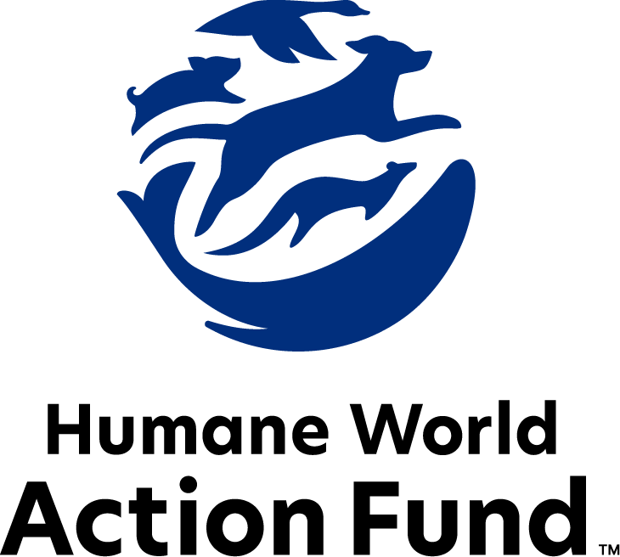

Formerly called
Humane Society Legislative Fund

CANDIDATE QUESTIONNAIRE
Kansas state office

2026 Kansas state office candidate questionnaire
Candidate Name: _____________________________________________________________________
Candidate Address: ___________________________________________________________________
Office Sought: ______________________________ Locality: ________________________________
Staff Contact Name: _________________________ Phone: _________________________________
Email: ____________________________________ Website: ________________________________

Animals play an important role in the lives of many Americans. Countless citizens look to their local government to protect animals from cruel treatment and exploitation. Humane-minded individuals care deeply about the positions their elected officials take on animal protection issues.
For information on the range and details of our issue areas, please visit the websites of Humane World Action Fund (humaneaction.org) or Humane World for Animals (humaneworld.org).

Background information

What actions have you taken to promote the welfare of animals in the past? (Please include any action taken in an official or unofficial context.)

Are there any animal welfare programs or issues of importance to you that you would take initiative on after you are elected?

Will you post information in your campaign materials stating your positions on animal protection issues?

Do you have, or have you had in the past, any pets that have made an impact on you personally?

STATE ISSUES:
Statewide office holders and members of state legislatures influence animal protection policy by supporting humane legislation, opposing government programs that use taxpayer funds to harm animals, supporting funding for government programs to protect animals and for adequate enforcement of animal welfare laws, and opposing inhumane laws or those which weaken current protections. We’d like to know your position on the following important animal welfare issues, which are subject to debate in your state.

PETS AND CRUELTY

Puppy Mills: Internet sales, flea markets, face-to-face sales and many pet stores that sell puppies are getting those dogs from puppy mills. A puppy mill is an inhumane, high-volume commercial dog breeding facility which churns out puppies for profit, ignoring the needs of the pups and their mothers. Dogs from puppy mills are often sick and unsocialized. Pet retailers often falsely assure consumers that the puppies they offer for sale are raised in reputable or humane breeding facilities, when really, they are coming from mass production puppy mills.

Will you support efforts to end the retail sale of puppies sourced from puppy mills in pet stores?

_____ Yes _____ No _____ Not Sure

Pet Animal Inspection Program: A bill (SB 130) updating certain terms related to the Kansas Pet Animal Act was introduced in 2025 by the Kansas Department of Agriculture with strong support from licensees. This bill makes it clear that there are needed changes to the law to help the Animal Facility Inspection (AFI) program facilitate the Kansas Pet Animal Act which governs pet animal breeders, shelters, rescues, pet stores, boarding/training kennels, research facilities and pet animal distributors. The shelter and rescue community need a section that states neonates can be fostered even if they are stray. Photos can be taken and pinned in the stray areas in case anyone is missing a litter of motherless kittens or puppies. Currently, the only options are for shelter staff to take them home and feed every 2 hours or euthanization.

The Department of Agriculture has been working with advocates to update the regulations to the Pet Animal Act over the past two years. The KDA is requiring head to tail examinations of all puppies and kittens being adopted by shelters and rescues. Shelters and rescues have protocols in place and should not have to do more than their veterinarian requires. The problems of sick puppies and kittens are not coming from shelters and rescues.

Will you support an update to the “Pet Animal Act,” allowing the Kansas Department of Agriculture AFI program to enforce the Act that governs the state’s hundreds of pet animal licensees?

_____ Yes _____ No _____ Not Sure

Preemption: It is well documented that nefarious pet stores have been a front for the puppy mill pipeline for decades. Many communities have addressed the sale of puppy mill puppies by passing pet store ordinances. Yet, these local initiatives are now jeopardized by the introduction of preemption bills in the state legislature. In these preemption bills, the “consumer merchandise” language will most likely prevent enforcement of any local sales or marketing-related animal welfare ordinances in Kansas, including pet store ordinances, fur ordinances, and ordinances relating to the sale of products derived from animals. In addition, any other ordinances related to the sale, lease, or marketing of virtually any product, animal or otherwise, will likely be preempted.

Regardless of the stated intent, the preemption language will void many areas of business regulation common at the local level, whether animal-related or not. Kansas cities and towns have enacted hundreds, if not thousands of ordinances that are likely preempted and unenforceable under these poorly written bills. These municipal governments have a core right to legislate freely on issues impacting their communities, but dangerous overreach by special interests is threatening their ability to do so.

Will you support municipal governments in their efforts to raise animal welfare standards within their jurisdiction?

_____ Yes _____ No _____ Not Sure

Raccoons as Pets: HB 2297 (2025) is a bill that would allow private ownership of raccoons as pets in Kansas. Current law prohibits the keeping of raccoons as pets. This law protects Kansans from unnecessary exposure to rabies, a near fatal disease, as well as zoonotic diseases and parasites that are transmissible to humans and other animals. The Kansas Department of Health and Environment opposes keeping raccoons as pets due to the lack of vaccines specifically designed to protect raccoons against rabies. Furthermore, the bill would allow raccoons to move into Kansas from other regions, which could jeopardize Kansas’ status as currently free from raccoon variant rabies.

Will you oppose legislation like HB 2297 (2025) that seeks to legalize keeping raccoons as pets?

_____ Yes _____ No _____ Not Sure

Trap-Neuter-Return: In at least 240 cities and counties in the U.S., a free-roaming cat with an “ear-tip” indicator is one you can trust has been vaccinated against rabies; spayed or neutered; and subsequently marked as a “community cat.” These services promote public health and safety by preventing illness in community cat populations, and by reducing aggressive or nuisance behavior exhibited by unsterilized cats. As a result of humane population control, public resources are preserved, and fewer free-roaming cats are admitted to overcrowded shelters. Yet, current Kansas law does not allow for the trap, spay/neuter, vaccination, and return of cats, classifying it as abandonment under the cruelty statute. By exempting feral cats from this statute, communities will be able to legally and humanely combat growing feral cat populations.

Will you support adding language to the cruelty statute to allow for the trap, spay/neuter, vaccination, and return of cats?

_____ Yes _____ No _____ Not Sure

ANIMALS IN RESEARCH

Cosmetics Testing: Humane and safe cosmetics can be made using the thousands of existing ingredients that have already been approved, and several non-animal safety tests are already available for new ingredients. These non-animal alternatives not only save countless animals, but can be cheaper, faster, and more relevant to human biology, and therefore more reliable at predicting safety. Countries with a collective 1.7 billion consumers, including India and those in the European Union, already prohibit the sale of cosmetics tested on animals, and global companies are meeting this demand with cruelty-free products. California, Maine, New Jersey, Maryland, Nevada, Virginia, Hawaii, and Illinois prohibit new animal testing for cosmetics safety substantiation, and it’s expected more states will consider legislation.

Will you support legislation which prohibits the manufacture and sale of newly animal-tested cosmetics?

_____ Yes _____ No _____ Not Sure

WILDLIFE

Captive Wildlife: Wild animals make unsuitable pets under virtually all circumstances, and very few people are equipped or have the expertise to properly maintain wild animals in household environments. To own animals such as primates and wolves requires that they suffer cruelly when captured, transported, or placed in close proximity to humans. And while already dangerous in and of themselves, many wild animals may also carry pathogens that cause significant human disease. Primates and wolves in captivity are increasingly an issue in Kansas as they have been found in Wichita, Sedgwick County, Wabaunsee County, and Emporia.

Would you support a bill to ban the private ownership of wolves and primates in Kansas?

_____ Yes _____ No _____ Not Sure

Thank you for your time! Please return the completed questionnaire to:

Humane World Action Fund
1255 23rd St NW, Suite 455
Washington, D.C. 20037
Phone: (202) 676-2314

Email: info@humaneaction.org

Rev. 1/20/2026
© 2025 Humane World Action Fund

About us
We fight for political and policy change to tackle the root causes of animal cruelty and suffering.
We work to advance our mission by
passing animal protection laws at the state and federal levels, educating the public about animal protection issues and supporting humane candidates for office. Together, we act to end animal cruelty.

humaneaction.org

