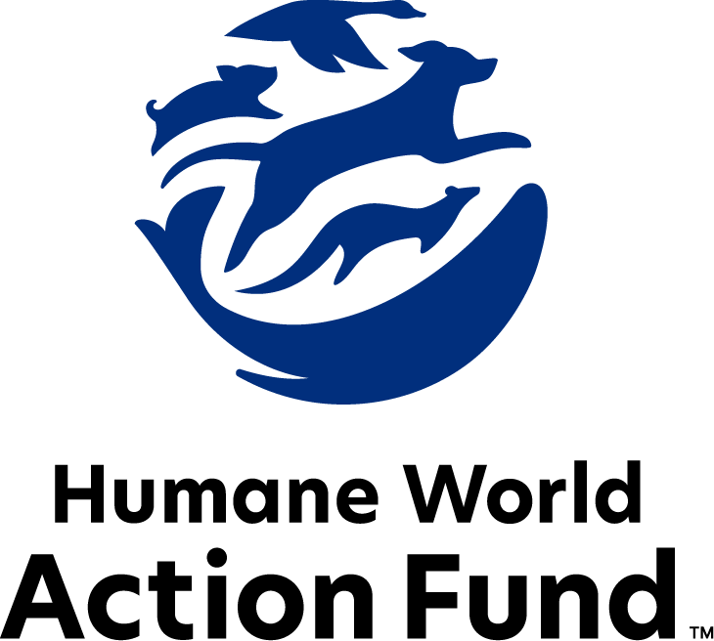

Formerly called
Humane Society Legislative Fund

CANDIDATE QUESTIONNAIRE
Maryland state office

2026 Maryland state office candidate questionnaire
Candidate Name: _____________________________________________________________________
Candidate Address: ___________________________________________________________________
Office Sought: ______________________________ Locality: ________________________________
Staff Contact Name: _________________________ Phone: _________________________________
Email: ____________________________________ Website: ________________________________

Animals play an important role in the lives of many Marylanders. Countless citizens look to their government to protect animals from cruel treatment and exploitation. Humane-minded individuals care deeply about the positions their elected officials take on animal protection issues.
For information on the range and details of our issue areas, please visit the websites of Humane World Action Fund (humaneaction.org) or Humane World for Animals (humaneworld.org).

Background information

What actions have you taken to promote the welfare of animals in the past? (Please include any action taken in an official or unofficial context.)

Are there any animal welfare programs or issues of importance to you that you would take initiative on after you are elected?

Will you post information in your campaign materials stating your positions on animal protection issues?

Do you have, or have you had in the past, any pets that have made an impact on you personally?

STATE ISSUES:
Statewide office holders and members of state legislatures influence animal protection policy by supporting humane legislation, opposing government programs that use taxpayer funds to harm animals, supporting funding for government programs to protect animals and for adequate enforcement of animal welfare laws, and opposing inhumane laws or those which weaken current protections. We’d like to know your position on the following important animal welfare issues, which are subject to debate in your state.

PETS AND CRUELTY

Pets in Housing: Monthly pet rents, non-refundable pet fees, and a variety of pet deposits are all legal in Maryland for rental housing, and there is no cap on their amount. Rental agencies and rental and home insurance providers also frequently ban or restrict dogs because of their breed, or more commonly, what is perceived to be their breed. Founded on myths and misinformation, breed-based policies and high, non-refundable pet fees and pet rents force dogs away from their families and into shelters, taking up kennel space and resources that could be used for other animals. This lack of affordable pet-friendly housing is one of the most common reasons Marylanders surrender their companion animals to state-run shelters. Recent research suggests that almost 75% of renters with pets have struggled to find affordable, pet-friendly housing, but will go to great lengths to stay with their pets, including renting poorer-quality housing. Altogether, pet ownership can be a mechanism for housing and financial insecurity among renters, as families with pets often feel powerless and discriminated against while seeking a home.

Will you support efforts to prohibit discriminatory breed-based policies in Maryland home rental agencies and insurance policies?

_____ Yes _____ No _____ Not Sure

Breed Specific Legislation: Across the United States, entire communities ban or restrict dogs because of their breed, or more commonly, what is perceived to be their breed. Breed-based policies aren't founded on science or credible data, but on myths and misinformation surrounding different breeds and their natures. The impact of these policies on families, pets, and animal shelters, though, is heartbreakingly real. Breed bans and restrictions force dogs out of homes and into shelters, taking up kennel space and resources that could be used for other animals. Additionally, breed bans do not address the actual problems harming public safety: lax animal codes or enforcement, pets running loose, and limited public education on safety around dogs. Prince George’s County, which had the nation’s largest breed ban by number of families affected and geographical size, recently repealed their decades old breed ban and replaced it with modern, effective policies. Maryland should follow that lead.

Will you support legislation to preempt municipalities from enacting harmful and misguided breed-specific legislation?

_____ Yes _____ No _____ Not Sure

FARM PROTECTION AND FOOD SAFETY

Confinement: On factory farms, egg-laying hens are packed into battery cages where they cannot even spread their wings. The space they are afforded is less than a single sheet of letter-sized paper. This extreme confinement is horrible for the welfare of egg-laying hens and increases food safety risk. Other states have passed legislation to prohibit the cruel caging of hens, and many are close behind, as public support to end this abuse continues to grow.

Will you support legislation like 2025’s SB 806/HB 834 to end the cruel confinement of egg-laying hens?

_____ Yes _____ No _____ Not Sure

Plant-Based Options: Americans eat more meat per person than any other country. Our habit is leading to poor health, environmental degradation, and the suffering of billions of animals every year. Each of us can make a difference by actively choosing to reduce our consumption of inhumanely produced animal products, refine the items in our shopping cart, and replace animal products with plant-based alternatives. But too often, plant-based options simply aren’t available at public venues.

Will you support legislation to require at least one plant-based meal option to be made available at all large public venues, excluding restaurants?

_____ Yes _____ No _____ Not Sure

ANIMALS IN RESEARCH

Animal Testing: While Maryland has joined several states in prohibiting new animal testing for cosmetics, animal testing still occurs on ingredients for a wide range of health products, for hygiene and medicinal purposes. Yet, currently, 90% of drugs tested on animals fail in human trials. Non-animal alternatives not only save countless animal lives, but can be cheaper, faster, and more relevant to human biology, and therefore more reliable at predicting safety.

Will you support legislation like 2025’s HB 1448 and SB 536, which prohibit research facilities from using animal testing if a non-animal alternative exists and set stronger welfare standards as long as such testing continues?

_____ Yes _____ No _____ Not Sure

Dogs in Research: Maryland was a leader in passing the “Beagle Freedom Bill,” which requires research facilities in the state to take reasonable steps to offer for adoption any dogs used in scientific experiments once they are no longer needed. Unfortunately, the legislation included no reporting requirements, leaving Marylanders with no way to know whether the law is being implemented. A transparency mechanism is crucial to ensure compliance. For example, in 2024, Inotiv, a CRO (contract research organization) that breeds animals for medical testing, paid a historic $35 million settlement for conspiring to knowingly violate the Animal Welfare Act. This is the largest ever fine in an Animal Welfare Act case and followed a surrender of 4,000 beagles to the Department of Justice from one of their facilities in neighboring Virginia. Inotiv is still active and has a presence in Maryland.

Will you support legislation like 2025’s SB 537 to strengthen Maryland’s Beagle Bill through an annual reporting requirement to the Department of Agriculture and the General Assembly?

_____ Yes _____ No _____ Not Sure

WILDLIFE

Exotic Pets: Due to clear threats to public health and safety, it is illegal in Maryland to own lions, tigers, other wild big cat species, monkeys, wolves, poisonous snakes, or alligators as pets. However, a new issue came to light in 2021 when three zebras escaped their enclosure on a private farm and roamed Prince George’s County. The owner was soon charged with 3 counts of animal cruelty - first after a failure to retrieve one zebra dying in an illegal snare trap bordering the property, and then after close inspection proved the owner hadn’t provided adequate shelter, food, water, or veterinary care. This case and others highlight the need to strengthen Maryland’s list of prohibited animals for private possession.

Will you support legislation to prohibit private ownership of a larger scope of wild animals?

_____ Yes _____ No _____ Not Sure

Appointments to State Agencies: Maryland state agencies are responsible for a wide range of policymaking, with immeasurable effects on the state’s animal populations and wildlife habitats. For example, the Maryland Department of Natural Resources engages in key decision making over endangered species protections and conservation of ecosystems, while also setting the standard for all hunting and fishing practices. While the use of state parks and wilderness areas has skyrocketed, only 2% of Marylander residents have a paid hunting license. As such, agencies must take into account a diverse range of perspectives, representing the broad interests of the public.

Will you encourage the appointment of a diverse range of experts committed to preserving Maryland’s natural beauty and wildlife, backed by science and conservation principles?

___ Yes _____ No _____ Not Sure

Thank you for your time! Please return the completed questionnaire to:

Humane World Action Fund
1255 23rd St NW, Suite 455
Washington, D.C. 20037
Phone: (202) 676-2314

Email: info@humaneaction.org

Rev. 2/10/2026
© 2025 Humane World Action Fund

About us
We fight for political and policy change to tackle the root causes of animal cruelty and suffering.
We work to advance our mission by
passing animal protection laws at the state and federal levels, educating the public about animal protection issues and supporting humane candidates for office. Together, we act to end animal cruelty.

humaneaction.org

