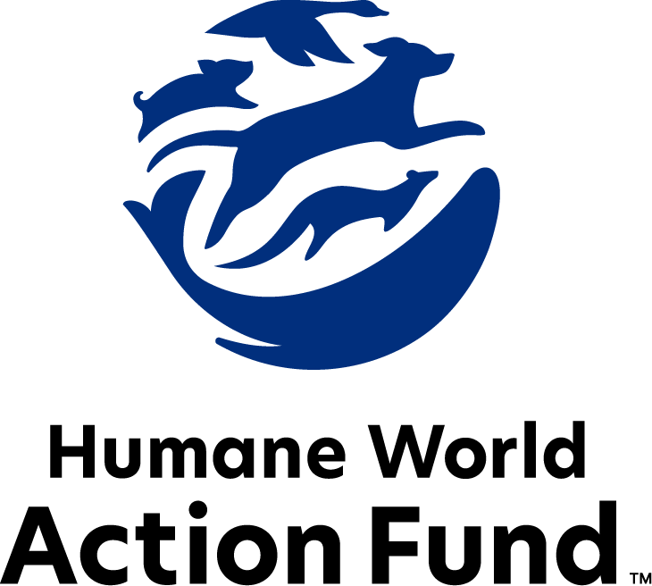

Formerly called
Humane Society Legislative Fund

CANDIDATE QUESTIONNAIRE
Nevada state office

2026 Nevada state office candidate questionnaire
Candidate Name: _____________________________________________________________________
Candidate Address: ___________________________________________________________________
Office Sought: ______________________________ Locality: ________________________________
Staff Contact Name: _________________________ Phone: _________________________________
Email: ____________________________________ Website: ________________________________

Animals play an important role in the lives of many Americans. Countless citizens look to their local government to protect animals from cruel treatment and exploitation. Humane-minded individuals care deeply about the positions their elected officials take on animal protection issues.
For information on the range and details of our issue areas, please visit the websites of Humane World Action Fund (humaneaction.org) or Humane World for Animals (humaneworld.org).

Background information

What actions have you taken to promote the welfare of animals in the past? (Please include any action taken in an official or unofficial context.)

Are there any animal welfare programs or issues of importance to you that you would take the initiative on after you are elected?

Will you post information in your campaign materials stating your positions on animal protection issues?

Do you have, or have you had in the past, any pets that have made an impact on you personally?

STATE ISSUES:
Statewide office holders and members of state legislatures influence animal protection policy by supporting humane legislation, opposing government programs that use taxpayer funds to harm animals, supporting funding for government programs to protect animals and for adequate enforcement of animal welfare laws, and opposing inhumane laws or those which weaken current protections. We’d like to know your position on the following important animal welfare issues, which are subject to debate in your state.

PETS AND CRUELTY

Puppy Mills: Internet sales, flea markets, face-to-face sales and many pet stores that sell puppies and kittens are getting those animals from large scale breeding operations, often known as puppy mills. A puppy mill is an inhumane, high-volume commercial dog breeding facility which churns out puppies for profit, ignoring the needs of the pups and their mothers. Dogs from puppy mills are often sick and unsocialized. Pet retailers often falsely assure consumers that the puppies they offer for sale are raised in reputable or humane breeding facilities, when really, they are coming from mass production puppy mills. Cindy Lou was one of these dogs, a tiny Havanese puppy kept in a Nevada pet store’s back room. She died of liver failure, and her suffering was extended as the pet store failed to provide veterinary care for her. That same store continued to exploit Cindy Lou’s image after her death.

Will you support efforts to end the sale of puppies sourced from puppy mills in pet stores?

_____ Yes _____ No _____ Not Sure

Predatory Pet Financing: Pet stores in Nevada that sell puppies and kittens—rather than partner with local rescues and shelters for sourcing adoptable animals—frequently offer financing for the purchase of pets using predatory lending practices with interest rates as high as 188%. The purchase price and financing documents are often not presented to potential buyers until after they interact with a puppy or kitten, and sometimes not until the final moments of a transaction. These practices often put families thousands of dollars in debt, and at risk of their animals being repossessed.

Will you support efforts to end predatory financing practices in Nevada's pet stores?

_____ Yes _____ No _____ Not Sure

Adequate Shelter: For any dog left outside and unattended for an extended period of time, access to a protective zone from direct sunlight and from unpredictable rain is not just smart—it is crucial to ensuring their safety. For an indoor pet to be confined to the outdoors over 15 minutes during a severe weather warning is not just negligent—it is potentially life-threatening. And on any pet’s day spent outside, the presence of clean, drinkable water and enough food to support their normal diet is not just a good idea—it is a necessity, especially given the extreme temperatures Nevadans can experience. Legislation like AB 86 (2023), which clearly outlines standards of animal welfare like access to food, water, and adequate shelter, can ensure that companion animals live comfortable lives free of cruelty.

Will you support legislation like AB 86 (2023) to ensure access to adequate food, water, and shelter for companion animals?

_____ Yes _____ No _____ Not Sure

Pets in Housing: Monthly pet rents, non-refundable pet fees, and a variety of pet deposits are all legal in Nevada rental housing. 72% of Americans report that pet-friendly rental housing is difficult to find, and 59% agree that where it is available, it’s too pricey to afford. Cost prohibitive pet rent and junk fees are increasingly making pet ownership a mechanism for housing and financial insecurity among renters as those with pets often feel powerless and discriminated against while seeking housing opportunities. Surrendering companion animals means losing a critical source of comfort, purpose, and family. As such, this alone creates a major barrier between housing security and the services available to pet owners.

Will you support pet-inclusive rental policies, including placing prohibitions on breed, size, weight and/or non-refundable pet deposits?

_____ Yes _____ No _____ Not Sure

Cat Declawing: Many countries and hundreds of cities in the U.S. have banned cat declawing because the procedure frequently results in chronic pain in the paw, infection, tissue necrosis (tissue death), lameness, and back pain. Removing claws changes the way a cat's foot meets the ground and can cause pain like wearing an uncomfortable pair of shoes. There can also be a regrowth of improperly removed claws, nerve damage, and bone spurs. Further, cat declawing has been associated with drastic changes in a cat’s behavior, including increasing biting, eliminating outside the litter box, and other negative behaviors. The Humane World Action Fund opposes declawing except for the rare cases when it is necessary for medical purposes to the feline, such as the removal of cancerous nail bed tumors.

Will you support legislation to prohibit the non-therapeutic surgical declawing of cats?

_____ Yes _____ No _____ Not Sure

VETERINARY CARE

Veterinary Telehealth: The U.S. is currently experiencing a nationwide shortage of veterinarians and vet technicians, with profound effects on the accessibility of in-office veterinary care to pet owners across the country. In 2023, laws were enacted in Arizona and California, lifting the barrier to common sense “telehealth” options. In many states, where clinics are understaffed but all veterinary exams are required to take place in-person, pets will go untreated due to logistical obstacles and financial barriers, limited access to veterinary care for low-income pet owners. As with the rise in human telehealth visits in recent years, veterinary telehealth has proven a faster, easier, and more effective solution for matters like issuing routine prescription fillings, diagnosing minor ailments, or assessing the improvement of a case diagnosed in person.

Will you support efforts to allow increased telehealth options with licensed veterinarians, for instances where a companion animal needs veterinary attention but does not require an in-person examination?

_____ Yes _____ No _____ Not Sure

Indirect Supervision: One way to increase access to veterinary care for pet owners in Nevada is to empower veterinary technicians to provide care, such as rabies vaccinations, microchips, and parasite control, with indirect supervision rather than immediate or direct supervision from a veterinarian. Indirect supervision means that a veterinarian does not need to be present on the premises of care, but that they still delegate care tasks via written or oral instructions to the technician. Affording veterinary technicians the ability to do the work they are trained to do without additional red tape frees up currently licensed veterinarians and technicians to treat more animals in need.

Will you support efforts to implement indirect supervision standards?

_____ Yes _____ No _____ Not Sure

Veterinarian Shortage: Nevada is currently experiencing a veterinary services shortage. In response, the state legislature approved SB 342 (2023), a bill which creates a funding partnership with a new veterinary school in Utah. In exchange for funding, this school will guarantee spots for Nevada residents who will be charged in-state tuition rates so long as they return to practice in Nevada after graduation. While this is a great start, more and expanded incentives are needed, particularly in rural areas of the state and in our non-profit shelters and rescues where the shortage is most acute.

Will you support further efforts to attract and retain veterinarians throughout the state?

_____ Yes _____ No _____ Not Sure

FARM PROTECTION AND FOOD SAFETY

Fashion: Animals need their fur coats more than we do. But on fur factory farms around the world, millions of rabbits, foxes, mink, and other wild animals spend their entire lives in cramped cages, deprived of the ability to engage in natural behaviors — only to be crudely gassed or electrocuted at the end. In the wild, animals are caught in crippling leghold traps for days without food or water. These archaic traps are indiscriminate, often maiming and killing non-target animals, like threatened species and even pets — all this in the name of fashion.

Will you support efforts to prohibit the sale of new products containing fur from animals?

_____ Yes _____ No _____ Not Sure

Extreme Confinement: In 2021, Nevada became the ninth state in the U.S. to ban cages for egg-laying hens when the governor signed legislation requiring eggs sold in Nevada be from cage-free facilities and outlawing caging of egg-laying chickens in general. However, the law has faced numerous attempts to delay implementation based on unfounded claims tying cage-free facilities to avian flu. Packing animals so tightly that they cannot turn around or even move a few inches is what really causes zoonotic disease to run rampant.

Will you oppose attempts to undermine Nevada’s cage-free egg law?

_____ Yes _____ No _____ Not Sure

WILDLIFE

Wildlife Killing Contests: Wildlife killing contests are organized events in which participants compete for prizes to see who can kill the most or the largest animals within a certain time period. Most Americans are shocked to learn that thousands of animals – including coyotes, foxes and bobcats – are killed in these events every year across the United States. In fact, a recent poll shows that 71% of Nevadans are in support of banning wildlife killing contests. Despite scientific evidence which shows that killing contests are ineffective at reducing carnivore populations and public outcry, Nevada hosts dozens of killing contests every year.

Will you support legislation to address killing contests by making it unlawful for any person to organize, sponsor, promote, conduct, or participate in a competitive event at which the participants harass or kill covered species for cash and prizes?

_____ Yes _____ No _____ Not Sure

Traveling Animal Acts: Decades of documented animal mistreatment have greatly reduced the popularity of exhibitions that use wild animals in their acts—Ringling Bros. and Barnum and Bailey closed in 2017 after the truth was exposed of almost 150 years of cruel practices. Wild animals used in circus acts are routinely beaten, poked, and shocked with electric prods—all to force them to perform unnatural, potentially dangerous tricks. After the show, elephants are chained inside trucks for transport, while lions and tigers may remain in small travel cages with only enough room to turn around. The Animal Welfare Act creates only minimum standards for animals in traveling exhibits, and it is poorly enforced. Persistent violators are rarely prosecuted, and those who are usually only face small fines.

Will you support efforts to ban traveling exhibitions in Nevada that use wild animals in their acts?

_____ Yes _____ No _____ Not Sure

Commissions: Nevada state agencies are responsible for a wide range of policymaking with immeasurable effects on the state’s animal populations and wildlife habitats. For example, the Nevada Board of Wildlife Commissioners, a governor-appointed board, establishes broad policy and sets regulations. This commission, housed within the Nevada Department of Wildlife, which manages nearly 900 different species and their habitats, is only required to have one biologist in its ranks. Sadly, much of the commission is dominated by the special interests of sportsmen and hunters. This stark imbalance allows one group to skew policy in their favor and away from mutualist initiatives. As a body with immense power over the welfare of wildlife, the commission should host a diverse group of perspectives, representing the broad interests of the public. Under the public trust doctrine, it is the Nevada Board of Wildlife Commissioners’ duty to hold and manage the public's wildlife in trust for the benefit and enjoyment of all Nevadans.

Will you encourage the governor’s appointment of a diverse range of experts committed to preserving Nevada’s natural beauty and wildlife, backed by science and not by special interests?

_____ Yes _____ No _____ Not Sure

Thank you for your time! Please return the completed questionnaire to:

Humane World Action Fund
1255 23rd St NW, Suite 455
Washington, D.C. 20037
Phone: (202) 676-2314

Email: info@humaneaction.org

Rev. 2/10/2026
© 2025 Humane World Action Fund

About us
We fight for political and policy change to tackle the root causes of animal cruelty and suffering.
We work to advance our mission by
passing animal protection laws at the state and federal levels, educating the public about animal protection issues and supporting humane candidates for office. Together, we act to end animal cruelty.

humaneaction.org

