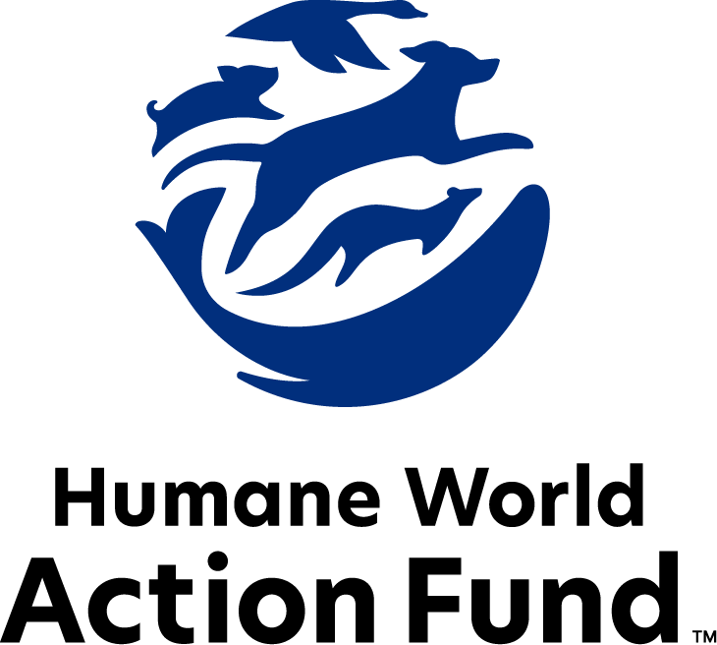

Formerly called
Humane Society Legislative Fund

CANDIDATE QUESTIONNAIRE
Georgia state office

2026 Georgia state office candidate questionnaire
Candidate Name: _____________________________________________________________________
Candidate Address: ___________________________________________________________________
Office Sought: ______________________________ Locality: ________________________________
Staff Contact Name: _________________________ Phone: _________________________________
Email: ____________________________________ Website: ________________________________

Animals play an important role in the lives of many Americans. Countless citizens look to their local government to protect animals from cruel treatment and exploitation. Humane-minded individuals care deeply about the positions their elected officials take on animal protection issues.
For information on the range and details of our issue areas, please visit the websites of Humane World Action Fund (humaneaction.org) or Humane World for Animals (humaneworld.org).

Background information

What actions have you taken to promote the welfare of animals in the past? (Please include any action taken in an official or unofficial context.)

Are there any animal welfare programs or issues of importance to you that you would take the initiative on after you are elected?

Will you post information in your campaign materials stating your positions on animal protection issues?

Do you have, or have you had in the past, any pets that have made an impact on you personally?

STATE ISSUES:
Statewide office holders and members of state legislatures influence animal protection policy by supporting humane legislation, opposing government programs that use taxpayer funds to harm animals, supporting funding for government programs to protect animals and for adequate enforcement of animal welfare laws, and opposing inhumane laws or those which weaken current protections. We’d like to know your position on the following important animal welfare issues, which are subject to debate in your state.

PETS AND CRUELTY

Cockfighting: Cockfighting is still a prevalent industry across the country with negative impacts on the birds themselves and on the communities in which cockfighting rings are run. Birds forced to participate in cockfighting suffer terribly before, during, and after fights—common injuries include punctured lungs, broken bones and pierced eyes, yet there is no escape from the fighting pit. The steel blades tied to the birds' legs are so sharp and dangerous that cockfighters themselves have been killed when accidentally slashed by their own birds. As federal and state law enforcement can attest, cockfighting is often associated with other criminal activities such as illegal gambling, drug trafficking, and illegal weapon sales. Animal cruelty, avian disease, and crime are all consequences of this dangerous industry. And yet, Georgia is the only state in the country without a felony state law to charge cockfighting offenders. SB 102 (2025) would change that by expanding current dogfighting provisions to cover cockfighting and make it a felony to possess game cocks for fighting, among other reforms.

Will you support legislation like SB 102 (2025) to strengthen penalties for individuals participating in cockfighting?

_____ Yes _____ No _____ Not Sure

Puppy Mills: Internet sales, flea markets, face-to-face sales, and the majority of pet stores that sell puppies are getting those dogs from puppy mills. A puppy mill is an inhumane, high-volume dog breeding facility that churns out puppies for profit, ignoring the needs of the pups and their mothers. Dogs from puppy mills are often sick and unsocialized. Pet retailers often falsely assure consumers that the puppies they offer for sale are raised in reputable or humane breeding facilities, even when they come from inhumane facilities like mass production puppy mills. Humane World for Animals – formerly called Humane Society of the United States – hears from thousands of devastated consumers every year who bring home a dog only to have the animal fall sick and, in some cases, even die.

Will you support efforts to end the sale of puppies sourced from puppy mills in pet stores, which would authorize a locality to regulate or restrict by ordinance the acquisition, marketing, and sale of animals in a pet shop?

_____ Yes _____ No _____ Not Sure

Pets in Housing: Monthly pet rents, non-refundable pet fees, and a variety of pet deposits are all legal in Georgia rental housing, and there is no cap on their amount. Rental agencies also frequently ban or restrict dogs because of their breed, or, more commonly, what is perceived to be their breed. Founded on myths and misinformation, breed-based policies and high, non-refundable pet fees and pet rents force companion animals away from their families and into shelters, taking up kennel space and resources that could be used for other animals. Recent research suggests that almost 75% of renters with pets have struggled to find affordable, pet-friendly housing, but will go to great lengths to stay with their pets, including renting poorer-quality housing. Altogether, pet ownership can be a mechanism for housing and financial insecurity among renters, as families with pets often feel powerless and discriminated against while seeking a home.

Will you support pet-inclusive rental housing, including efforts to prohibit breed-based policies by home rental agencies in Georgia?

_____ Yes _____ No _____ Not Sure

RESEARCH, TESTING, AND FASHION

Retirement: Tens of thousands of dogs are used in research facilities in the U.S. each year. It is a bleak life for these animals, who spend almost every hour of their short lives behind bars in cold steel cages, never knowing what it is like to play fetch, lie in the sun, or roll over happily for a belly rub. Those who have adopted former research dogs and cats can attest to the resilience and affection of these animals once they are given the chance to flourish in a home environment.

Will you support legislation to require research facilities to offer cats and dogs no longer used for educational, research, or scientific purposes to animal rescue organizations for adoption?

_____ Yes _____ No _____ Not Sure

FARM PROTECTION AND FOOD SAFETY

Farm Innovation Tax Credits: Several states, including Utah, Nevada, California, and Arizona, prohibit the caging of hens—and more states are close behind, as public outcry grows louder. Georgia farmers who recognize the safer, more humane way to keep their animals should qualify for the financial support necessary to keep farmers competitive, as the global marketplace continues to increase its demands for more humanely-sourced products.

Will you support a tax credit for farmers who transition to more sustainable and humane practices like crate-free and reduced-crate housing?

_____ Yes _____ No _____ Not Sure

Livestock Cruelty Code: Georgia’s current livestock cruelty laws make it difficult for law enforcement to intervene in even the most severe cases of neglect, particularly involving horses and cattle. In many instances, prolonged starvation, untreated injuries, or illness result only in misdemeanor charges. Additionally, broad exemptions for “customary farming practices” can prevent authorities from taking action, even in clearly cruel situations.
Would you support strengthening Georgia’s livestock cruelty laws by making severe neglect a felony on the first offense and ensuring that claims of “customary farming practices” cannot be used to excuse inhumane treatment?

_____ Yes _____ No _____ Not Sure

WILDLIFE

Trafficking Wildlife Parts: The United States is among the world’s largest markets for illegal wildlife goods, such as elephant ivory and rhino horn. The illegal wildlife trade is a lucrative, multi-billion-dollar enterprise, fueling transnational crime and incentivizing the cruel killing of animals for their parts. Enforcement efforts are often hampered by a lack of resources or the difficulty of visually distinguishing illegal ivory from legally-acquired ivory.

Will you support legislation to combat the trafficking of wildlife parts in Georgia?

_____ Yes _____ No _____ Not Sure

Appointments to State Agencies: Georgia state agencies are responsible for a wide range of policymaking with immeasurable effects on the state’s animal populations and wildlife habitats. With much to gain, special interests often fill state commission seats—where there should instead be a diverse group of perspectives, representing the broad interests of the public.

Will you encourage the appointment of a diverse range of experts committed to preserving Georgia’s natural beauty and wildlife, backed by science and not by special interests?

_____ Yes _____ No _____ Not Sure

Thank you for your time! Please return the completed questionnaire to:

Humane World Action Fund
1255 23rd St NW, Suite 455
Washington, D.C. 20037
Phone: (202) 676-2314

Email: info@humaneaction.org

Rev. 2/10/2026
© 2025 Humane World Action Fund

About us
We fight for political and policy change to tackle the root causes of animal cruelty and suffering.
We work to advance our mission by
passing animal protection laws at the state and federal levels, educating the public about animal protection issues and supporting humane candidates for office. Together, we act to end animal cruelty.

humaneaction.org

