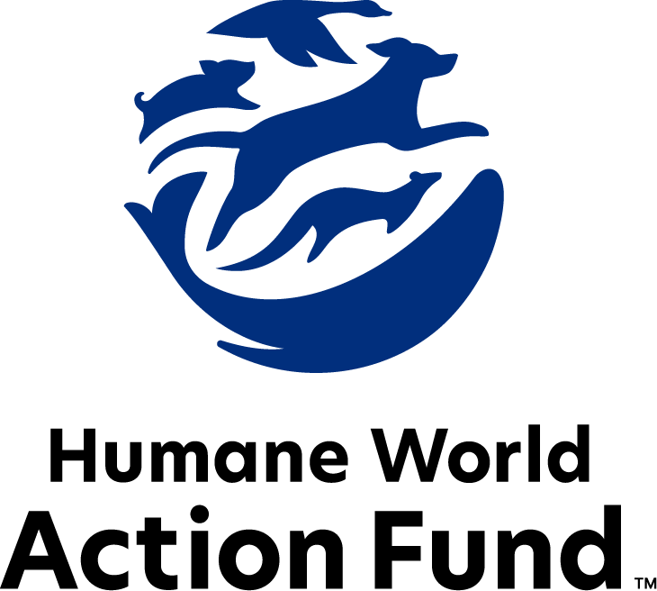

Formerly called
Humane Society Legislative Fund

CANDIDATE QUESTIONNAIRE
Kentucky state office

2026 Kentucky state office candidate questionnaire
Candidate Name: _____________________________________________________________________
Candidate Address: ___________________________________________________________________
Office Sought: ______________________________ Locality: ________________________________
Staff Contact Name: _________________________ Phone: _________________________________
Email: ____________________________________ Website: ________________________________

Animals play an important role in the lives of many Americans. Countless citizens look to their local government to protect animals from cruel treatment and exploitation. Humane-minded individuals care deeply about the positions their elected officials take on animal protection issues.
For information on the range and details of our issue areas, please visit the websites of Humane World Action Fund (humaneaction.org) or Humane World for Animals (humaneworld.org).

Background information

What actions have you taken to promote the welfare of animals in the past? (Please include any action taken in an official or unofficial context.)

Are there any animal welfare programs or issues of importance to you that you would take the initiative on after you are elected?

Will you post information in your campaign materials stating your positions on animal protection issues?

Do you have, or have you had in the past, any pets that have made an impact on you personally?

STATE ISSUES:
Statewide office holders and members of state legislatures influence animal protection policy by supporting humane legislation, opposing government programs that use taxpayer funds to harm animals, supporting funding for government programs to protect animals and for adequate enforcement of animal welfare laws, and opposing inhumane laws or those which weaken current protections. We’d like to know your position on the following important animal welfare issues, which are subject to debate in your state.

PETS AND CRUELTY

Preemption & Local Control: It is well documented that some nefarious pet stores have been a front for the puppy mill pipeline for decades. These stores and their allies who seek to profit off puppies will stop at no cost, even using state level preemption legislation to overturn local ordinances, including puppy mill and pet store reforms. Additionally, some special interests are actively seeking to pass legislation that would exempt “working animals” from local cruelty laws. As such, it is essential to protect local communities’ ability to address these bad actors and preserve the core right of local governments to legislate freely on issues impacting their communities.

Will you oppose legislation such as SB 122 (2025) or SB 45 (2026) which could prohibit local governments from establishing or maintaining animal welfare standards within their jurisdiction?

_____ Yes _____ No _____ Not Sure

Animal Fighting: Animal fighting continues to be a prevalent industry across the country. Dogfights often result in death by blood loss, shock, dehydration, exhaustion or infection hours or even days after the fight. The dogs used in the majority of these fights have been specifically bred and trained for fighting—an upbringing that relies on abuse and mistreatment from puppyhood. Additionally, birds forced to participate in cockfighting suffer terribly before, during, and after fights—common injuries include punctured lungs, broken bones and pierced eyes, yet there is no escape from the fighting pit. The steel blades tied to the birds' legs are so sharp and dangerous that cockfighters themselves have been killed when accidentally slashed by their own birds. As federal and state law enforcement can attest, cockfighting is often associated with other criminal activities such as illegal gambling, drug trafficking, gang activity and illegal weapon sales.

Will you support legislation such as SB 39 (2025) establishing clear and consistent penalties for animal fighting in Kentucky, including facilitating or participating in an animal fight, owning or possessing animals for the purpose of fighting, and bringing a minor to an animal fight?

_____ Yes _____ No _____ Not Sure

Cost of Animal Care: Animal cruelty cases can involve the seizure of dozens or even hundreds of animals. Providing care for these animals for months or years pending trial can be financially devastating to county animal shelters and to the well-being of these abused animals. Large-scale cases can be a financial burden for shelters, preventing critical resources from reaching other homeless, abused or at-risk animals.

Will you support legislation that shifts this financial burden to those who abused or neglected the animals?

_____ Yes _____ No _____ Not Sure

Adequate Shelter: For dogs that primarily live outdoors or are left outside and unattended for an extended period of time, it is crucial to have access to shelter from extreme heat, cold, and other elements to ensure their safety and wellbeing.

Will you support legislation requiring access to adequate shelter for dogs?

_____ Yes _____ No _____ Not Sure

Spay/Neuter Funding: For decades, Kentucky has awarded grants to animal shelters and non-profit groups for spay/neuter programs using funds from the sale of the Kentucky spay/neuter license plate and donations. However, this funding has reached historic lows due to the arrival of dozens of competitive plates and reduced donations, even as the cost of spay/neuter services continues to grow. As a result, additional funding is needed, including through innovative solutions such as a voluntary income tax check-off option.

Will you support legislation such as HB 217 (2026) to increase funding for spay/neuter services?

_____ Yes _____ No _____ Not Sure

RESEARCH, TESTING, AND FASHION

Retirement: Tens of thousands of dogs and cats are used in research facilities in the U.S. each year. It is a bleak life for many of these animals, who spend almost every hour of their short lives behind bars in cold steel cages, never knowing what it is like to play fetch, lie in the sun, or roll over happily for a belly rub. Those who have adopted former research dogs and cats can attest to the resilience and affection of these animals once they are given the chance to flourish in a home environment.

Will you support legislation such as HB 465 (2026) requiring research facilities, including institutions of higher education, to offer dogs and cats no longer used for educational, research, or scientific purposes to animal shelters or rescue organizations for adoption prior to euthanizing them?

_____ Yes _____ No _____ Not Sure
Transparency: The federal government currently requests basic information about facilities that experiment on animals. However, this information only provides a partial picture, and concerningly, some species are completely exempt from these reporting requirements. As we continue to develop more non-animal research alternatives, we need to understand the full scope of animal testing that is taking place in our state.

Will you support legislation such as HB 465 (2026) requiring facilities to annually disclose information on how many animals they are using in research, what species are being used, and the purposes of their animal experiments?

_____ Yes _____ No _____ Not Sure

FARM PROTECTION AND FOOD SAFETY

Factory Farming: The proposed Food Security and Farm Protection Act (S. 1326) and Save Our Bacon Act (H.R. 4673) on the federal level aim to prevent states from regulating agricultural practices within their own borders. If passed, the language would overturn critical animal welfare standards, such as Kentucky’s ban on veal crates, across the country.

Will you support efforts to ensure states retain the authority to end the cruelest industry practices on factory farms?

_____ Yes _____ No _____ Not Sure

WILDLIFE

Wildlife Killing Contests: Wildlife killing contests are organized events in which participants compete for prizes to see who can kill the most or the largest animals within a certain time. Most Americans are shocked to learn that thousands of animals – including coyotes, foxes, bobcats, rabbits, and squirrels – are killed in these events every year across the United States. For example, participants in Kentucky's “Predator Hunting Coyote Calling Championship” compete to kill the highest number of bobcats and foxes, along with the largest and smallest coyotes. These animals are often discarded, leaving their dependent young to die from starvation, predation, or exposure.

Will you support efforts to outlaw these inhumane and wasteful wildlife killing contests in Kentucky?

_____ Yes _____ No _____ Not Sure

Thank you for your time! Please return the completed questionnaire to:

Humane World Action Fund
1255 23rd St NW, Suite 455
Washington, D.C. 20037
Phone: (202) 676-2314

Email: info@humaneaction.org

Rev. 2/10/2026
© 2025 Humane World Action Fund

humaneaction.org

About us
We fight for political and policy change to tackle the root causes of animal cruelty and suffering.
We work to advance our mission by
passing animal protection laws at the state and federal levels, educating the public about animal protection issues and supporting humane candidates for office. Together, we act to end animal cruelty.

