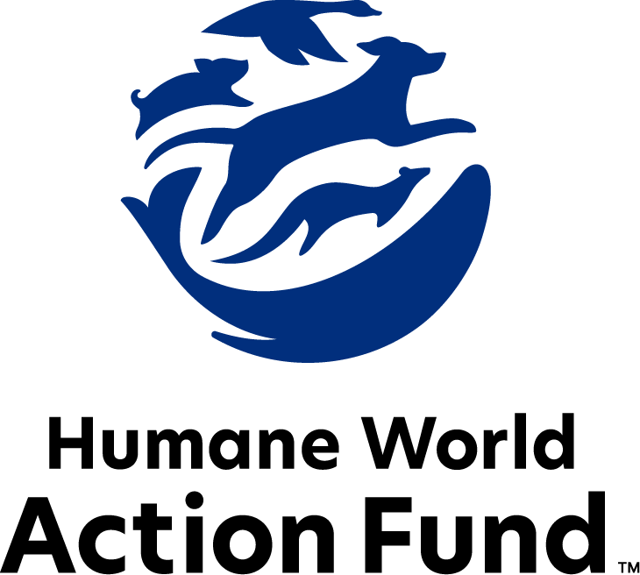

Formerly called
Humane Society Legislative Fund

CANDIDATE QUESTIONNAIRE
Maine state office

2026 Maine state office candidate questionnaire
Candidate Name: _____________________________________________________________________
Candidate Address: ___________________________________________________________________
Office Sought: ______________________________ Locality: ________________________________
Staff Contact Name: _________________________ Phone: _________________________________
Email: ____________________________________ Website: ________________________________

Animals play an important role in the lives of many Americans. Countless citizens look to their local government to protect animals from cruel treatment and exploitation. Humane-minded individuals care deeply about the positions their elected officials take on animal protection issues.
For information on the range and details of our issue areas, please visit the websites of Humane World Action Fund (humaneaction.org) or Humane World for Animals (humaneworld.org).

Background information

What actions have you taken to promote the welfare of animals in the past? (Please include any action taken in an official or unofficial context.)

Are there any animal welfare programs or issues of importance to you that you would take the initiative on after you are elected?

Will you post information in your campaign materials stating your positions on animal protection issues?

Do you have, or have you had in the past, any pets that have made an impact on you personally?

STATE ISSUES:
Statewide office holders and members of state legislatures influence animal protection policy by supporting humane legislation, opposing government programs that use taxpayer funds to harm animals, supporting funding for government programs to protect animals and for adequate enforcement of animal welfare laws, and opposing inhumane laws or those which weaken current protections. We’d like to know your position on the following important animal welfare issues, which are subject to debate in your state.

PETS AND CRUELTY

Pets in Housing: Monthly pet rents, non-refundable pet fees, and a variety of pet deposits are all legal in Maine rental housing, and there is no cap on their amount. Rental agencies also frequently ban or restrict dogs because of their breed, or, more commonly, what is perceived to be their breed. Weight restrictions are also common barriers. Founded on myths and misinformation, breed-based policies and high, non-refundable pet fees and pet rents force dogs away from their families and into shelters, taking up kennel space and resources that could be used for other animals. Recent research suggests that almost 75% of renters with pets have struggled to find affordable, pet-friendly housing, but will go to great lengths to stay with their pets, including renting lower-quality housing. Altogether, pet ownership can be a mechanism for housing and financial insecurity among renters, as families with pets often feel powerless and discriminated against while seeking a home.

Will you support pet-inclusive, affordable practices in Maine rental housing policies?

_____ Yes _____ No _____ Not Sure

Access to Care: The U.S. is currently experiencing a nationwide shortage of veterinarians and vet technicians, with profound effects on the accessibility of in-office veterinary care to pet owners across the country. Both clinics and animal shelters are overwhelmed by the number of animals requiring care. The lack of both animal care resources and pet-friendly housing options is most felt by those in underserved communities; more than 20 million pets experience poverty with their families in this country. People love their pets but are struggling to care for them because of these access barriers that can be alleviated through more veterinary training, direct care programs, and policy making.

Will you support legislation that increases access to care?

_____ Yes _____ No _____ Not Sure

Support for Animal Cruelty Law Enforcement: Maine law requires municipalities appoint one or more animal control officers (ACOs) to enforce state and local animal cruelty laws. ACOs provide essential services to help animals, support their communities, and bring abusers to justice. However, there is a significant lack of resources available for ACOs and statutory obstacles, resulting in situations going unaddressed

Will you support updating animal cruelty laws and the creation of additional funding to help bolster humane law enforcement in the state of Maine?

_____ Yes _____ No _____ Not Sure

Cost of Care: Animal cruelty cases can involve the seizure of dozens or even hundreds of animals. Providing care for the animals for months or years pending trial can be financially devastating to animal shelters and to the well-being of these abused animals. Large-scale cases can be a financial burden for the state, municipalities, and shelters, preventing critical resources from reaching other homeless, abused or at-risk animals.

Will you support efforts to shift this financial burden to those who abused or neglected the animals?

_____ Yes _____ No _____ Not Sure

Cat Declawing: Many countries and hundreds of cities in the U.S. have banned cat declawing because the procedure frequently results in pain in the paw, infection, tissue necrosis (tissue death), lameness, and back pain. Removing claws changes the way a cat's foot meets the ground and can cause pain like wearing an uncomfortable pair of shoes. There can also be a regrowth of improperly removed claws, nerve damage, and bone spurs. Further, cat declawing has been associated with drastic changes in a cat’s behavior, increasing biting and other negative behaviors. The Humane World Action Fund opposes declawing except for the rare cases when it is necessary for medical purposes to the feline, such as the removal of cancerous nail bed tumors.

Will you support legislation to prohibit the non-therapeutic surgical declawing of cats?

_____ Yes _____ No _____ Not Sure

RESEARCH, TESTING, AND FASHION

Alternatives: The vast majority of animal testing is for drugs, vaccines, medical devices, and to assess the risk of chemicals — however, 90% of drugs tested on animals fail in human trials. Non-animal alternatives not only save countless animal lives, but can be cheaper, faster, and more relevant to human biology, therefore more reliable at predicting safety. Despite the evidence that animal testing is an unreliable metric for determining efficacy of products for humans, many laboratories across the United States, including the Jackson Laboratory in Bar Harbor, continue to test on animals. Legislative support can aid in expanding the use of more humane, scientifically accurate methods.

Will you support legislation to encourage the use of non-animal testing alternatives?

_____ Yes _____ No _____ Not Sure

Fur: On fur factory farms in the U.S. and around the world, millions of rabbits, foxes, mink, and other wild animals spend their entire lives in cramped cages, deprived of the ability to engage in natural behaviors—only to be crudely gassed or electrocuted at the end. These farms have also proven to be dangerous breeding grounds for a variety of diseases transmissible to humans, such as avian influenza. Prohibiting the sale of new fur products will support efforts to end this cruel industry, while still allowing businesses to sell vintage or used fur products and to continue services caring for fur products, such as storage and cleaning.

Will you support legislation to prohibit the sale of new products containing fur, sourced from animals raised solely to produce fur products?

_____ Yes _____ No _____ Not Sure

FARM PROTECTION AND FOOD SAFETY

Extreme Confinement: On factory farms, egg-laying hens are packed into battery cages where they can't even spread their wings. Hens in these conditions will endure a lifetime of captivity in a space smaller than a piece of letter-sized paper. Packing animals so tightly is cruel and means zoonotic disease, like avian flu, can spread quickly. Multiple states have passed legislation to prohibit the caging of hens as the public outcry to this abuse grows louder.

Will you support efforts to end the sale of products that come from extreme confinement?

_____ Yes _____ No _____ Not Sure

WILDLIFE

Bear Hounding: Maine’s bears live under threat of being hunted with dogs every year during the season. Hound hunting is a tactic in which packs of dogs pursue exhausted, frightened animals until they seek refuge in a tree—where they are then shot—or turn to fight to the death. After this gruesome conflict, any babies left orphaned are vulnerable to their natural predators, or to mauling by the same dogs. In turn, the dogs involved can suffer broken bones, punctured lungs or other serious injuries.

Will you support efforts to end the cruel practice of hound hunting bears?

_____ Yes _____ No _____ Not Sure

Bear Baiting: One component of bear hunting seasons in Maine is the baiting of bears. Hunters do this by stacking donuts, candy, rotting garbage, corn, fish, meat, and other high-calorie foods in large bait piles, targeting the bears’ most basic need for survival. The unsuspecting, feeding bear is then far easier to shoot and kill, and those that survive may later succumb to the poisonous, bacteria-ridden food they’ve ingested. Not only is it cruel and unsportsmanlike—the practice of bear baiting also increases conflicts with humans, and carries environmental consequences, as the unnatural food and garbage disrupt fragile forest ecosystems.

Will you support efforts to end the cruel practice of bear baiting in Maine?

_____ Yes _____ No _____ Not Sure

Bear Trapping: Another component of bear hunting seasons in Maine is the snaring of bears with cable foot traps. These traps force animals to endure unimaginable pain for hours, only to be brutally killed. An animal captured in a snare trap desperately lunges in a futile attempt to escape, often leading to lacerations, hemorrhaging and repeated loss of consciousness. Utilizing traps causes intense suffering and also endangers animals other than bears who may be caught in the trap.

Will you support efforts to prohibit bear trapping?

_____ Yes _____ No _____ Not Sure

Right to Hunt Amendment: Legislation has been introduced that could place a so-called Right to Hunt and Fish Amendment on the ballot in Maine, establishing hunting and fishing as the preferred means of controlling wildlife. While this is framed as an amendment to protect hunting and fishing, it contains risks to Maine’s wildlife and ecosystems. If passed, the amendment would codify cruel practices like trapping, baiting, trophy hunting, and more while ignoring non-lethal conflict prevention methods that are more humane and effective. It also jeopardizes passage of new wildlife protections.

Will you oppose legislative action that puts a right to hunt amendment on the ballot?

_____ Yes _____ No _____ Not Sure

Wildlife Killing Contests: Wildlife killing contests are organized events in which participants compete for prizes by killing wildlife during a certain time period. Most Americans are shocked to learn that thousands of animals – including coyotes, foxes and bobcats – are killed in these events every year across the United States. Despite scientific evidence that shows that killing contests are ineffective at reducing carnivore populations, Maine permits coyote killing contests with no restrictions.

Will you support legislation to address killing contests by making it unlawful for any person to organize, sponsor, promote, conduct, or participate in a competitive event at which the participants harass or take covered wildlife?

_____ Yes _____ No _____ Not Sure

Wild Animal Acts: Decades of documented animal mistreatment have greatly reduced the popularity of exhibitions that use wild animals in their acts—Ringling Bros. and Barnum and Bailey closed in 2017 after the truth was exposed of almost 150 years of cruel practices. Wild animals used in circus acts are routinely beaten, poked, and shocked with electric prods—all to force them to perform unnatural, potentially-dangerous tricks. After the show, elephants are chained inside trucks for transport, while lions and tigers may remain in small travel cages with only enough room to turn around. The Animal Welfare Act creates only minimum standards for animals in traveling exhibits, and it is poorly enforced. Persistent violators are rarely prosecuted, and those who are usually only face small fines.

Will you support efforts to ban traveling exhibitions in Maine that use wild animals in their acts?

_____ Yes _____ No _____ Not Sure

Appointments to State Agencies: Maine state agencies and councils, like the Department of Inland Fishers and Wildlife’s Advisory Council, are responsible for a wide range of policymaking with immeasurable effects on the state’s animal populations and wildlife habitats. With much to gain, special interests often fill these seats—where there should instead be a diverse group of perspectives, representing the broad interests of the public.

Will you encourage the appointment of a diverse range of experts committed to preserving Maine’s natural beauty and wildlife, backed by science and not by special interests?

_____ Yes _____ No _____ Not Sure

Thank you for your time! Please return the completed questionnaire to:

Humane World Action Fund
1255 23rd St NW, Suite 455
Washington, D.C. 20037
Phone: (202) 676-2314

Email: info@humaneaction.org

Rev. 2/13/2026
© 2025 Humane World Action Fund

About us
We fight for political and policy change to tackle the root causes of animal cruelty and suffering.
We work to advance our mission by
passing animal protection laws at the state and federal levels, educating the public about animal protection issues and supporting humane candidates for office. Together, we act to end animal cruelty.

humaneaction.org

