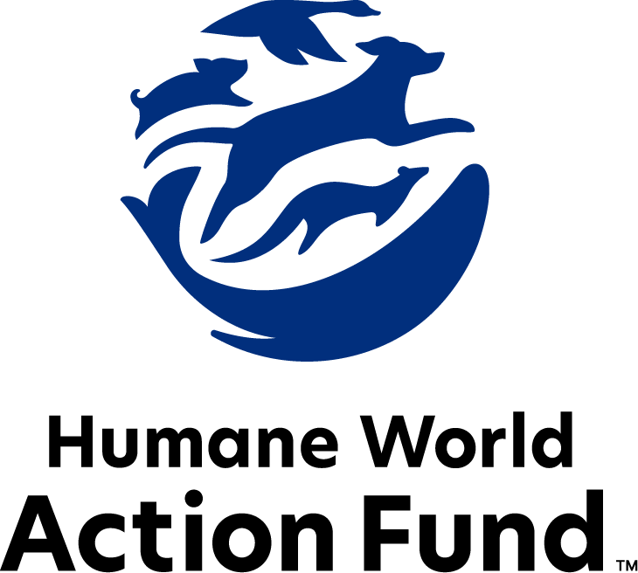

Formerly called
Humane Society Legislative Fund

CANDIDATE QUESTIONNAIRE
Ohio state office

2026 Ohio state office candidate questionnaire
Candidate Name: _____________________________________________________________________
Candidate Address: ___________________________________________________________________
Office Sought: ______________________________ Locality: ________________________________
Staff Contact Name: _________________________ Phone: _________________________________
Email: ____________________________________ Website: ________________________________

Animals play an important role in the lives of many Americans. Countless citizens look to their local government to protect animals from cruel treatment and exploitation. Humane-minded individuals care deeply about the positions their elected officials take on animal protection issues.
For information on the range and details of our issue areas, please visit the websites of Humane World Action Fund (humaneaction.org) or Humane World for Animals (humaneworld.org).

Background information

What actions have you taken to promote the welfare of animals in the past? (Please include any action taken in an official or unofficial context.)

Are there any animal welfare programs or issues of importance to you that you would take the initiative on after you are elected?

Will you post information in your campaign materials stating your positions on animal protection issues?

Do you have, or have you had in the past, any pets that have made an impact on you personally?

STATE ISSUES:
Statewide office holders and members of state legislatures influence animal protection policy by supporting humane legislation, opposing government programs that use taxpayer funds to harm animals, supporting funding for government programs to protect animals and for adequate enforcement of animal welfare laws, and opposing inhumane laws or those which weaken current protections. We’d like to know your position on the following important animal welfare issues, which are subject to debate in your state.

PETS AND CRUELTY

Preemption: It is well documented that nefarious pet stores have been a front for the puppy mill pipeline for decades. Individuals who seek to profit off puppies will stop at no cost, even using state level preemption legislation to overturn local ordinances, including puppy mill and pet store reforms. Ohio currently has a preemption law such as this in place, preventing communities from addressing bad actors. It is essential to protect localities’ self-determination and to repeal the preemption law that allows special interests to profit off of animals’ suffering against the wishes of community leaders.

Will you support repeal of Ohio’s pet store preemption law to support municipal governments in their efforts to raise animal welfare standards in their jurisdiction?

_____ Yes _____ No _____ Not Sure

Predatory Pet Financing: Pet stores in Ohio that sell puppies and kittens—rather than partner with local rescues and shelters for sourcing adoptable animals—frequently offer financing for the purchase of pets using predatory lending practices with interest rates as high as 188%. The purchase price and financing documents are often not presented to potential buyers until after they interact with a puppy or kitten, and sometimes not until the final moments of a transaction. These practices often put families thousands of dollars in debt, and at risk of their animals being repossessed.

Will you support efforts to end predatory financing practices in Ohio’s pet stores?

_____ Yes _____ No _____ Not Sure

Adequate Shelter: For any dog left outside and unattended for an extended period of time, access to a protective zone from direct sunlight and from unpredictable rain is not just smart—it is crucial to ensuring their safety. For an indoor pet to be confined to the outdoors over 15 minutes during a severe weather warning is not just negligent—it is potentially life-threatening. And on any pet’s day spent outside, the presence of clean, drinkable water and enough food to support their normal diet is not just a good idea—it is a necessity.
Will you support efforts to ensure access to adequate food, water, and shelter for companion animals?

_____ Yes _____ No _____ Not Sure
Indirect Supervision: One way to increase access to veterinary care for pet owners in Ohio is to empower veterinary technicians to provide care, such as rabies vaccinations, with indirect supervision rather than immediate or direct supervision from a veterinarian. Indirect supervision means that a veterinarian does not need to be present on the premises of care, but that they still delegated care tasks via written or oral instructions to the technician. Affording veterinary technicians the ability to do the work they are trained to do without additional red tape frees up currently licensed veterinarians and technicians to treat more animals in need.

Will you support efforts to implement indirect supervision standards?

_____ Yes _____ No _____ Not Sure

RESEARCH, TESTING, AND FASHION

Transparency: The federal government currently requests basic information about facilities that experiment on animals. Concerningly, several species are completely exempted from these reporting requirements. As we continue to develop more nonanimal research alternatives, we need to understand the full scope of animal testing that has taken place in our state, including within the labs housed in Ohio’s universities.

Will you support legislation requiring facilities to disclose information to the state describing how many animals they have, what species are being used, and the purposes of their animal experiments?

_____ Yes _____ No _____ Not Sure

FARM PROTECTION AND FOOD SAFETY

Family Farming: On factory farms, egg-laying hens are packed into battery cages where they can't even spread their wings. Baby calves are taken from their mothers and confined in pens so small they can barely move, and pigs are locked in gestation crates the width and length of their bodies, unable to even turn around.

Will you support efforts to protect Ohio’s family farmers by prohibiting cruel industry practices on factory farms?

_____ Yes _____ No _____ Not Sure

Fur and Urine Farming: Last year, authorities in Ashtabula County, OH responded to a commercial wildlife farm where hundreds of wild animals like coyotes and foxes were being held captive in extremely cruel conditions. The owner of the facility was breeding the animals and selling them as pets, collecting their urine and selling it for hunting and agricultural uses, and killing the animals for their fur. Many of the animals had to be euthanized while others were removed and placed into sanctuaries.

Will you support efforts to protect wild animals used in these types of commercial settings?
_____ Yes _____ No _____ Not Sure

WILDLIFE
Right to Hunt Amendment: Legislation has been introduced that could place a so-called Right to Hunt and Fish Amendment on the ballot in Ohio, establishing hunting and fishing as the preferred means of controlling wildlife. While this is framed as an amendment to protect hunting and fishing, it contains risks to Ohio’s wildlife and ecosystems. If passed, the amendment would codify cruel practices like trapping, baiting, trophy hunting, and more while ignoring non-lethal conflict prevention methods that are more humane and effective. It also jeopardizes passage of new wildlife protections.

Will you oppose legislative action that puts a right to hunt amendment on the ballot?

_____ Yes _____ No _____ Not Sure

Appointments to State Agencies: Ohio state agencies and boards like the Wildlife Council, Commercial Dog Breeding Advisory Board, and Livestock Care Standards Board are responsible for a wide range of policymaking with immeasurable effects on the state’s animal populations and wildlife habitats. With much to gain, special interests often fill state commission seats—where there should instead be a diverse group of perspectives, representing the broad interests of the public.

Will you encourage the appointment of a diverse range of experts committed to preserving Ohio’s natural beauty and wildlife, backed by science and not by special interests?

_____ Yes _____ No _____ Not Sure

Thank you for your time! Please return the completed questionnaire to:

Humane World Action Fund
1255 23rd St NW, Suite 455
Washington, D.C. 20037
Phone: (202) 676-2314

Email: info@humaneaction.org

Rev. 2/13/2026
© 2025 Humane World Action Fund

About us
We fight for political and policy change to tackle the root causes of animal cruelty and suffering.
We work to advance our mission by
passing animal protection laws at the state and federal levels, educating the public about animal protection issues and supporting humane candidates for office. Together, we act to end animal cruelty.

humaneaction.org

