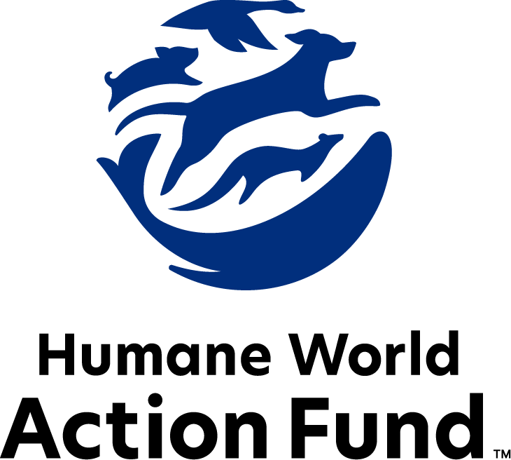

Formerly called
Humane Society Legislative Fund

CANDIDATE QUESTIONNAIRE
Iowa state office

2026 Iowa state office candidate questionnaire
Candidate Name: _____________________________________________________________________
Candidate Address: ___________________________________________________________________
Office Sought: ______________________________ Locality: ________________________________
Staff Contact Name: _________________________ Phone: _________________________________
Email: ____________________________________ Website: ________________________________

Animals play an important role in the lives of many Americans. Countless citizens look to their local government to protect animals from cruel treatment and exploitation. Humane-minded individuals care deeply about the positions their elected officials take on animal protection issues.
For information on the range and details of our issue areas, please visit the websites of Humane World Action Fund (humaneaction.org) or Humane World for Animals (humaneworld.org).

Background information

What actions have you taken to promote the welfare of animals in the past? (Please include any action taken in an official or unofficial context.)

Are there any animal welfare programs or issues of importance to you that you would take the initiative on after you are elected?

Will you post information in your campaign materials stating your positions on animal protection issues?

Do you have, or have you had in the past, any pets that have made an impact on you personally?

STATE ISSUES:
Statewide office holders and members of state legislatures influence animal protection policy by supporting humane legislation, opposing government programs that use taxpayer funds to harm animals, supporting funding for government programs to protect animals and for adequate enforcement of animal welfare laws, and opposing inhumane laws or those which weaken current protections. We’d like to know your position on the following important animal welfare issues, which are subject to debate in your state.

PETS AND CRUELTY

Law Enforcement Investigations: Iowa code requires law enforcement to consult with a licensed veterinarian when determining if a companion animal is “threatened,” and should be removed from harm. However, law enforcement agencies sometimes have difficulty finding a veterinarian who will assist, due to the potential risk of civil lawsuits initiated by the defendant.
Will you support efforts to ensure law enforcement agencies in Iowa can find veterinarians to assist with animal cruelty cases, and prevent the risk of veterinarians losing their practices due to frivolous lawsuits?

_____ Yes _____ No _____ Not Sure

Predatory Pet Financing: Pet stores in Iowa that sell puppies and kittens—rather than partner with local rescues and shelters for sourcing adoptable animals—offer financing for the purchase of pets with interest rates capped at 36%. The purchase price and financing documents are often not presented to potential buyers until after they interact with a puppy or kitten, and sometimes not until the final moments of a transaction. These practices often put families thousands of dollars in debt, and at risk of their animals being repossessed.

Will you support efforts to end predatory financing practices in Iowa’s pet stores?
_____ Yes _____ No _____ Not Sure

Local Control: Over the past few years, numerous bills have been filed to overturn hundreds of local ordinances related to animals. These overly broad bills would eliminate common-sense restrictions on the minimum amount of space needed for in-town livestock; local public safety measures restricting dangerous public contact with captive wild animals; and local ordinances prohibiting the sale of dogs from puppy mills in some cities. The bills have also aimed to eliminate local zoning restrictions, noise and odor restrictions, and any other local ordinance that might negatively impact a business selling animals or products made from animals.

Will you oppose any legislative efforts to prohibit municipal and county ordinances related to animals?

_____ Yes _____ No _____ Not Sure

Federally-Licensed Pet Breeder Oversight: In 2020, the Iowa Department of Agriculture & Land Stewardship and the legislature’s Administrative Rules Review Committee (ARRC) enacted an upgraded set of animal care standards for commercial establishments like dog breeders, pet stores, animal shelters, and boarding facilities. These new rules aimed to ensure the wellbeing of dogs, cats, and other pets through all steps of the pet supply chain in Iowa. However, under current state code, federally licensed “USDA breeders” are exempt from Iowa state rules, while all other animal businesses and nonprofits must meet the minimum standards of care to retain licensure. Two high-profile arrests of USDA breeders were made in Iowa in 2022 and 2023, alone, where over 120 violations of the Animal Welfare Act took place, and where altogether four counts of “animal neglect with serious injury or death” and seven counts of “animal neglect with serious injury” were recorded.

Will you support legislative efforts to ensure all dog breeders, whether USDA- or state-licensed, are held to the Iowa Department of Agriculture & Land Stewardship’s animal welfare standards?

_____ Yes _____ No _____ Not Sure

Breed-Specific Legislation: Across the state, a shrinking minority of communities ban or restrict the ownership of dogs due to their breed, or more often their perceived breed. Breed-based policies aren't founded on science or credible data, but on myths and misinformation surrounding different breeds and their natures. The impact of these policies on dogs, families, and animal rescues, though, is heartbreakingly real—they force dogs out of homes and into shelters, taking up kennel space and resources that could be used for animals who are in need. These bans also have major economic impacts on communities—a recent economic study from Overland Park, Kansas shows that their now-repealed breed restriction cost the community millions of dollars in economic growth and tax revenue, and stifled significant job creation.

Will you support efforts to protect the right of Iowans to own the dog of their choice, and prohibit discriminatory breed-based policies in Iowa counties or cities?

_____ Yes _____ No _____ Not Sure

RESEARCH, TESTING, AND FASHION
Toxicity Testing: In 2022, the state of Iowa passed the “Beagle Freedom Bill,” requiring taxpayer-funded research labs to create adoption programs through which to retire their dogs. This legislation was introduced in response to public outcry over the National Institutes of Health funding cruel toxicity testing on dogs. According to the U.S. Food and Drug Administration, only 8% of drugs tested on animals even end up proving safe and effective for human use—92% go on to fail in human trials. Advancements in technology are moving us closer to the day when no animals are used for testing and research, and are replaced with more effective ways to address human health and safety. A number of humane alternatives already are in place and proving superior to animal use.

Will you support legislation to prevent taxpayer-funded entities in Iowa from accepting federal research dollars for testing on dogs, when an alternative research method is available?
_____ Yes _____ No _____ Not Sure
Will you support funding for the continued development of non-animal testing alternatives?

_____ Yes _____ No _____ Not Sure

Will you support increased transparency requirements for laboratories?

_____ Yes _____ No _____ Not Sure

FARM PROTECTION AND FOOD SAFETY
Livestock Cruelty Code: Iowa’s current livestock neglect code has been used successfully by law enforcement. However, there are regular cases that are complicated by the involvement of farm animals such as horses.

Would you support updating the state’s Mistreatment to Livestock code to make it easier for law enforcement to intervene in cases of extreme cruelty to farm animals?

_____ Yes _____ No _____ Not Sure

Egg Sales: As consumers more frequently demand animal products from humane sources, and entire states enact humane sourcing standards, Iowa farmers are still forced by law to use cruel, outdated farming practices. Egg producers around the world are investing millions of dollars into cage-free farms, but if Iowa retailers want to sell cage-free eggs, they are legally required to keep those egg-laying hens in “confinement animal feeding operations” (or “CAFO’s”)—essentially negating their cage-free status with similar agonizing, high-density conditions.
Will you support efforts to repeal the Iowa law requiring confinement egg sales, and allow Iowa’s family farms the freedom to take advantage of new market opportunities?

_____ Yes _____ No _____ Not Sure

WILDLIFE
Native Carnivore Protection: Mountain lions, gray wolves, and black bears have no legal protections in Iowa and can be killed at any time. These native-to-Iowa species provide enormous ecosystem contributions and play a key role in increasing biological diversity. Studies have also shown that native carnivores like wolves and mountain lions target deer infected with chronic wasting disease, which helps keep our wild herds healthier. CWD has been slowly spreading throughout our state, and natural predators help keep this deadly disease in check.

Will you support efforts to provide protections for mountain lions, gray wolves, and black bears?
_____ Yes _____ No _____ Not Sure

Wildlife Killing Contests: Wildlife killing contests are organized events in which participants compete for prizes to see who can kill the most or the largest animals within a certain time. Most Americans are shocked to learn that thousands of animals–including coyotes, foxes, bobcats, prairie dogs, rabbits, and squirrels–are killed in these events every year across the U.S. For example, participants in Iowa’s “Howlers Bawl Coyote Contest” compete for the highest number of coyotes killed, using cruel lures and calls to draw them close enough to kill. Then, the animals are often discarded, leaving their dependent young to die from starvation, predation, or exposure.

Will you support efforts to outlaw these inhumane and wasteful wildlife killing contests in Iowa?

_____ Yes _____ No _____ Not Sure

Constitutional Amendment: Legislation has recently been introduced to amend the state constitution to “protect the right to hunt.” The proposed amendment would require the Department of Natural Resources and Natural Resources Commission to include “traditional methods” of hunting and trapping in wildlife management plans, and as tools to respond to animal conflicts where lethal management may not be necessary. This would include the use of agonizing, indiscriminate steel-jawed leghold traps. Just 7% of Iowans hold a hunting license, and that number has shrunk over recent years. Moreover, the amendment would make it more difficult to pass wildlife protection legislation in the future.
Would you oppose efforts to amend the state constitution to include the so-called “right to hunt?”

_____ Yes _____ No _____ Not Sure

Public Contact: While exciting to see up close, wild animals are altogether unfit for public contact. Substandard wildlife attractions in Iowa, like roadside zoos and exotic animal shows, exploit these animals to turn a quick profit, often with such neglect that horror stories have been recorded through undercover investigations. Not only do wild animals suffer cruelly when captured, transported, or placed in close proximity to humans—the risks they then pose to human health and safety are enormous. Cases of aggression may prove life-threatening, as may a host of zoonotic diseases these animals contract.

Will you support legislation to prohibit direct public contact with bears and non-human primates in Iowa?

_____ Yes _____ No _____ Not Sure

Appointments to State Agencies: The 7 members of the Iowa Natural Resource Commission engage in key decision-making on the topics of wildlife, forestry, fisheries, land and waters, law enforcement, state parks, and more. Appointed to 6-year terms by the Governor and confirmed by the Senate, the commissioners determine hunting and fishing rules; public land acquisitions and easements; and other matters determining the fate of Iowa’s wild animals and their habitats. Because just 7% of Iowans hold hunting licenses, the commissioners serve to represent the interests of all Iowans—in particular, the 93% supermajority of Iowans who do not engage in hunting.

Will you support the confirmation of commissioners who represent the best interests of Iowa’s natural beauty and wildlife, backed by science and not special interests?

_____ Yes _____ No _____ Not Sure

Wildlife Crossings: Legislation has recently been introduced to produce a study on the feasibility of wildlife crossings at highway locations where high numbers of vehicle crashes involving animals occur. Approximately 7,500 of these crashes are reported in Iowa each year, accounting for 13.5% of all motor vehicle crashes in the state, killing thousands of animals and totaling $129 million dollars in vehicle damages.
Will you support legislation that studies the feasibility of wildlife crossings on Iowa highways?

_____ Yes _____ No _____ Not Sure

Thank you for your time! Please return the completed questionnaire to:

Humane World Action Fund
1255 23rd St NW, Suite 455
Washington, D.C. 20037
Phone: (202) 676-2314

Email: info@humaneaction.org

Rev. 2/13/2026
© 2025 Humane World Action Fund

About us
We fight for political and policy change to tackle the root causes of animal cruelty and suffering.
We work to advance our mission by
passing animal protection laws at the state and federal levels, educating the public about animal protection issues and supporting humane candidates for office. Together, we act to end animal cruelty.

humaneaction.org

