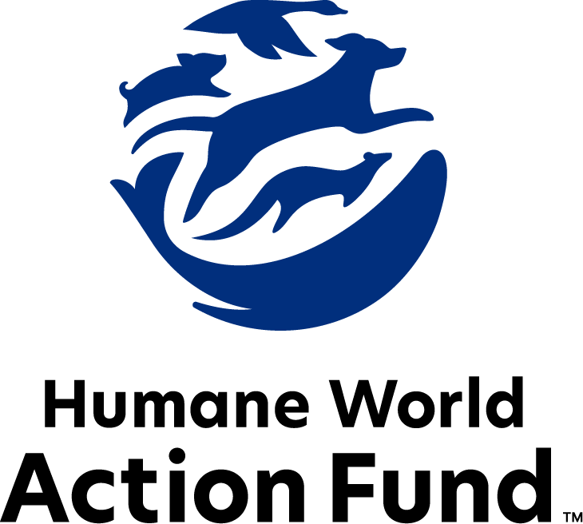

Formerly called
Humane Society Legislative Fund

CANDIDATE QUESTIONNAIRE
Oregon state office

2026 Oregon state office candidate questionnaire
Candidate Name: _____________________________________________________________________
Candidate Address: ___________________________________________________________________
Office Sought: ______________________________ Locality: ________________________________
Staff Contact Name: _________________________ Phone: _________________________________
Email: ____________________________________ Website: ________________________________

Animals play an important role in the lives of many Americans. Countless citizens look to their local government to protect animals from cruel treatment and exploitation. Humane-minded individuals care deeply about the positions their elected officials take on animal protection issues.
For information on the range and details of our issue areas, please visit the websites of Humane World Action Fund (humaneaction.org) or Humane World for Animals (humaneworld.org).

Background information

What actions have you taken to promote the welfare of animals in the past? (Please include any action taken in an official or unofficial context.)

Are there any animal welfare programs or issues of importance to you that you would take the initiative on after you are elected?

Will you post information in your campaign materials stating your positions on animal protection issues?

Do you have, or have you had in the past, any pets that have made an impact on you personally?

STATE ISSUES:
Statewide office holders and members of state legislatures influence animal protection policy by supporting humane legislation, opposing government programs that use taxpayer funds to harm animals, supporting funding for government programs to protect animals and for adequate enforcement of animal welfare laws, and opposing inhumane laws or those which weaken current protections. We’d like to know your position on the following important animal welfare issues, which are subject to debate in your state.

PETS AND CRUELTY

Breeder Oversight & Regulatory Equity Oregon is ranked first in the nation for the strength of its animal welfare laws. Animal Rescue Entities (AREs), primarily nonprofit organizations, are licensed, inspected, and regulated by the Oregon Department of Agriculture and must meet ongoing compliance requirements to operate. In contrast, dog and cat breeders in Oregon are not subject to state licensing, routine inspection, or an oversight program. While state law limits very large puppy mill breeding operations and establishes baseline care standards, there is no structured licensing framework to ensure consistent compliance or accountability.
Breeders operate at varying scales, from small operations producing a few litters per year to larger commercial enterprises selling puppies and kittens for significant profit. A thoughtfully designed licensing program could allow the Oregon Department of Agriculture to establish proportional requirements through rulemaking, ensuring that oversight is appropriate to the scale and commercial nature of the operation.
Such a program would:
- Promote consistent standards of care
- Establish enforceable accountability
- Increase transparency and consumer protection
- Ensure regulatory equity across sectors involved in the sale and transfer of dogs and cats

Would you support legislation to establish a balanced, scalable, and enforceable licensing and inspection program for dog and cat breeders in Oregon to promote accountability, transparency, and regulatory equity?

_____ Yes _____ No _____ Not Sure

Expanding the Role of Certified Veterinary Technicians to Increase Access to Care: Oregon continues to face significant barriers to veterinary care, particularly for low-income families and those in rural, tribal, and under resourced communities. Rabies vaccination is legally required and a core public health protection under a One Health framework, recognizing the interconnected health of people, animals, and the environment. Yet many Oregonians cannot access required preventive services due to cost, geography, or lack of available veterinarians, especially with raising cost of veterinary care by 42% since 2019.
One strategy to increase access is to allow Certified Veterinary Technicians to administer preventive services—including rabies vaccinations—under indirect supervision. Indirect supervision means a licensed veterinarian delegates tasks to a CVT through written or oral instructions but does not need to be physically present on the premises.
CVTs are educated, trained, and licensed professionals. Allowing CVTs to practice to the full extent of their training under indirect supervision, meaning a veterinarian delegates tasks without being physically present (such as an onsite community-based vaccine clinic) would:
- Expand access to legally required rabies vaccinations
- Increase availability of preventive parasite control
- Reduce strain on the veterinary workforce
- Promote equitable access to care
- Prevent unnecessary pet surrender and suffering

Do you support statutory changes that would allow Certified Veterinary Technicians to administer rabies vaccinations and other preventive services under indirect supervision of a licensed veterinarian?

_____ Yes _____ No _____ Not Sure

WILDLIFE
Native Carnivore Protection: A majority of Oregon voters passed Measure 18 in 1994, prohibiting the hunting of cougars with packs of radio-collared dogs (“hounding”). An even greater majority voted in 1996 to reject the repeal of Measure 18. Thus, Oregonians have stated twice that they oppose the hounding of cougars for sport, or for “trophy hunting,” because it is inhumane, unsporting, and violates the ethics of fair chase. Moreover, a 2019 poll by Remington Research Group found that a 65% majority of voters are opposed to the trophy hunting of Oregon’s iconic cougars. Still, almost every year since 1997, legislation has been introduced to either weaken and/or repeal Measure 18.

Will you support efforts to uphold Measure 18, which banned the cruel, unsportsmanlike practices of bear baiting and hound hunting of bears and cougars in Oregon?

_____ Yes _____ No _____ Not Sure

Traveling Animal Acts: Neighboring states such as Washington and California have banned traveling animal acts in their states because of decades of documented animal mistreatment have greatly reduced the popularity of exhibitions that use wild animals in their acts—Ringling Bros. and Barnum and Bailey closed in 2017 after the truth was exposed of almost 150 years of cruel practices. Wild animals used in circus acts are routinely beaten, poked, and shocked with electric prods—all to force them to perform unnatural, potentially dangerous tricks. After the show, elephants are chained inside trucks for transport, while lions and tigers may remain in small travel cages with only enough room to turn around. The Animal Welfare Act creates only minimum standards for animals in traveling exhibits, and it is poorly enforced. Persistent violators are rarely prosecuted, and those who are usually only face small fines. In Oregon, multiple counties have already banned traveling animal acts, including Washington, Multnomah and Benton Counties.

Will you support efforts to ban traveling exhibitions in Oregon that use wild animals in their acts?

_____ Yes _____ No _____ Not Sure

Thank you for your time! Please return the completed questionnaire to:

Humane World Action Fund
1255 23rd St NW, Suite 455
Washington, D.C. 20037
Phone: (202) 676-2314

Email: info@humaneaction.org

Rev. 3/9/2025
© 2025 Humane World Action Fund

About us
We fight for political and policy change to tackle the root causes of animal cruelty and suffering.
We work to advance our mission by
passing animal protection laws at the state and federal levels, educating the public about animal protection issues and supporting humane candidates for office. Together, we act to end animal cruelty.

humaneaction.org

