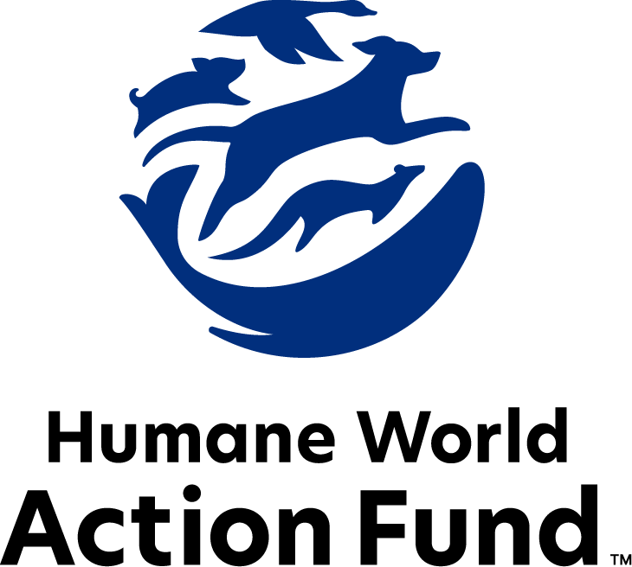

Formerly called
Humane Society Legislative Fund

CANDIDATE QUESTIONNAIRE
Wisconsin state office

2026 Wisconsin state office candidate questionnaire
Candidate Name: _____________________________________________________________________
Candidate Address: ___________________________________________________________________
Office Sought: ______________________________ Locality: ________________________________
Staff Contact Name: _________________________ Phone: _________________________________
Email: ____________________________________ Website: ________________________________

Animals play an important role in the lives of many Americans. Countless citizens look to their local government to protect animals from cruel treatment and exploitation. Humane-minded individuals care deeply about the positions their elected officials take on animal protection issues.
For information on the range and details of our issue areas, please visit the websites of Humane World Action Fund (humaneaction.org) or Humane World for Animals (humaneworld.org).

Background information

What actions have you taken to promote the welfare of animals in the past? (Please include any action taken in an official or unofficial context.)

Are there any animal welfare programs or issues of importance to you that you would take the initiative on after you are elected?

Will you post information in your campaign materials stating your positions on animal protection issues?

Do you have, or have you had in the past, any pets that have made an impact on you personally?

STATE ISSUES:
Statewide office holders and members of state legislatures influence animal protection policy by supporting humane legislation, opposing government programs that use taxpayer funds to harm animals, supporting funding for government programs to protect animals and for adequate enforcement of animal welfare laws, and opposing inhumane laws or those which weaken current protections. We’d like to know your position on the following important animal welfare issues, which are subject to debate in your state.

PETS AND CRUELTY
Preemption: It is well documented that nefarious pet stores have been a front for the puppy mill pipeline for decades. As such, it is essential to protect local communities’ ability to address these bad actors. Individuals who seek to profit off puppies will stop at no cost, even using state level preemption legislation to overturn local ordinances, including puppy mill and pet store reforms. Special interests exhibit a dangerous overreach, coming head-to-head with the core right of local governments to legislate freely on issues impacting their communities.

Will you support municipal governments in their efforts to raise animal welfare standards within their jurisdiction?

_____ Yes _____ No _____ Not Sure

Puppy Mills: Internet sales, flea markets, face-to-face sales and many pet stores that sell puppies and kittens are getting those animals from large scale breeding operations, often known as puppy mills. A puppy mill is an inhumane, high-volume commercial dog breeding facility which churns out puppies for profit, ignoring the needs of the pups and their mothers. Dogs from puppy mills are often sick and unsocialized. Pet retailers often falsely assure consumers that the puppies they offer for sale are raised in reputable or humane breeding facilities, when really, they are coming from mass production puppy mills.

Will you support legislation to end the retail sale of puppies sourced from puppy mills in pet stores?

_____ Yes _____ No _____ Not Sure

RESEARCH, TESTING, AND FASHION
Retirement: Tens of thousands of dogs are used in research facilities in the U.S. each year. It is a bleak life for these animals, who spend almost every hour of their short lives behind bars in cold steel cages, never knowing what it is like to play fetch, lie in the sun, or roll over happily for a belly rub. Those who have adopted former research dogs and cats can attest to the resilience and affection of these animals once they are given the chance to flourish in a home environment.

Will you support legislation to require research facilities to offer cats and dogs no longer used for educational, research, or scientific purposes to animal rescue organizations for adoption?

_____ Yes _____ No _____ Not Sure

Alternatives: The vast majority of animal testing is for drugs, vaccines, medical devices, and to assess the risk of chemicals — however, 90% of drugs tested on animals fail in human trials. Non-animal alternatives not only save countless animal lives, but can be cheaper, faster, and more relevant to human biology, therefore more reliable at predicting safety. Despite the evidence that animal testing is an unreliable metric for determining efficacy of products for humans, many laboratories across the United States, including those housed in universities, continue to test on animals. Continued reliance on these outdated and inhumane testing methods harms the animals confined to the cages of the laboratories and stunts scientific development

Will you support legislation to encourage the use of non-animal testing alternatives?

_____ Yes _____ No _____ Not Sure

FARM PROTECTION AND FOOD SAFETY
Factory Farming: On factory farms, egg-laying hens are packed into battery cages where they can't even spread their wings. Baby calves are taken from their mothers and confined in pens so small they can barely move, and pigs are locked in gestation crates the width and length of their bodies, unable to even turn around.

Will you support efforts to protect family farmers by prohibiting cruel industry practices on factory farms?

_____ Yes _____ No _____ Not Sure

WILDLIFE
Wildlife Management: The Wisconsin Department of Natural Resources currently lacks sufficient state funding for non-lethal abatement education and assistance. Humane wildlife management strategies are essential for mitigating and preventing human-wildlife conflicts. They consistently produce more effective, long-term outcomes for wildlife populations than relying primarily on hunting and trapping. It is essential that the Department of Natural Resources is equipped with the resources necessary to prioritize proactive, humane solutions and promote responsible wildlife stewardship.

Will you support funding for non-lethal abatement measures in the state budget?

_____ Yes _____ No _____ Not Sure

Wolves: Wisconsin is the only state with a statutory requirement to hold an annual wolf hunt when wolves are not listed as a federally endangered species, despite their irreplaceable role in maintaining ecosystem balance and biodiversity. During the 2011-2012 biennium, Act 169 advanced through the legislative process in just 62 days, despite significant public opposition. No other wildlife species in the state is managed through statute in this way. Wildlife management decisions are best guided by state agencies, which have scientific expertise for sound decision-making.

Will you support moving authority on wolf hunt policy from the state legislature to the Department of Natural Resources?

_____ Yes _____ No _____ Not Sure

Appointments to State Agencies: The Natural Resources Board (NRB) is a seven-member citizen board appointed by the Governor and confirmed by the Senate to serve staggered six-year terms. As the policy-setting body for the Department of Natural Resources, it plays a central role in decisions affecting wildlife, forestry, land acquisition, water and air regulations, state parks and more. Given the scope of its authority, the Board should reflect diverse perspectives that serve the broader public rather than special interests.

Will you encourage the appointment of a diverse range of experts committed to preserving Wisconsin’s natural beauty and wildlife, backed by science and not by special interests?

_____ Yes _____ No _____ Not Sure

Bear Baiting: Wisconsin has the longest black bear baiting season in the nation – 182 days compared to an average of 23 days in other states. There is no limit on the number of bait piles a hunter can place, which often consist of calorie-dense, highly processed, sugary foods, including chocolate. Bears can access these unnatural food sources for approximately five months before the hunting season opens. Wisconsin’s excessive baiting practices increase human-wildlife conflicts, disrupts fragile forest ecosystems, contributes to higher bear populations and can have cascading effects on numerous species.

Will you support efforts to end the cruel practice of bear baiting?

_____ Yes _____ No _____ Not Sure

Thank you for your time! Please return the completed questionnaire to:

Humane World Action Fund
1255 23rd St NW, Suite 455
Washington, D.C. 20037
Phone: (202) 676-2314

Email: info@humaneaction.org

Rev. 3/25/2026
© 2025 Humane World Action Fund

About us
We fight for political and policy change to tackle the root causes of animal cruelty and suffering.
We work to advance our mission by
passing animal protection laws at the state and federal levels, educating the public about animal protection issues and supporting humane candidates for office. Together, we act to end animal cruelty.

humaneaction.org

