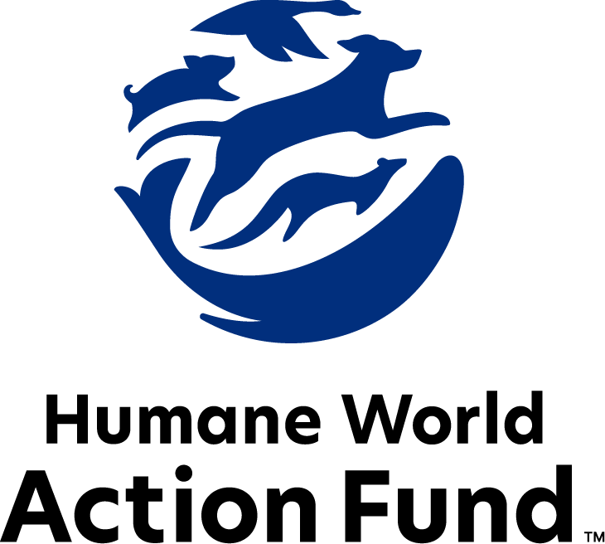

Formerly called
Humane Society Legislative Fund

CANDIDATE QUESTIONNAIRE
Oklahoma state office

2026 Oklahoma state office candidate questionnaire
Candidate Name: _____________________________________________________________________
Candidate Address: ___________________________________________________________________
Office Sought: ______________________________ Locality: ________________________________
Staff Contact Name: _________________________ Phone: _________________________________
Email: ____________________________________ Website: ________________________________

Animals play an important role in the lives of many Americans. Countless citizens look to their local government to protect animals from cruel treatment and exploitation. Humane-minded individuals care deeply about the positions their elected officials take on animal protection issues.
For information on the range and details of our issue areas, please visit the websites of Humane World Action Fund (humaneaction.org) or Humane World for Animals (humaneworld.org).

Background information

What actions have you taken to promote the welfare of animals in the past? (Please include any action taken in an official or unofficial context.)

Are there any animal welfare programs or issues of importance to you that you would take the initiative on after you are elected?

Will you post information in your campaign materials stating your positions on animal protection issues?

Do you have, or have you had in the past, any pets that have made an impact on you personally?

STATE ISSUES:
Statewide office holders and members of state legislatures influence animal protection policy by supporting humane legislation, opposing government programs that use taxpayer funds to harm animals, supporting funding for government programs to protect animals and for adequate enforcement of animal welfare laws, and opposing inhumane laws or those which weaken current protections. We’d like to know your position on the following important animal welfare issues, which are subject to debate in your state.

PETS AND CRUELTY
Preemption: It is well documented that puppy-selling pet stores have been a front for the puppy mill pipeline for decades. As such, it is essential to protect local communities’ ability to address these bad actors. Individuals who seek to profit from mass-produced and inhumanely raised puppies will stop at nothing even using state-level preemption legislation to overturn local ordinances, including puppy mill and pet store reforms. Special interests exhibit a dangerous overreach, coming head-to-head with the core right of local governments to legislate freely on issues impacting their communities.

Will you support municipal governments in their efforts to raise animal welfare standards within their jurisdiction?

_____ Yes _____ No _____ Not Sure

Spay-Neuter Funding: The U.S. is currently experiencing a nationwide shortage of veterinarians and vet technicians, with profound effects on the accessibility of veterinary care to pet owners across the country such as spay-neuter services. For residential pet owners, these services don’t just keep the headcount from growing at home—they also curb unwanted animal behaviors and promote a proven longer lifespan in both dogs and cats. For feral cat caregivers, these humane population control methods promote public health and safety by preventing illness in community cats, and by reducing aggressive or nuisance tendencies exhibited by cats who are unsterilized.

Will you support the establishment of a spay-neuter grant program in Oklahoma?

_____ Yes _____ No _____ Not Sure

Animal Fighting: Animal fighting continues to be a prevalent industry across the country. Dogfights often result in death by blood loss, shock, dehydration, exhaustion or infection hours or even days after the fight. The dogs used in the majority of these fights have been specifically bred and trained for fighting—an upbringing that relies on abuse and mistreatment from puppyhood. Additionally, birds forced to participate in cockfighting suffer terribly before, during, and after fights—common injuries include punctured lungs, broken bones and pierced eyes, yet there is no escape from the fighting pit. The steel blades tied to the birds' legs are so sharp and dangerous that cockfighters themselves have been killed when accidentally slashed by their own birds. As federal and state law enforcement can attest, cockfighting is often associated with other criminal activities such as illegal gambling, drug trafficking, gang activity, and illegal weapon sales. Oklahoma passed a law against dogfighting in 1982, and Oklahomans approved the state’s cockfighting law on a statewide ballot in 2002. There is no reason to take a more lenient stance on animal fighting.

Will you oppose efforts to rollback animal fighting laws and instead support efforts to strengthen animal fighting penalties?

_____ Yes _____ No _____ Not Sure

Cruelty Code: Oklahoma’s animal cruelty statute is a critical mechanism for preventing animal cruelty and abuse and is considered one of the best animal cruelty laws in the U.S. Lawmakers must prevent Oklahoma’s law from being eroded in the face of efforts to weaken enforcement mechanisms or carve out special exemptions for special interest groups seeking to remove themselves from accountability for actions that violate Oklahoma’s cruelty statute.

Will you oppose efforts to weaken penalties for animal cruelty offenses?

_____ Yes _____ No _____ Not Sure

RESEARCH, TESTING, AND FASHION
Pound Seizure: Pound seizure is the taking of dogs and cats from animal shelters for use in experimentation or training – a highly controversial practice that undermines the ability of animal shelters to effectively carry out their important work with the full support and confidence of the public. Pound seizure has historically often led to back-room deals that prevented animals from being 1) reunited with their owners, 2) kept available for adoption, or 3) humanely euthanized in the absence of a loving home. Due to widespread public opposition, Oklahoma is now the only state in the U.S. that still mandates this practice.

Will you support efforts to repeal Oklahoma’s outdated and inhumane pound seizure statute?
_____ Yes _____ No _____ Not Sure

FARM PROTECTION AND FOOD SAFETY
Factory Farming: On factory farms, egg-laying hens are packed into battery cages where they can't even spread their wings. Baby calves are taken from their mothers and confined in pens so small they can barely move, and pigs are locked in gestation crates the width and length of their bodies, unable to even turn around.

Will you support legislation to prohibit cruel industry practices on factory farms?
_____ Yes _____ No _____ Not Sure

WILDLIFE
Mountain Lions: Mountain lions have few legal protections in Oklahoma even though they contribute to the ecosystem and play a key role in increasing biological diversity. Mountain lions have been classified as a game species in the state for decades, but no hunting season currently exists for them.

Will you oppose efforts to establish a mountain lion hunting season?

_____ Yes _____ No _____ Not Sure

Appointments to State Agencies: Oklahoma state agencies are responsible for a wide range of policymaking with immeasurable effects on the state’s animal populations and wildlife habitats. With much to gain, special interests often fill state commission seats—where there should instead be a diverse group of perspectives, representing the broad interests of the public.

Will you encourage the appointment of a diverse range of experts committed to preserving Oklahoma’s natural beauty and wildlife, backed by science and not by special interests?

_____ Yes _____ No _____ Not Sure

Thank you for your time! Please return the completed questionnaire to:

Humane World Action Fund
1255 23rd St NW, Suite 455
Washington, D.C. 20037
Phone: (202) 676-2314

Email: info@humaneaction.org

Rev. 4/2/2026
© 2025 Humane World Action Fund

About us
We fight for political and policy change to tackle the root causes of animal cruelty and suffering.
We work to advance our mission by
passing animal protection laws at the state and federal levels, educating the public about animal protection issues and supporting humane candidates for office. Together, we act to end animal cruelty.

humaneaction.org

