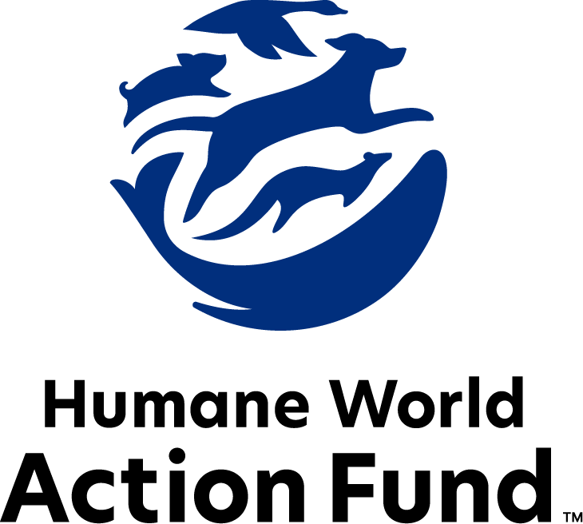

Formerly called
Humane Society Legislative Fund

CANDIDATE QUESTIONNAIRE
Tennessee state office

2026 Tennessee state office candidate questionnaire
Candidate Name: _____________________________________________________________________
Candidate Address: ___________________________________________________________________
Office Sought: ______________________________ Locality: ________________________________
Staff Contact Name: _________________________ Phone: _________________________________
Email: ____________________________________ Website: ________________________________

Animals play an important role in the lives of many Americans. Countless citizens look to their local government to protect animals from cruel treatment and exploitation. Humane-minded individuals care deeply about the positions their elected officials take on animal protection issues.
For information on the range and details of our issue areas, please visit the websites of Humane World Action Fund (humaneaction.org) or Humane World for Animals (humaneworld.org).

Background information

What actions have you taken to promote the welfare of animals in the past? (Please include any action taken in an official or unofficial context.)

Are there any animal welfare programs or issues of importance to you that you would take the initiative on after you are elected?

Will you post information in your campaign materials stating your positions on animal protection issues?

Do you have, or have you had in the past, any pets that have made an impact on you personally?

STATE ISSUES:
Statewide office holders and members of state legislatures influence animal protection policy by supporting humane legislation, opposing government programs that use taxpayer funds to harm animals, supporting funding for government programs to protect animals and for adequate enforcement of animal welfare laws, and opposing inhumane laws or those which weaken current protections. We’d like to know your position on the following important animal welfare issues, which are subject to debate in your state.

PETS AND CRUELTY

Spay-Neuter Funding: The U.S. is currently experiencing a nationwide shortage of veterinarians and vet technicians, with profound effects on the accessibility of veterinary care to pet owners across the country such as spay-neuter services. For residential pet owners, these services don’t just keep the headcount from growing at home—they also curb unwanted animal behaviors and promote a proven longer lifespan in both dogs and cats. For feral cat caregivers, these humane population control methods promote public health and safety by preventing illness in community cats, and by reducing aggressive or nuisance tendencies exhibited by cats who are unsterilized.

Will you support increased funding for spay-neuter services?

_____ Yes _____ No _____ Not Sure

Access to Care: Both clinics and animal shelters are overwhelmed by the number of animals requiring care. The lack of both animal care resources and pet-friendly housing options is acutely felt across Tennessee, especially in rural communities where many have to travel across multiple counties to access the closest veterinarian. People love their pets but are struggling to care for them because of these access barriers that can be alleviated through more veterinary training, direct care programs, and policy making.

Will you support legislation that increases access to care?

_____ Yes _____ No _____ Not Sure

Animal Shelters: Animal shelters are critical to their communities, reuniting lost pets with their families and adopting companion animals to loving homes. The current pressures of overcrowding and lack of funds strains shelters and their ability to respond to cruelty cases, offer spay and neuter services, and help maintain public health. Furthermore, Tennessee has no regulations regarding shelters. Regulation, standardization, and funding will help shelters provide better services for Tennessee’s animals.

Will you support legislation to standardize and regulate Tennessee’s animal shelters?

_____ Yes _____ No _____ Not Sure
Cockfighting: Cockfighting is still a prevalent industry across the country with negative impacts on the birds themselves and on the communities in which cockfighting rings are run. Birds forced to participate in cockfighting suffer terribly before, during, and after fights—common injuries include punctured lungs, broken bones and pierced eyes, yet there is no escape from the fighting pit. The steel blades tied to the birds' legs are so sharp and dangerous that cockfighters themselves have been killed when accidentally slashed by their own birds. As federal and state law enforcement can attest, cockfighting is often associated with other criminal activities such as illegal gambling, drug trafficking, and illegal weapon sales. Animal cruelty, avian disease, and crime are all consequences of this dangerous industry. Yet, cockfighting is only classed as a misdemeanor in Tennessee.

Will you support legislation to raise the penalty for cockfighting from a misdemeanor to felony status?

_____ Yes _____ No _____ Not Sure

Puppy Mills: Internet sales, flea markets, face-to-face sales and many pet stores that sell puppies and kittens are getting those animals from large scale breeding operations, often known as puppy mills. A puppy mill is an inhumane, high-volume commercial dog breeding facility which churns out puppies for profit, ignoring the needs of the pups and their mothers. Dogs from puppy mills are often sick and unsocialized. Pet retailers often falsely assure consumers that the puppies they offer for sale are raised in reputable or humane breeding facilities, when really, they are coming from mass production puppy mills.

Will you support legislation to end the retail sale of puppies sourced from puppy mills in pet stores?

_____ Yes _____ No _____ Not Sure

Commercial Breeder Regulation: While the state of Tennessee once required that dog and cat breeders meet certain standards for the care of their animals, there is currently no oversight or licensing to hold dog and cat breeders accountable for failing to meet those base-level standards of adequate food, water, space to move around, and medical attention. A licensing program for Tennessee dog and cat breeders would establish standards for greater transparency, responsibility, accountability, and consistency of care across all levels and sectors of dog and cat stewardship. Further, such a program would ensure an enforcement mechanism for illegal puppy mill operations; heightened consumer awareness and protection; and education of proper animal care and breeding practices.

Will you support legislation to establish a dog and cat breeder licensing program in Tennessee?

_____ Yes _____ No _____ Not Sure

RESEARCH, TESTING, AND FASHION

Alternatives: The vast majority of animal testing is for drugs, vaccines, medical devices, and to assess the risk of chemicals — however, 90% of drugs tested on animals fail in human trials. Non-animal alternatives not only save countless animal lives, but can be cheaper, faster, and more relevant to human biology, therefore more reliable at predicting safety. Despite the evidence that animal testing is an unreliable metric for determining efficacy of products for humans, many laboratories across the United States, including those housed in universities, continue to test on animals.

Will you support legislation to encourage the use of non-animal testing alternatives?

_____ Yes _____ No _____ Not Sure

FARM PROTECTION AND FOOD SAFETY

Factory Farming: On factory farms, egg-laying hens are packed into battery cages where they can't even spread their wings. Baby calves are taken from their mothers and confined in pens so small they can barely move, and pigs are locked in gestation crates the width and length of their bodies, unable to even turn around. Due to this suffering and the momentum behind shifting away from products of extreme confinement, many family farmers have chosen to focus on more sustainable, humane production and made the corresponding investments to meet consumer demand.

Will you support efforts to protect Tennessee’s family farmers by prohibiting cruel industry practices on factory farms?

_____ Yes _____ No _____ Not Sure

WILDLIFE

Exotic Pets: Wild animals make unsuitable pets under virtually all circumstances, and very few people are equipped or have the expertise to properly maintain wild animals in household environments. Despite the host of threats to public health and safety, it is legal to own many wild animals as pets in Tennessee. Not only do they suffer cruelty when captured, transported, or placed in close proximity to humans—cases of aggression may prove life-threatening, and many species may carry zoonotic diseases that can harm humans or domestic species. Despite this, Tennessee’s restrictions on private ownership do not cover all wild animals. It is still legal to own giraffes, zebras, kangaroos, certain nonhuman primates, and more across the state.

Will you support legislation prohibiting the private ownership of a larger scope of wild animals?

_____ Yes _____ No _____ Not Sure

Bears: People value bears for their considerable aesthetic and ecological purposes, as crucial members of their forest habitats and as iconic animal species. As one of our country’s most photographed and watched animals, Tennessee’s bears help bolster the state’s crucial tourism industry. Yet, with Tennessee’s growing human population, efforts to promote cohabitation are paramount. Biologists have found that almost all human-bear conflicts revolve around food attractants, primarily unsecured garbage cans, outdoor pet food, and bird feeders. And as such, bear-proof trash cans are an effective tool to limit nuisance behavior and hazardous bear activity in residential areas.

Will you support continued funding for, implementation of, and education by the FWC’s “BearWise” program—developed by state agency bear biologists—which provides programmatic support and bear-proof trash cans to local Tennessee governments that apply?

_____ Yes _____ No _____ Not Sure

Appointments to State Agencies: Tennessee state agencies are responsible for a wide range of policymaking with immeasurable effects on the state’s animal populations and wildlife habitats. With much to gain, special interests often fill state commission seats—where there should instead be a diverse group of perspectives, representing the broad interests of the public.

Will you encourage the appointment of a diverse range of experts committed to preserving Tennessee’s natural beauty and wildlife, backed by science and not by special interests?

_____ Yes _____ No _____ Not Sure

Thank you for your time! Please return the completed questionnaire to:

Humane World Action Fund
1255 23rd St NW, Suite 455
Washington, D.C. 20037
Phone: (202) 676-2314

Email: info@humaneaction.org

Rev. 4/28/2026
© 2025 Humane World Action Fund

About us
We fight for political and policy change to tackle the root causes of animal cruelty and suffering.
We work to advance our mission by
passing animal protection laws at the state and federal levels, educating the public about animal protection issues and supporting humane candidates for office. Together, we act to end animal cruelty.

humaneaction.org

