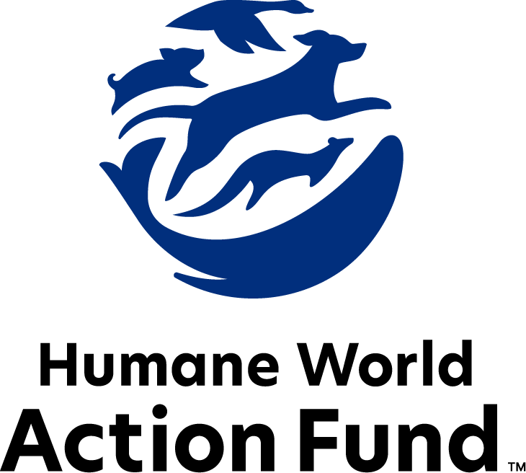

Formerly called
Humane Society Legislative Fund

CANDIDATE QUESTIONNAIRE
Utah state office

2026 Utah state office candidate questionnaire
Candidate Name: _____________________________________________________________________
Candidate Address: ___________________________________________________________________
Office Sought: ______________________________ Locality: ________________________________
Staff Contact Name: _________________________ Phone: _________________________________
Email: ____________________________________ Website: ________________________________

Animals play an important role in the lives of many Americans. Countless citizens look to their local government to protect animals from cruel treatment and exploitation. Humane-minded individuals care deeply about the positions their elected officials take on animal protection issues.
For information on the range and details of our issue areas, please visit the websites of Humane World Action Fund (humaneaction.org) or Humane World for Animals (humaneworld.org).

Background information

What actions have you taken to promote the welfare of animals in the past? (Please include any action taken in an official or unofficial context.)

Are there any animal welfare programs or issues of importance to you that you would take the initiative after you are elected?

Will you post information in your campaign materials stating your positions on animal protection issues?

Do you have, or have you had in the past, any pets that have made an impact on you personally?

STATE ISSUES:
Statewide office holders and members of state legislatures influence animal protection policy by supporting humane legislation, opposing government programs that use taxpayer funds to harm animals, supporting funding for government programs to protect animals and for adequate enforcement of animal welfare laws, and opposing inhumane laws or those which weaken current protections. We’d like to know your position on the following important animal welfare issues, which are subject to debate in your state.

PETS AND CRUELTY

Cost of Care: Animal cruelty cases can involve the seizure of dozens or even hundreds of animals. Providing care for the animals for months or years of pending trial can be financially devastating to county animal shelters and to the well-being of these abused animals. Large-scale cases can be a financial burden for shelters, preventing critical resources from reaching other homeless, abused or at-risk animals.

Will you support efforts to shift this financial burden to those who abused or neglected the animals?

_____ Yes _____ No _____ Not Sure

Animal Control Officers: Animal Control Officers are often the first responders to cases involving animal cruelty, neglect, dangerous animals, hoarding situations, and public safety threats. Despite performing duties like other emergency responders, Animal Control Officers are not formally recognized as first responders under Utah law. This designation can impact training opportunities, access to resources, recruitment, retention, and protections afforded to those serving in these critical roles. Additionally, they work alongside other first responders such as law enforcement, EMT’s, and firefighters on a regular basis during weather emergencies, natural disasters, and other catastrophic events. The very core of an animal control officer is deeply rooted in community engagement, public safety, and welfare of non-human animals. These ACO’s are frontline workers in their community.

Will you support efforts to designate ACO’s as first responders?

_____ Yes _____ No _____ Not Sure

Cruelty Code Updates: Utah’s animal cruelty code is a critical mechanism for preventing animal cruelty and abuse. It is crucial that the code be continually updated – for example, the section concerning shooting dogs has not been updated in 100 years. Lawmakers must prevent the cruelty code from being eroded as well as make amendments to further strengthen penalties for the worst cases of animal cruelty.

Will you support efforts to strengthen Utah’s animal cruelty code?

_____ Yes _____ No _____ Not Sure

Animal Fighting: Animal fighting continues to be a prevalent industry across the country. Dogfights often result in death by blood loss, shock, dehydration, exhaustion or infection hours or even days after the fight. The dogs used in the majority of these fights have been specifically bred and trained for fighting—an upbringing that relies on abuse and mistreatment from puppyhood. Additionally, birds forced to participate in cockfighting suffer terribly before, during, and after fights—common injuries include punctured lungs, broken bones and pierced eyes, yet there is no escape from the fighting pit. The steel blades tied to the birds' legs are so sharp and dangerous that cockfighters themselves have been killed when accidentally slashed by their own birds. As federal and state law enforcement can attest, cockfighting is often associated with other criminal activities such as illegal gambling, drug trafficking, gang activity, and illegal weapon sales.

Will you support legislation strengthening criminal penalties for organized animal fighting, including dogfighting, cockfighting, attendance at animal fights, and related facilitation or promotion activities in Utah?

_____ Yes _____ No _____ Not Sure

Preemption: It is well documented that nefarious pet stores have been a front for the puppy mill pipeline for decades. As such, it is essential to protect local communities’ ability to address these bad actors. Individuals who seek to profit from puppies will stop at no cost, even using state level preemption legislation to overturn local ordinances, including puppy mill and pet store reforms. Special interests exhibit a dangerous overreach, coming head-to-head with the core right of local governments to legislate freely on issues impacting their communities.

Will you support municipal governments in their efforts to raise animal welfare standards within their jurisdictions?

_____ Yes _____ No _____ Not Sure

RESEARCH, TESTING, AND FASHION

Fur: Whether trapped in the wild or raised on farms, animals used in the fur industry suffer immensely. On fur factory farms in the U.S. and around the world, millions of rabbits, foxes, mink, and other wild animals spend their entire lives in cramped cages, deprived of the ability to engage in natural behaviors—only to be crudely gassed or electrocuted at the end. In the wild, animals are caught in crippling leghold traps without food or water, suffering for days before they die or are killed. Leghold traps are indiscriminate, often maiming and killing non-target animals, like threatened species and even pets—all this in the name of fashion. Prohibiting the sales of new fur products will support efforts to end this cruel industry, while still allowing businesses to sell vintage or used fur products, and continue services caring for fur products, such as storage and cleaning.

Will you support efforts to prohibit the sale of new products containing fur, sourced from animals raised solely to produce fur products?

_____ Yes _____ No _____ Not Sure

FARM PROTECTION AND FOOD SAFETY

Confinement: In 2021, Utah banned the cruel cage confinement of egg-laying hens, eliminating one of the worst factory farming practices. The law requires all egg-laying hens be housed in cage-free systems; sets minimum space requirements; and requires farms be certified as compliant with the new standards. Despite its passage, the law has faced battles over rescission, extension, and review.

Will you oppose efforts to weaken or further delay implementation of Utah’s egg-laying hens confinement ban?

_____ Yes _____ No _____ Not Sure

WILDLIFE
Trophy Hunting: Each year, hundreds of thousands of wild animals around the world are killed in trophy hunts, where the primary motivation is to obtain animal parts (that is, their heads, hides or claws and even the whole stuffed animal) for display and for bragging rights, but not for subsistence. Cruel and unsportsmanlike practices like baiting, hounding and trapping—also captive hunts, in which hunters pursue animals who can’t escape—ensure that animals don’t stand a chance, and hunters bag an easy prize.

Will you support efforts to reduce trophy hunting?

_____ Yes _____ No _____ Not Sure

Appointments to State Agencies: Utah state agencies, like the Department of Wildlife Resources, are responsible for a wide range of policymaking with immeasurable effects on the state’s animal populations and wildlife habitats. With much to gain, special interests often fill state commission seats—where there should instead be a diverse group of perspectives, representing the broad interests of the public.

Will you encourage the appointment of a diverse range of experts committed to preserving Utah's natural beauty and wildlife, backed by science and not by special interests?

_____ Yes _____ No _____ Not Sure

Thank you for your time! Please return the completed questionnaire to:

Humane World Action Fund
1255 23rd St NW, Suite 455
Washington, D.C. 20037
Phone: (202) 676-2314

Email: info@humaneaction.org

Rev. 5/13/2026
© 2025 Humane World Action Fund

About us
We fight for political and policy change to tackle the root causes of animal cruelty and suffering.
We work to advance our mission by
passing animal protection laws at the state and federal levels, educating the public about animal protection issues and supporting humane candidates for office. Together, we act to end animal cruelty.

humaneaction.org

