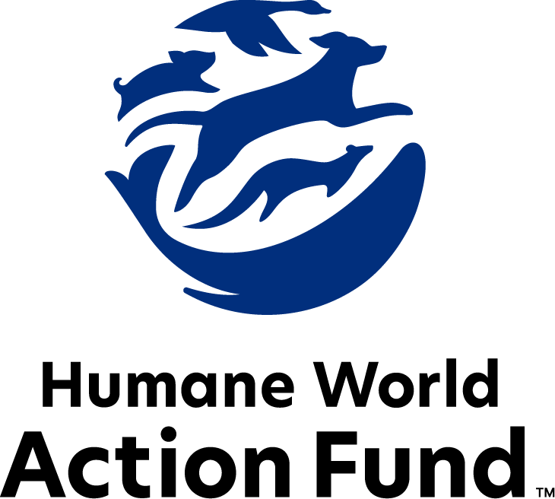

Formerly called
Humane Society Legislative Fund

CANDIDATE QUESTIONNAIRE
Florida state office

2026 Florida state office candidate questionnaire
Candidate Name: _____________________________________________________________________
Candidate Address: ___________________________________________________________________
Office Sought: ______________________________ Locality: ________________________________
Staff Contact Name: _________________________ Phone: _________________________________
Email: ____________________________________ Website: ________________________________

Animals play an important role in the lives of many Americans. Countless citizens look to their local government to protect animals from cruel treatment and exploitation. Humane-minded individuals care deeply about the positions their elected officials take on animal protection issues.
For information on the range and details of our issue areas, please visit the websites of Humane World Action Fund (humaneaction.org) or Humane World for Animals (humaneworld.org).

Background information

What actions have you taken to promote the welfare of animals in the past? (Please include any action taken in an official or unofficial context.)

Are there any animal welfare programs or issues of importance to you that you would take the initiative on after you are elected?

Will you post information in your campaign materials stating your positions on animal protection issues?

Do you have, or have you had in the past, any pets that have made an impact on you personally?

STATE ISSUES:
Statewide office holders and members of state legislatures influence animal protection policy by supporting humane legislation, opposing government programs that use taxpayer funds to harm animals, supporting funding for government programs to protect animals and for adequate enforcement of animal welfare laws, and opposing inhumane laws or those which weaken current protections. We’d like to know your position on the following important animal welfare issues, which are subject to debate in your state.

PETS AND CRUELTY
Puppy Mills: Internet sales, flea markets, face-to-face sales, and many pet stores that sell puppies are getting those dogs from puppy mills. A puppy mill is an inhumane, high-volume commercial dog breeding facility which churns out puppies for profit, ignoring the needs of the pups and their mothers. Dogs from puppy mills are often sick and unsocialized, requiring veterinary care that saddles new owners with unexpected expenses. Pet retailers often falsely assure consumers that the puppies they offer for sale are raised in reputable or humane breeding facilities, when really, they are coming from mass production puppy mills.

Will you support legislation to phase out the retail sale of puppies sourced from puppy mills in pet stores?

_____ Yes _____ No _____ Not Sure

Pet Retail Sales: Humane World for Animals, formerly the Humane Society of the United States, hears from thousands of devastated consumers every year who bring home a dog only to have the animal fall sick and, in some cases, even die, due to the negligence in high-volume breeding operations. As such, it is crucial to have safeguards holding pet dealers accountable for the good health and treatment of any animal sold. Many states, including Florida, maintain these protections, but they can often prove weak or full of loopholes. For example, in Florida, if an animal becomes ill with a condition that existed at the time of sale, the law requires pet sellers to only reimburse a pet owner for veterinary bills up to the same value as the purchase price of the animal—in which case it’s still possible for the new owner to be saddled with significant financial burden.

Will you support legislation to mandate that if a pet sale be terminated due to the state of the animal’s health, the buyer may terminate the financing agreement without penalty? This would include reimbursement for any pertinent veterinary cost without limit.

_____ Yes _____ No _____ Not Sure

Preemption: It is well documented that nefarious pet stores have been a front for the puppy mill pipeline for decades. As such, it is essential to protect local communities’ ability to address these bad actors. Individuals who seek to profit off puppies will stop at no cost, even using state level preemption legislation to overturn local ordinances, including pet retail sale reforms.

Will you support municipal governments in their efforts to maintain animal protection standards within their jurisdiction?

_____ Yes _____ No _____ Not Sure

Pets in Housing: Humane World Action Fund is committed to helping keep Florida families and their pets together. Monthly pet rents, non-refundable pet fees, and a variety of high pet deposits are all legal in Florida rental housing, and there is no cap on their amount. 72% of Americans report that nationwide, pet-friendly rental housing is a challenge to find, and 59% agree that where it is available, it’s too pricey to afford. These conditions often prove too difficult to overcome, and end up tearing families and their pets apart. When animals are forced out of their homes and into shelters, this contributes to the crisis of overcrowded shelter and kennel space across the state, putting additional strain on local governments and demanding further resources that are already scarce.

Will you support efforts to manage additional pet fees and deposits in Florida rental housing, to keep Florida families and their pets together?

_____ Yes _____ No _____ Not Sure

WILDLIFE
Bear Protection: People value bears for their considerable aesthetic and ecological purposes, as crucial members of their forest habitats and as iconic animal species. As one of our country’s most photographed and watched animals, Florida’s bears help bolster the state’s crucial tourism industry. Yet, with Florida’s growing human population, efforts to promote cohabitation are paramount. Biologists have found that almost all human-bear conflicts revolve around food attractants, primarily unsecured garbage cans, outdoor pet food, and bird feeders. And as such, bear-proof trash cans are an effective tool to limit nuisance behavior and hazardous bear activity in residential areas.

Will you support continued funding for, implementation of, and education by the FWC’s “BearWise” program—developed by state agency bear biologists—which provides bear-proof trash cans to local Florida governments that apply?

_____ Yes _____ No _____ Not Sure

Appointments to State Agencies: Florida state agencies are responsible for a wide range of policymaking, with immeasurable effects on the state’s animal populations and wildlife habitats. For example, the Florida Fish and Wildlife Conservation Commission has constitutional authority, making it the country’s most influential commission of its kind. It issues a variety of rules on wildlife conservation, including protections for the most endangered or vulnerable species across the state.

Will you encourage the appointment of commissioners with varied backgrounds including experience with wildlife conservation to help preserve Florida’s treasured resources and wildlife?

_____ Yes _____ No _____ Not Sure

RESEARCH, TESTING, AND FASHION
Retirement: It is a bleak life for the tens of thousands of dogs and cats used in testing and research in U.S. laboratories each year. When they aren’t subjected to cruel, painful product tests, these animals spend almost every hour of their short lives behind bars in cold steel cages, never knowing what it is like to play fetch, lie in the sun, or roll over for a belly rub. Those who have adopted former research dogs and cats can attest to the resilience and affection of these animals once they are given the chance to flourish in a home environment.

Will you support legislation to require research facilities to offer cats and dogs no longer used for educational, research, or scientific purposes to animal rescue organizations for adoption prior to euthanizing the animals? This effort would also require publicly funded institutions to make information available to the Florida Department of Agriculture and Consumer Services (FDACS) concerning animal testing activities.

_____ Yes _____ No _____ Not Sure

Thank you for your time! Please return the completed questionnaire to:

Humane World Action Fund
1255 23rd St NW, Suite 455
Washington, D.C. 20037
Phone: (202) 676-2314

Email: info@humaneaction.org

Rev. 5/28/2025
© 2025 Humane World Action Fund

About us
We fight for political and policy change to tackle the root causes of animal cruelty and suffering.
We work to advance our mission by
passing animal protection laws at the state and federal levels, educating the public about animal protection issues and supporting humane candidates for office. Together, we act to end animal cruelty.

humaneaction.org

