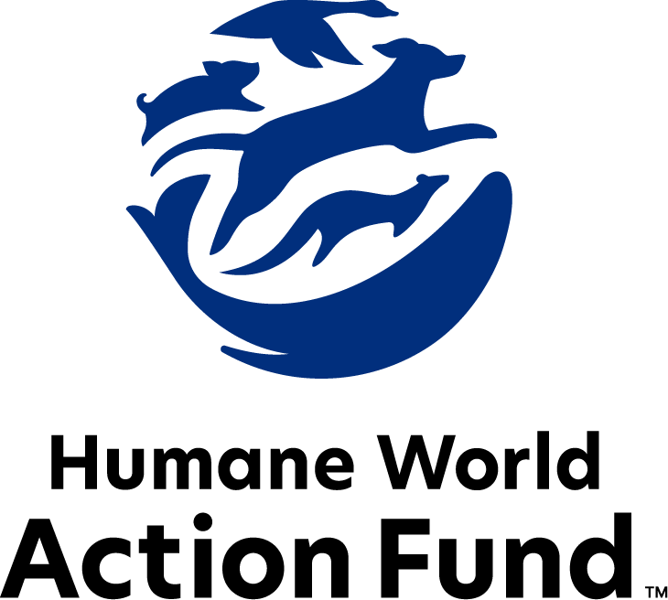

Formerly called
Humane Society Legislative Fund

CANDIDATE QUESTIONNAIRE
Colorado state office

2026 Colorado state office candidate questionnaire
Candidate Name: _____________________________________________________________________
Candidate Address: ___________________________________________________________________
Office Sought: ______________________________ Locality: ________________________________
Staff Contact Name: _________________________ Phone: _________________________________
Email: ____________________________________ Website: ________________________________

Animals play an important role in the lives of many Americans. Countless citizens look to their local government to protect animals from cruel treatment and exploitation. Humane-minded individuals care deeply about the positions their elected officials take on animal protection issues.
For information on the range and details of our issue areas, please visit the websites of Humane World Action Fund (humaneaction.org) or Humane World for Animals (humaneworld.org).

Background information

What actions have you taken to promote the welfare of animals in the past? (Please include any action taken in an official or unofficial context.)

Are there any animal welfare programs or issues of importance to you that you would take the initiative on after you are elected?

Will you post information in your campaign materials stating your positions on animal protection issues?

Do you have, or have you had in the past, any pets that have made an impact on you personally?

STATE ISSUES:
Statewide office holders and members of state legislatures influence animal protection policy by supporting humane legislation, opposing government programs that use taxpayer funds to harm animals, supporting funding for government programs to protect animals and for adequate enforcement of animal welfare laws, and opposing inhumane laws or those which weaken current protections. We’d like to know your position on the following important animal welfare issues, which are subject to debate in your state.

PETS AND CRUELTY

Puppy Mills: Internet sales, flea markets, face-to-face sales and many pet stores that sell puppies are getting those dogs from puppy mills. A puppy mill is an inhumane, high-volume commercial dog breeding facility which churns out puppies for profit, ignoring the needs of the sick, unsocialized pups and their mothers. Pet retailers often falsely assure consumers that the puppies they offer for sale are raised in reputable or humane breeding facilities, when really, they are coming from mass production puppy mills—most of which are out of state, sending truck shipments of animals into Colorado for sale.

Will you support legislation to end the retail sale of puppies sourced from puppy mills in pet stores?

_____ Yes _____ No _____ Not Sure

Pets in Housing: 72% of Americans report that pet-friendly rental housing is difficult to find, and 59% agree that where it is available, it’s too pricey to afford. Pet ownership has proven to be an increasing mechanism for housing and financial insecurity among renters, as families with pets often feel powerless and discriminated against while seeking a home. Colorado renters have some protection against this as the state has laws capping pet rent and deposits. However, homeowners’ association restrictions and prohibitions combined with the cost of living and housing crises in the state continue to put pressure on pet owners seeking housing.

Will you support legislation to further implement pet-inclusive housing?

_____ Yes _____ No _____ Not Sure

WILDLIFE

Public Contact: While exciting to see up close, wild animals are altogether unfit for public contact. Substandard wildlife zoos or attractions in Colorado, offering direct animal interaction, exploit these animals to turn a quick profit, often with such neglect that horror stories have been recorded through undercover investigations. Not only do wild animals suffer cruelly when captured, transported, or placed in close proximity to humans—the risks they then pose to human health and safety are enormous. Cases of aggression may prove life-threatening, as may a host of zoonotic diseases. For example, the “interactive” aquarium SeaQuest in Littleton closed its doors this year after complaints that members of the public had been injured by the animals. Yet, similar businesses are still allowed to operate in Colorado—just outside of Alamosa, a facility with over 300 alligators allows visitors to pay to wrestle with the animals.

Will you support legislation to prohibit direct public contact with wild animals (including alligators and marine life) in Colorado?

_____ Yes _____ No _____ Not Sure

Live Trapping: In 1996, Colorado voters banned the recreational and commercial snare trapping of bobcats, foxes, and other wildlife on public lands. However, Colorado Parks and Wildlife still allows trappers to take and kill these animals for their fur and for trophies using “live,” or “box,” traps. A box trap may seem harmless, but once the door shuts on this mesh wire cage, a bear, bobcat, or mountain lion caught inside is left defenseless. And under current law, these furbearing animals captured in live traps cannot be moved from the capture site without a permit, and must actually be killed or released on site when the trap is checked. Even though fur sales are plummeting across the world, these animals are still highly profitable to trappers—who, for example, still target Colorado’s bobcats for their soft belly fur, which is sold in international markets.

Will you support legislation to prohibit the trapping of animals for their fur?

_____ Yes _____ No _____ Not Sure

Hound Hunting: Hound hunting is a tactic in which packs of dogs pursue exhausted, frightened animals until they seek refuge in a tree—where they are then shot—or turn to fight to the death. After this gruesome conflict, any babies left orphaned are vulnerable to their natural predators, or to mauling by the same dogs. In turn, the dogs involved can suffer broken bones, punctured lungs, or other serious injuries, and are frequently dumped at municipal animal shelters or left in the woods if they do not perform adequately. It is already illegal to hound hunt bears in Colorado—voters chose to outlaw the practice by ballot measure in 1992, with the support of sportsmen who view the use of hounds as unsportsmanlike, defeating the purpose of “fair chase.”

Will you support legislation to prohibit the cruel hounding of bobcats and mountain lions in Colorado?

_____ Yes _____ No _____ Not Sure

Beavers: Beavers inhabiting Colorado’s waterways are integral to their ecosystems for a number of reasons – one of which is forest fire management. Beavers create and maintain wetlands, retaining water on the landscape. When beaver populations dwindle due to recreational hunting, dams aren’t built and wetlands are lost, increasing the intensity of drought and wildfires. Wetlands are a natural, free tool in wildfire management, and Colorado’s beavers are on the frontlines of maintaining them. However, current wildlife management policies do little to protect these animals. Currently in Colorado, individuals with a furbearer license can kill an unlimited number of beavers and do not have to report how many they take.

Will you support efforts to prohibit the recreational hunting of beavers in order to maintain this ecologically necessary population?

_____ Yes _____ No _____ Not Sure

Appointments to State Agencies: Colorado state agencies are responsible for a wide range of policymaking, with immeasurable effects on the state’s animal populations and wildlife habitats. For example, the Colorado Parks and Wildlife Commission engages in key decision-making over protections for critically important species; wildlife management; the issuance of hunting licenses; and the establishment of harvest limits for hunters. However, it is required by statute that people representing the oil, gas, agriculture, and sportsperson industries fill designated seats as commissioners, with one seat allocated to a representative of a non-profit organization. This stark imbalance invites special interests to skew policy in their favor and away from pro-animal initiatives. Instead, the commission should host a diverse group of perspectives, representing the broad interests of the public.

Will you support legislation to amend the statute mandating the appointment of Parks and Wildlife commissioners backed by certain special interests, instead allowing the Governor to appoint a diverse range of experts to serve on the commission?

_____ Yes _____ No _____ Not Sure

FARM PROTECTION AND FOOD SAFETY

Fashion: On fur factory farms in the U.S. and around the world, millions of rabbits, foxes, mink, and other wild animals spend their entire lives in cramped cages, deprived of the ability to engage in natural behaviors—only to be crudely gassed or electrocuted at the end. These farms have also proven to be dangerous breeding grounds for a variety of diseases transmissible to humans, such as avian influenza. Prohibiting the sales of new fur products will support efforts to end this cruel industry, while still allowing businesses to sell vintage or used fur products and to continue services caring for fur products, such as storage and cleaning.

Will you support legislation to prohibit the sale of new products containing fur from animals?

_____ Yes _____ No _____ Not Sure

Cage-Free Eggs: As of 2025, all eggs sold in Colorado must be from a cage-free facility thanks to the passage of the cage-free law in 2020. This law spares approximately 6 million chickens each year from being locked in tiny wire cages where they cannot even spread their wings. Colorado’s progress on this front is also in step with the industry itself, as egg producers around the world are investing millions of dollars into cage-free farms.

Will you oppose efforts to repeal Colorado’s cage-free egg law?

_____ Yes _____ No _____ Not Sure

ANIMALS IN RESEARCH

Cosmetics Testing: Humane and safe cosmetics can be made using the thousands of existing ingredients that have already been approved, and several non-animal safety tests are already available for new ingredients. These non-animal alternatives not only save countless animals, but can be cheaper, faster, and more relevant to human biology, and therefore more reliable at predicting safety. Countries with a collective 1.7 billion consumers, including India and those in the European Union, already prohibit the sale of cosmetics tested on animals, and global companies are meeting this demand with cruelty-free products. California, Hawaii, Illinois, Louisiana, Maine, Maryland, Nevada, New Jersey, New York, Oregon, and Virginia prohibit new animal testing for cosmetics safety substantiation, and it’s expected more states will consider legislation.

Will you support legislation to prohibit the manufacture and sale of newly animal-tested cosmetics?

_____ Yes _____ No _____ Not Sure

Alternative Development: The vast majority of animal testing is for drugs, vaccines, medical devices, and to assess the risk of chemicals — however, 90% of drugs tested on animals fail in human trials. Non-animal alternatives not only save countless animal lives, but can be cheaper, faster, and more relevant to human biology, therefore more reliable at predicting safety. Despite the evidence that animal testing is an unreliable metric for determining efficacy of products for humans, many laboratories across the United States, including those housed in universities, continue to test on animals. Animal testing needlessly subjects animals to lives of cruelty and abuse, wastes money and resources, and stunts scientific development.

Will you support the continued development of alternative, non-animal testing methods?

_____ Yes _____ No _____ Not Sure

Transparency: The federal government currently requests basic information about facilities that experiment on animals. Concerningly, several species are completely exempted from these reporting requirements. As we continue to develop more nonanimal research alternatives, we need to understand the full scope of animal testing that has taken place in our state, especially in higher education institutions where this type of testing is still being conducted.

Will you support legislation requiring facilities to disclose information to the state describing how many animals they have, what species are being used, and the purposes of their animal experiments?

_____ Yes _____ No _____ Not Sure

Thank you for your time! Please return the completed questionnaire to:

Humane World Action Fund
1255 23rd St NW, Suite 455
Washington, D.C. 20037
Phone: (202) 676-2314

Email: info@humaneaction.org

Rev. 12/4/2025
© 2025 Humane World Action Fund

About us
We fight for political and policy change to tackle the root causes of animal cruelty and suffering.
We work to advance our mission by
passing animal protection laws at the state and federal levels, educating the public about animal protection issues and supporting humane candidates for office. Together, we act to end animal cruelty.

humaneaction.org

