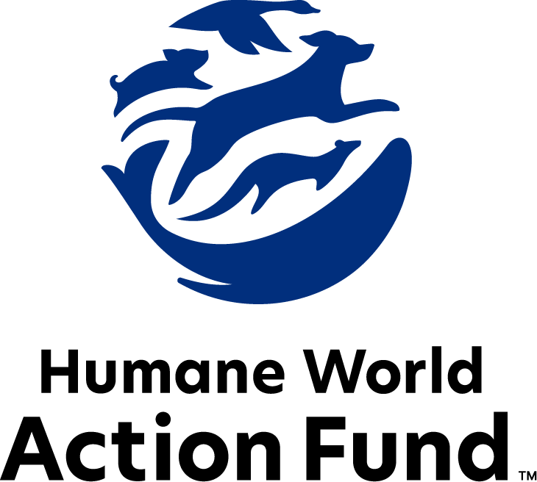

Formerly called
Humane Society Legislative Fund

CANDIDATE QUESTIONNAIRE
Connecticut state office

2026 Connecticut state office candidate questionnaire
Candidate Name: _____________________________________________________________________
Candidate Address: ___________________________________________________________________
Office Sought: ______________________________ Locality: ________________________________
Staff Contact Name: _________________________ Phone: _________________________________
Email: ____________________________________ Website: ________________________________

Animals play an important role in the lives of many Americans. Countless citizens look to their local government to protect animals from cruel treatment and exploitation. Humane-minded individuals care deeply about the positions their elected officials take on animal protection issues.
For information on the range and details of our issue areas, please visit the websites of Humane World Action Fund (humaneaction.org) or Humane World for Animals (humaneworld.org).

Background information

What actions have you taken to promote the welfare of animals in the past? (Please include any action taken in an official or unofficial context.)

Are there any animal welfare programs or issues of importance to you that you would take the initiative on after you are elected?

Will you post information in your campaign materials stating your positions on animal protection issues?

Do you have, or have you had in the past, any pets that have made an impact on you personally?

STATE ISSUES:
Statewide office holders and members of state legislatures influence animal protection policy by supporting humane legislation, opposing government programs that use taxpayer funds to harm animals, supporting funding for government programs to protect animals and for adequate enforcement of animal welfare laws, and opposing inhumane laws or those which weaken current protections. We’d like to know your position on the following important animal welfare issues, which are subject to debate in your state.

PETS AND CRUELTY

Office of Animal Advocate: Legislation is only as good as its enforcement mechanisms – it is critical for animals in Connecticut to be protected by humane laws that are enforced by experts with adequate resources. Creating an Office of the Animal Advocate would build out a body with the expertise and ability to carry out Connecticut’s anti-cruelty laws rather than the burden falling to agencies and offices that may not be best equipped to do so.

Would you support the creation of the Office of the Animal Advocate to better enforce anti-cruelty laws?

_____ Yes _____ No _____ Not Sure

Access to Care: The U.S. is currently experiencing a nationwide shortage of veterinarians and veterinary technicians, with profound effects on the accessibility of in-office veterinary care to pet owners across the country. Both clinics and animal shelters are overwhelmed by the number of animals requiring care. The lack of both animal care resources and pet-friendly housing options is most felt by those in underserved communities; more than 20 million pets experience poverty with their families in this country. People love their pets but are struggling to care for them because of these access barriers that can be alleviated through more veterinary training, direct care programs, and policy making.

Will you support the convening of a working group to determine ways to increase access to care?

_____ Yes _____ No _____ Not Sure

Desmond’s Law: With the passage of Desmond’s Law, Connecticut became the first state to allow a court-appointed advocate to testify on behalf of animal victims in cruelty cases. The law bolsters animal protection in the legal system and also helps to ease the workloads of overburdened prosecutors. However, Desmond’s Law only applies to dogs and cats. By applying Desmond’s Law to apply to all animals as defined by Connecticut’s cruelty statutes, all of the state’s animals can benefit from this groundbreaking law.

Will you support efforts to expand Desmond’s Law to cover all animals as defined by Connecticut’s cruelty statutes?

_____ Yes _____ No _____ Not Sure

Puppy Mills: Internet sales, flea markets, face-to-face sales and many pet stores that sell puppies and kittens are getting those animals from large-scale breeding operations, often known as puppy mills. A puppy mill is an inhumane, high-volume commercial dog breeding facility which churns out puppies for profit, ignoring the needs of the pups and their mothers. Dogs from puppy mills are often sick and unsocialized. Pet retailers often falsely assure consumers that the puppies they offer for sale are raised in reputable or humane breeding facilities when, really, they are coming from mass production puppy mills. Reputable breeders never sell to pet shops.

Will you support legislation to end the retail sale of puppies in pet stores?

_____ Yes _____ No _____ Not Sure

Cat Declawing: Many countries and hundreds of cities in the U.S. have banned cat declawing because the procedure frequently results in pain in the paw, infection, tissue necrosis (tissue death), lameness, and back pain. Removing claws changes the way a cat's foot meets the ground and can cause pain like wearing an uncomfortable pair of shoes. There can also be a regrowth of improperly removed claws, nerve damage, and bone spurs. Further, cat declawing has been associated with drastic changes in a cat’s behavior, increasing biting and other negative behaviors. The Humane World Action Fund opposes declawing except for the rare cases when it is necessary for medical purposes to the feline, such as the removal of cancerous nail bed tumors.

Will you support legislation to prohibit the non-therapeutic surgical declawing of cats?

_____ Yes _____ No _____ Not Sure

RESEARCH, TESTING, AND FASHION

Fur: Whether trapped in the wild or raised on farms, animals used in the fur industry suffer immensely. On fur factory farms in the U.S. and around the world, millions of rabbits, foxes, mink, and other wild animals spend their entire lives in cramped cages, deprived of the ability to engage in natural behaviors—only to be crudely gassed or electrocuted at the end. In the wild, animals are caught in crippling leghold traps without food or water, suffering for days before they die or are killed. Leghold traps are indiscriminate, often maiming and killing non-target animals, like threatened species and even pets—all this in the name of fashion. Prohibiting the sales of new fur products will support efforts to end this cruel industry, while still allowing businesses to sell vintage or used fur products, and continue services caring for fur products, such as storage and cleaning.

Will you support efforts to prohibit the sale of new products containing fur, sourced from animals raised solely to produce fur products?

_____ Yes _____ No _____ Not Sure

Transparency: The federal government currently requests basic information about facilities that experiment on animals. Concerningly, several species are completely exempted from these reporting requirements. As we continue to develop more nonanimal research alternatives, we need to understand the full scope of animal testing that has taken place in our state. And, we must oppose attempts to further shield these institutions from transparency.

Will you support efforts to increase transparency standards for animal research facilities?

_____ Yes _____ No _____ Not Sure

Alternatives: The vast majority of animal testing is for drugs, vaccines, medical devices, and to assess the risk of chemicals — however, 90% of drugs tested on animals fail in human trials. Non-animal alternatives not only save countless animal lives, but can be cheaper, faster, and more relevant to human biology, therefore more reliable at predicting safety. Despite the evidence that animal testing is an unreliable metric for determining efficacy of products for humans, many laboratories across the United States, including those housed in universities, continue to test on animals. Continued reliance on these outdated and inhumane testing methods harms the animals confined to the cages of the laboratories and stunts scientific development.

Will you support legislation to encourage the use of non-animal testing alternatives?

_____ Yes _____ No _____ Not Sure

FARM PROTECTION AND FOOD SAFETY

Confinement: On a typical factory farm, egg-laying hens are packed into battery cages where they cannot engage in their most basic behavioral needs or even spread their wings. As consumer awareness grows about the agonizing, high-density conditions animals like battery hens endure, there is higher demand for animal products from more humane conditions. In response, egg producers around the world are investing in cage-free farms—where cage-free hens are able to walk, spread their wings and lay their eggs in nests—and entire states are enacting humane sourcing standards.

Will you support legislation to prohibit the production and sale of eggs from egg-laying hens that are cruelly confined to battery cages on factory farms?

_____ Yes _____ No _____ Not Sure

Rabbit Factory Farming: There have been attempts in Connecticut to promote the large-scale slaughter of rabbits for food. Legalizing such factory farming of rabbits would likely exacerbate the spread of viral diseases. And, immense cruelty would be inflicted on rabbits as they are exempt from the Humane Methods of Slaughter Act. There is no demonstrable demand for rabbit meat and promoting such farming of it is misaligned with how people view rabbits, the third most popular household pet.

Will you oppose efforts to promote the factory farming of rabbits in Connecticut?

_____ Yes _____ No _____ Not Sure

WILDLIFE
Wildlife Trade: The wildlife trade poses a major threat to wild animals across the globe as it is now one of the most lucrative illicit markets in the world. It puts a price tag on vulnerable species, leading to unsustainable population declines and causing undue pain and distress to animals killed for their body parts. They are otherwise smuggled long distances for the cruel, unsafe pet market.

Will you support legislation to crack down on the illegal wildlife trade?

_____ Yes _____ No _____ Not Sure

Bear Hunting: Connecticut is one of a few states that has no bear hunting season. This status is critical to preserving the health of the state’s environment as any bear killed has a tremendous negative impact on the population and its ecosystems. People value black bears for their ecological purpose and as an iconic animal species.

Will you oppose efforts to open a black bear hunting season?

_____ Yes _____ No _____ Not Sure

Bobcats: Every year in the United States, 3 to 5 million wild animals are estimated to be caught and killed through the process of trapping. Steel-jaw leghold traps, wire neck snares, and body-gripping traps crush animals in an agonizing grip while they await the return of their trappers. If an animal has not been killed by predators or by the trap itself, the trapper will often kill it in a way that preserves its cosmetic value—through violent suffocation or a blow to the head. These traps pose a risk to endangered species, family pets, and children.

Will you support efforts to stop creating an open season for hunting or trapping bobcats in Connecticut?

_____ Yes _____ No _____ Not Sure

Rodenticide: Chemical rodenticides are commonly used in commercial rodent control in Connecticut. These include Second Generation Anticoagulant Rodenticides (SGARs), which induce a particularly insidious death due to excessive bleeding. Not only is this control method highly inhumane—it has also proven to rapidly enter the bodies of predators up the food chain, from owls to big cats and beyond, who ingest the poison and often succumb to it, themselves. Once these compounds enter the environment, they rapidly move across it, virtually unstoppably except at the source. The number of animals who are either compromised or die from the poison is enormous.

Will you support legislation to monitor and reduce the use of Second Generation Anticoagulant Rodenticides (SGARs) in Connecticut to protect our wildlife and pets?

_____ Yes _____ No _____ Not Sure

Thank you for your time! Please return the completed questionnaire to:

Humane World Action Fund
1255 23rd St NW, Suite 455
Washington, D.C. 20037
Phone: (202) 676-2314

Email: info@humaneaction.org

Rev. 2/4/2026

© 2025 Humane World Action Fund

About us
We fight for political and policy change to tackle the root causes of animal cruelty and suffering.
We work to advance our mission by
passing animal protection laws at the state and federal levels, educating the public about animal protection issues and supporting humane candidates for office. Together, we act to end animal cruelty.

humaneaction.org

