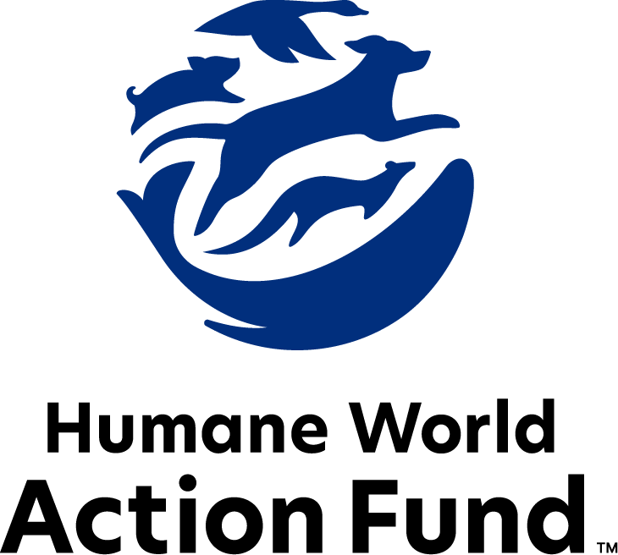

Formerly called
Humane Society Legislative Fund

CANDIDATE QUESTIONNAIRE
Illinois state office

2026 Illinois state office candidate questionnaire
Candidate Name: _____________________________________________________________________
Candidate Address: ___________________________________________________________________
Office Sought: ______________________________ Locality: ________________________________
Staff Contact Name: _________________________ Phone: _________________________________
Email: ____________________________________ Website: ________________________________

Animals play an important role in the lives of many Americans. Countless citizens look to their local government to protect animals from cruel treatment and exploitation. Humane-minded individuals care deeply about the positions their elected officials take on animal protection issues.
For information on the range and details of our issue areas, please visit the websites of Humane World Action Fund (humaneaction.org) or Humane World for Animals (humaneworld.org).

Background information

What actions have you taken to promote the welfare of animals in the past? (Please include any action taken in an official or unofficial context.)

Are there any animal welfare programs or issues of importance to you that you would take initiative on after you are elected?

Will you post information in your campaign materials stating your positions on animal protection issues?

Do you have, or have you had in the past, any pets that have made an impact on you personally?

STATE ISSUES:
Statewide office holders and members of state legislatures influence animal protection policy by supporting humane legislation, opposing government programs that use taxpayer funds to harm animals, supporting funding for government programs to protect animals and for adequate enforcement of animal welfare laws, and opposing inhumane laws or those which weaken current protections. We’d like to know your position on the following important animal welfare issues, which are subject to debate in your state.

PETS AND CRUELTY

Puppy Mills: In 2021, in a landmark victory in the fight against cruel puppy mills, Gov. Pritzker signed the Humane Pet Store Bill (H.B. 1711) into law. Illinois pet stores were selling thousands of puppies each year from large-scale commercial breeders and brokers who treat mother dogs as little more than breeding machines, and puppies as mere products. These animals often leave the mills sick and unsocialized. Dozens of Illinois puppy-selling pet stores can no longer offer commercially raised puppies and kittens for sale—they must instead source from shelters, rescues, and responsible breeders. The new law sends a clear message: the days when pet stores can showcase the puppy or kitten in the window, while puppy and kitten mills hide their cruelty and negligence, are coming to an end. However, new bills constantly threaten to wipe out this critical progress—for example, 2022’s H.B. 4643 and 2023’s H.B. 2793 sought to once again allow pet stores to source from high-volume, inhumane puppy and kitten mills.

Will you oppose legislation to repeal or reverse the Humane Pet Store Law?

_____ Yes _____ No _____ Not Sure

Cat Declawing: Many countries and hundreds of cities in the U.S. have banned cat declawing because the procedure frequently results in pain in the paw, infection, tissue necrosis (tissue death), lameness, and back pain. Removing claws changes the way a cat's foot meets the ground and can cause pain. There can also be a regrowth of improperly removed claws, nerve damage, and bone spurs. Further, cat declawing has been associated with drastic changes in a cat’s behavior, increasing biting, and other negative behaviors. Humane World Action Fund opposes declawing except for the rare cases when it is necessary for medical purposes to the feline, such as the removal of cancerous nail bed tumors.

Will you support legislation to prohibit the non-therapeutic surgical declawing of cats?

_____ Yes _____ No _____ Not Sure

Pets in Housing: Monthly pet rents, non-refundable pet fees, and a variety of pet deposits are all legal in Illinois rental housing, and there is no cap on their amount. 72% of Americans report that pet-friendly rental housing is difficult to find, and 59% agree that where it is available, it’s too pricey to afford. Pet ownership has proven to be an increasing mechanism for housing and financial insecurity among renters, as families with pets often feel powerless and discriminated against while seeking a home. Additionally, pets provide companionship, warmth, and security to many people experiencing homelessness—but while up to 10 percent of the national homeless population maintains companion animals, they are often not permitted in shelters, motels, or in other assisted housing. Surrendering these animals means losing a critical source of comfort, purpose, and family. As such, pet owners will often go to great lengths to remain united with their animals, and this alone creates a major barrier between homelessness and the services available to homeless pet owners.

Will you support pet-inclusive, affordable practices in Illinois rental housing policies to keep pets and families together?

_____ Yes _____ No _____ Not Sure
Veterinary Care: The U.S. is currently experiencing a nationwide shortage of veterinarians and vet technicians, with profound effects on the accessibility of in-office veterinary care to pet owners across the country. What’s more, the cost of veterinary care has risen over the past years, and the lack of veterinarians and veterinary professional staff relative to demand plays a significant role in these increasing costs. While the impacts of these increasing costs are severe, there are several paths to alleviating the strain on animals and their families. Veterinary license reciprocity, veterinary student loan forgiveness, and expanding telehealth options are all policies that can, and do, help in bringing down the cost of care.

Will you support legislation to expand access to veterinary care in Illinois?

_____ Yes _____ No _____ Not Sure

FARM PROTECTION AND FOOD SAFETY

Fur Fashion: Animals need their fur coats more than we do, and whether trapped in the wild or raised on farms, animals used in the fur industry suffer immensely. On fur factory farms in the U.S. and around the world, millions of rabbits, foxes, mink, and other wild animals spend their entire lives in cramped cages, deprived of the ability to engage in natural behaviors—only to be crudely gassed or electrocuted at the end. In the wild, animals are caught in crippling leghold traps without food or water, suffering for days before they die or are killed. Leghold traps are indiscriminate, often maiming and killing non-target animals, like threatened species and even pets—all this in the name of fashion. Prohibiting the sales of new fur products will support efforts to end this cruel industry, while still allowing businesses to sell vintage or used fur products, and continue services caring for fur products, such as storage and cleaning.

Will you support legislation to prohibit the sale of new products containing fur from animals?

_____ Yes _____ No _____ Not Sure

Factory Farming: On a typical factory farm, egg-laying hens are packed into battery cages where they cannot engage in their most basic behavioral needs or even spread their wings. As consumer awareness grows of the agonizing, high-density conditions animals like battery hens endure, there is higher demand for animal products from more humane conditions. In response, egg producers around the world are investing in cage-free farms—where cage-free hens are able to walk, spread their wings, and lay their eggs in nests—and entire states are enacting humane sourcing standards.

Will you support legislation to prohibit the production and sale of eggs from egg-laying hens that are cruelly confined to battery cages on factory farms?

_____ Yes _____ No _____ Not Sure

ANIMALS IN RESEARCH

Alternatives Development: It would shock most Americans to learn that tens of thousands of dogs are used in research experiments each year in the U.S. But in 2023, Illinois passed a trailblazing new law prohibiting the use of dogs or cats in toxicological research—with no exemption carved out for pharmaceutical companies. As a leader in laboratory animal protection, Illinois will no longer allow terrified dogs and cats to be subjected to unnecessary, painful product testing. Yet, other animals such as rabbits, mice, guinea pigs, and nonhuman primates are still made to suffer endlessly as test subjects, and needlessly. In 2016, the federal government established a mandate to promote the development and implementation of test methods and strategies to reduce animal testing, and to provide information of equivalent or better scientific quality and relevance for assessing risks to human health or the environment. Many of these non-animal alternatives are already in use by industry, and the reality is that they don't just spare countless animals from cruelty, but can also be cheaper, faster, and more relevant to human biology—therefore more reliable at predicting safety.

Will you support the continued development of alternative, non-animal testing methods?

_____ Yes _____ No _____ Not Sure

WILDLIFE
Wild Animal Acts: Decades of documented animal mistreatment have greatly reduced the popularity of exhibitions that use wild animals in their acts—Ringling Bros. and Barnum and Bailey closed in 2017 after the truth was exposed of almost 150 years of cruel practices. Wild animals used in circus acts are routinely beaten, poked, and shocked with electric prods—all to force them to perform unnatural, potentially dangerous tricks. After the show, elephants are chained inside trucks for transport, while lions and tigers may remain in small travel cages with only enough room to turn around. The Animal Welfare Act creates only minimum standards for animals in traveling exhibits, and it is poorly enforced. Persistent violators are rarely prosecuted, and those who are usually only face small fines.

Illinois has already banned the use of elephants in traveling shows. Will you support legislation to require the same protections for big cats, bears, and primates?

_____ Yes _____ No _____ Not Sure

Killing Contests: Wildlife killing contests are organized events in which participants compete for prizes to see who can kill the most or the largest animals within a certain time period. Thousands of animals–including coyotes, foxes, bobcats, prairie dogs, rabbits, and squirrels–are killed in these events every year across the U.S.

Will you support legislation to address killing contests by making it unlawful for any person to organize, sponsor, promote, conduct, or participate in a competitive event at which the participants harass or take covered wildlife?

_____ Yes _____ No _____ Not Sure

Appointments to State Agencies: Illinois state agencies are responsible for a wide range of policymaking, with immeasurable effects on the state’s animal populations and wildlife habitats. For example, the Illinois Department of Natural Resources sets protections for endangered species, maintains nature preserves, and manages a series of habitat conservation programs, while also issuing a multitude of hunting and fishing licenses. With much to gain, special interests often fill state commission seats—where there should instead be a diverse group of perspectives, representing the broad interests of the public.

Will you encourage the appointment of a diverse range of experts committed to preserving Illinois’ natural beauty and wildlife, backed by science and not by special interests?

_____ Yes _____ No _____ Not Sure

Thank you for your time! Please return the completed questionnaire to:

Humane World Action Fund
1255 23rd St NW, Suite 455
Washington, D.C. 20037
Phone: (202) 676-2314

Email: info@humaneaction.org

Rev. 1/20/2026
© 2025 Humane World Action Fund

About us
We fight for political and policy change to tackle the root causes of animal cruelty and suffering.
We work to advance our mission by
passing animal protection laws at the state and federal levels, educating the public about animal protection issues and supporting humane candidates for office. Together, we act to end animal cruelty.

humaneaction.org

