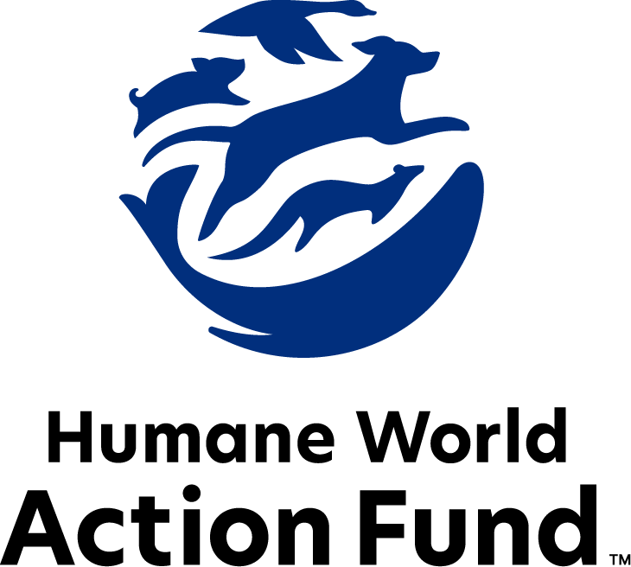

Formerly called
Humane Society Legislative Fund

CANDIDATE QUESTIONNAIRE
Minnesota State Office

2026 Minnesota state office candidate questionnaire
Candidate Name: _____________________________________________________________________
Candidate Address: ___________________________________________________________________
Office Sought: ______________________________ Locality: ________________________________
Staff Contact Name: _________________________ Phone: _________________________________
Email: ____________________________________ Website: ________________________________

Animals play an important role in the lives of many Americans. Countless citizens look to their local government to protect animals from cruel treatment and exploitation. Humane-minded individuals care deeply about the positions their elected officials take on animal protection issues.
For information on the range and details of our issue areas, please visit the websites of Humane World Action Fund (humaneaction.org) or Humane World for Animals (humaneworld.org).

Background information

What actions have you taken to promote the welfare of animals in the past? (Please include any action taken in an official or unofficial context.)

Are there any animal welfare programs or issues of importance to you that you would take the initiative on after you are elected?

Will you post information in your campaign materials stating your positions on animal protection issues?

Do you have, or have you had in the past, any pets that have made an impact on you personally?

STATE ISSUES:
Statewide office holders and members of state legislatures influence animal protection policy by supporting humane legislation, opposing government programs that use taxpayer funds to harm animals, supporting funding for government programs to protect animals and for adequate enforcement of animal welfare laws, and opposing inhumane laws or those which weaken current protections. We’d like to know your position on the following important animal welfare issues, which are subject to debate in your state.

PETS AND CRUELTY
Puppy Mills: Internet sales, flea markets, face-to-face sales and many pet stores that sell puppies and kittens are getting those animals from large scale breeding operations, often known as puppy mills. A puppy mill is an inhumane, high-volume commercial dog breeding facility which churns out puppies for profit, ignoring the needs of the pups and their mothers. Dogs from puppy mills are often sick and unsocialized. Pet retailers often falsely assure consumers that the puppies they offer for sale are raised in reputable or humane breeding facilities, when really, they are coming from mass production puppy mills.

Will you support legislation to end the retail sale of puppies sourced from puppy mills in pet stores?

_____ Yes _____ No _____ Not Sure

Cat Declawing: Many countries and hundreds of cities in the U.S. have banned cat declawing because the procedure frequently results in pain in the paw, infection, tissue necrosis (tissue death), lameness, and back pain. Removing claws changes the way a cat's foot meets the ground and can cause pain like wearing an uncomfortable pair of shoes. There can also be a regrowth of improperly removed claws, nerve damage, and bone spurs. Further, cat declawing has been associated with drastic changes in a cat’s behavior, increasing biting and other negative behaviors. The Humane World Action Fund opposes declawing except for the rare cases when it is necessary for medical purposes to the feline, such as the removal of cancerous nail bed tumors.

Will you support legislation to prohibit the non-therapeutic surgical declawing of cats?

_____ Yes _____ No _____ Not Sure

Research: The USDA allows several categories for research on animals. Some of these categories allow for minimum to no amount of pain, and others, specifically including category E, call for pain to be involved with the research. According to the USDA, Category E research can include procedures that would cause significant pain or distress, where the use of anesthetics, analgesics, or tranquilizers is withheld. Virginia took steps to prohibit this type of cruel, outdated, and unreliable research. Many non-animal alternatives already exist and are in use, sparing countless animals from cruelty, while also being cheaper, faster, and more relevant to human biology.

Would you be in support of banning Category E research on animals in Minnesota?

_____ Yes _____ No _____ Not Sure

FARM ANIMAL PROTECTION AND FOOD SAFETY
Fashion: Animals need their fur coats more than we do, and whether trapped in the wild or raised on farms, animals used in the fur industry suffer immensely. On fur factory farms in the U.S. and around the world, millions of rabbits, foxes, mink, and other wild animals spend their entire lives in cramped cages, deprived of the ability to engage in natural behaviors — only to be crudely gassed or electrocuted at the end. In the wild, animals are caught in crippling leghold traps without food or water, suffering for days before they die or are killed. Leghold traps are indiscriminate, often maiming and killing non-target animals, like threatened species and even pets—all this in the name of fashion. Prohibiting the sales of new fur products will support efforts to end this cruel industry, while still allowing businesses to sell vintage or used fur products, and continue services caring for fur products, such as storage and cleaning.

Will you support legislation to prohibit the sale of new products containing fur from animals?

_____ Yes _____ No _____ Not Sure

Factory Farming: On factory farms, egg-laying hens are packed into battery cages where they can't even spread their wings. Baby calves are taken from their mothers and confined in pens so small they can barely move, and pigs are locked in gestation crates the width and length of their bodies, unable to even turn around.

Will you support efforts to end cruel industry practices on factory farms?

_____ Yes _____ No _____ Not Sure
WILDLIFE
Wolves: Minnesota livestock owners are compensated for confirmed or even suspected losses to wolves. There have been zero documented incidents in which a wolf has posed a threat to human safety in the state of Minnesota. The state’s wolf population has remained stable.
Given the lack of scientific justification and overwhelming public opposition to wolf hunting in the state of Minnesota, will you oppose legislation that encourages a hunting season for wolves across the state?
Would you support legislation that would prevent recreational trophy wolf hunting?

_____ Yes _____ No _____ Not Sure

Appointments to State Agencies: Minnesota state agencies, such as the Department of Natural Resources, are responsible for a wide range of policymaking, with immeasurable effects on the state’s animal populations and wildlife habitats. With much to gain, special interests often fill state commission seats—where there should instead be a diverse group of perspectives, representing the broad interests of the public.

Will you encourage the Governor’s appointment of a diverse range of experts committed to preserving Minnesota’s natural beauty and wildlife, backed by science and not by special interests?

_____ Yes _____ No _____ Not Sure

Thank you for your time! Please return the completed questionnaire to:

Humane World Action Fund
1255 23rd St NW, Suite 455
Washington, D.C. 20037
Phone: (202) 676-2314
Email: info@humaneaction.org

Rev. 2/13/2026
© 2025 Humane World Action Fund

About us
We fight for political and policy change to tackle the root causes of animal cruelty and suffering.
We work to advance our mission by
passing animal protection laws at the state and federal levels, educating the public about animal protection issues and supporting humane candidates for office. Together, we act to end animal cruelty.

humaneaction.org

