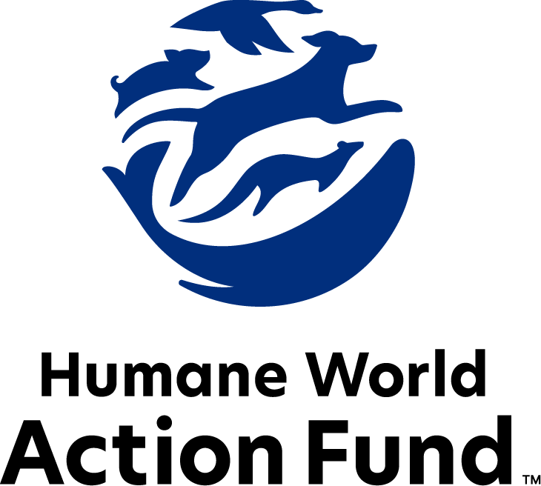

Formerly called
Humane Society Legislative Fund

CANDIDATE QUESTIONNAIRE
New Hampshire state office

2026 New Hampshire state office candidate questionnaire
Candidate Name: _____________________________________________________________________
Candidate Address: ___________________________________________________________________
Office Sought: ______________________________ Locality: ________________________________
Staff Contact Name: _________________________ Phone: _________________________________
Email: ____________________________________ Website: ________________________________

Animals play an important role in the lives of many Americans. Countless citizens look to their local government to protect animals from cruel treatment and exploitation. Humane-minded individuals care deeply about the positions their elected officials take on animal protection issues.
For information on the range and details of our issue areas, please visit the websites of Humane World Action Fund (humaneaction.org) or Humane World for Animals (humaneworld.org).

Background information

What actions have you taken to promote the welfare of animals in the past? (Please include any action taken in an official or unofficial context.)

Are there any animal welfare programs or issues of importance to you that you would take initiative on after you are elected?

Will you post information in your campaign materials stating your positions on animal protection issues?

Do you have, or have you had in the past, any pets that have made an impact on you personally?

STATE ISSUES:
Statewide office holders and members of state legislatures influence animal protection policy by supporting humane legislation, opposing government programs that use taxpayer funds to harm animals, supporting funding for government programs to protect animals and for adequate enforcement of animal welfare laws, and opposing inhumane laws or those which weaken current protections. We’d like to know your position on the following important animal welfare issues, which are subject to debate in your state.

PETS AND CRUELTY

Puppy Mills: Internet sales, flea markets, face-to-face sales and many pet stores that sell puppies are getting those dogs from puppy mills. A puppy mill is an inhumane, high-volume commercial dog breeding facility which churns out puppies for profit, ignoring the needs of the pups and their mothers. Dogs from puppy mills are often sick and unsocialized. Pet retailers often falsely assure consumers that the puppies they offer for sale are raised in reputable or humane breeding facilities when, really, they are coming from mass production puppy mills.

Will you support efforts to end the sale of puppies sourced from puppy mills in pet stores?

_____ Yes _____ No _____ Not Sure

Pets in Housing: Monthly pet rents; non-refundable pet fees; and pet deposits equaling an entire extra month’s rent are all legal in New Hampshire rental housing. 72% of Americans report that pet-friendly rental housing is difficult to find, and 59% agree that where it is available, it’s too pricey to afford. Pet ownership has proven to be an increasing mechanism for housing and financial insecurity among renters—particularly for low-income individuals or families—as those with pets often feel powerless and discriminated against while seeking housing opportunities. Yet, surrendering companion animals means losing a critical source of comfort, purpose, and family. As such, this alone creates a major barrier between housing security and the options available to pet owners.

Will you support pet-inclusive, affordable practices in New Hampshire rental housing policies?

_____ Yes _____ No _____ Not Sure

Indirect Supervision: The U.S. is currently experiencing a nationwide shortage of veterinarians and veterinary technicians, with profound effects on the accessibility of in-office veterinary care to pet owners across the country. One way to increase access for pet owners in New Hampshire is to empower veterinary technicians to provide care, such as rabies vaccinations, with indirect supervision rather than immediate or direct supervision from a veterinarian. Indirect supervision means that a veterinarian does not need to be present on the premises of care, but that they still delegated care tasks via written or oral instructions to the technician. Affording veterinary technicians the ability to do the work they are trained to do without additional red tape frees up currently licensed veterinarians and technicians to treat more animals in need.

Will you support efforts to implement indirect supervision standards?

_____ Yes _____ No _____ Not Sure

Shelter Fundraising: Animal shelters provide essential services to prevent animal homelessness and increase access to resources for pet owners. They are there to take animals in that are rescued from cruelty situations, collaborating with law enforcement to end animal abuse and make our communities safer. And now, more than ever, their resources are stretched thin as several across the state have hit capacity. Shelters in New Hampshire should not have overly burdensome restrictions placed on their ability to fundraise – they should be able to promote their good works, including their work with law enforcement, in fundraising materials so that they may continue to support our animals and our communities.

Will you oppose efforts to restrict the fundraising abilities of animal shelters?

_____ Yes _____ No _____ Not Sure

Shelter Fostering: In 2025, New Hampshire’s Department of Agriculture implemented a rule against placing pregnant or lactating animals in foster care, severely impacting shelter operations and further restricting their capacity during a time where most are already overwhelmed. Without the ability to use foster homes to house these sensitive cases, shelters are scrambling to keep these animals in their facilities. Keeping pregnant and nursing animals in shelter environments exposes them to increased stress, higher risk of disease transmission, and reduces individualized monitoring. Fostering reduces the risk of exposure to illness and affords newborns a quieter, more controlled environment. Foster care is a crucial mechanism for shelters to do their jobs and keep animals safe, happy, and healthy.

Will you support efforts to reinterpret the rule and end the crackdown on shelter fostering?

_____ Yes _____ No _____ Not Sure

FARM PROTECTION AND FOOD SAFETY

Factory Farming: On factory farms, egg-laying hens are packed into battery cages where they can't even spread their wings. Baby calves are taken from their mothers and confined in pens so small they can barely move, and pigs are locked in gestation crates the width and length of their bodies, unable to turn around.

Will you support legislation to prohibit cruel industry practices on factory farms?

_____ Yes _____ No _____ Not Sure

RESEARCH, TESTING, AND FASHION

Product Testing: Humane and safe products can be made using the thousands of existing ingredients that have already been approved, and several non-animal safety tests are already available for new ingredients. These non-animal alternatives not only save countless animals, but can be cheaper, faster, and more relevant to human biology, therefore more reliable at predicting safety. Countries with a collective 1.7 billion consumers, including India and those in the European Union, and 11 states in the U.S. already prohibit the sale of new cosmetics tested on animals—and as such, global companies are meeting this demand with an increasing variety of products free from animal testing.

Will you support efforts to prohibit the manufacture and sale of newly animal-tested products, where non-animal testing methods are available?

_____ Yes _____ No _____ Not Sure

WILDLIFE

Killing Contests: Wildlife killing contests are organized events in which participants compete for prizes to see who can kill the most or the largest animals within a certain time period. Most Americans are shocked to learn that thousands of animals–including coyotes, foxes, bobcats, prairie dogs, rabbits and squirrels–are killed in these events every year across the United States.

Will you support efforts to address killing contests by making it unlawful for any person to organize, sponsor, promote, conduct, or participate in a competitive event at which the participants harass or take covered wildlife?

_____ Yes _____ No _____ Not Sure

Bear Baiting: September 1st marks the start of the bear baiting season in New Hampshire, during which it is legal to hunt bears over bait. Hunters do this by stacking donuts, candy, rotting garbage, corn, fish, meat, and other high-calorie foods in large bait piles, targeting the bears’ most basic need for survival. It is not just cruel and unsportsmanlike—the practice of bear baiting also increases conflicts with humans, and carries environmental consequences, as the unnatural food and garbage disrupt fragile forest ecosystems.

Will you support efforts to end the cruel practice of bear baiting?

_____ Yes _____ No _____ Not Sure

Bear Hounding: Hound hunting is a tactic in which packs of dogs pursue exhausted, frightened animals until they seek refuge in a tree—where they are then shot—or turn to fight to the death. After this gruesome conflict, any babies left orphaned are vulnerable to their natural predators, or to mauling by the same dogs. In turn, the dogs involved can suffer broken bones, punctured lungs or other serious injuries, and are frequently dumped at municipal animal shelters or left in the woods if they do not perform adequately. Currently, New Hampshire allows the hound hunting of bears during a season wherein hunters may use up to six dogs. Bear hounding is cruel to both the bears hunted and the dogs used for this unsportsmanlike cruelty.

Will you support efforts to end bear hounding in New Hampshire?

_____ Yes _____ No _____ Not Sure

Wildlife Trapping: Every year in the United States, millions of wild animals are estimated to be caught and killed through the process of trapping. Steel-jaw leghold traps, wire neck snares, and body-gripping traps crush animals in an agonizing grip while they await the return of their trappers. If an animal has not been killed by predators or by the trap, itself, the trapper will often kill it in a way that preserves its cosmetic value—through violent suffocation or a blow to the head. These traps pose a risk to endangered species, family pets, and children.

Will you support efforts to prohibit recreational trapping in New Hampshire?

_____ Yes _____ No _____ Not Sure

Appointments to State Agencies: New Hampshire state agencies are responsible for a wide range of policymaking, with immeasurable effects on the state’s animal populations and wildlife habitats. For example, the New Hampshire Department of Agriculture, Markets and Food decides a range of matters concerning animal health; police training in animal abuse laws; and the transfer of companion animals. The Fish and Game Department engages in key decision making over endangered species protections and conservation of ecosystems, while also setting the standard for all hunting and fishing practices. With much to gain, special interests often fill state commission seats—where there should instead be a diverse group of perspectives, representing the broad interests of the public.

Will you encourage the appointment of a diverse range of experts committed to preserving New Hampshire’s natural beauty and wildlife, backed by science and not by special interests?

_____ Yes _____ No _____ Not Sure

Thank you for your time! Please return the completed questionnaire to:

Humane World Action Fund
1255 23rd St NW, Suite 455
Washington, D.C. 20037
Phone: (202) 676-2314

Email: info@humaneaction.org

Rev. 1/25/2026
© 2025 Humane World Action Fund

About us
We fight for political and policy change to tackle the root causes of animal cruelty and suffering.
We work to advance our mission by
passing animal protection laws at the state and federal levels, educating the public about animal protection issues and supporting humane candidates for office. Together, we act to end animal cruelty.

humaneaction.org

