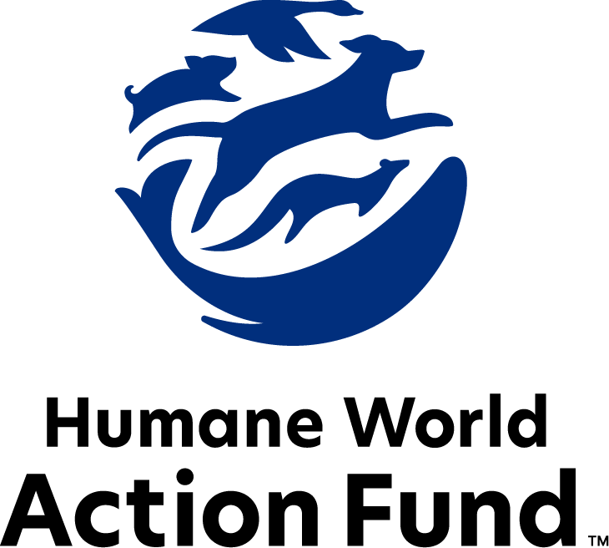

Formerly called
Humane Society Legislative Fund

CANDIDATE QUESTIONNAIRE
Washington State Office

2026 Washington state office candidate questionnaire
Candidate Name: _____________________________________________________________________
Candidate Address: ___________________________________________________________________
Office Sought: ______________________________ Locality: ________________________________
Staff Contact Name: _________________________ Phone: _________________________________
Email: ____________________________________ Website: ________________________________

Animals play an important role in the lives of many Americans. Countless citizens look to their local government to protect animals from cruel treatment and exploitation. Humane-minded individuals care deeply about the positions their elected officials take on animal protection issues.
For information on the range and details of our issue areas, please visit the websites of Humane World Action Fund (humaneaction.org) or Humane World for Animals (humaneworld.org).

Background information

What actions have you taken to promote the welfare of animals in the past? (Please include any action taken in an official or unofficial context.)

Are there any animal welfare programs or issues of importance to you that you would take the initiative on after you are elected?

Will you post information in your campaign materials stating your positions on animal protection issues?

Do you have, or have you had in the past, any pets that have made an impact on you personally?

STATE ISSUES:
Statewide office holders and members of state legislatures influence animal protection policy by supporting humane legislation, opposing government programs that use taxpayer funds to harm animals, supporting funding for government programs to protect animals and for adequate enforcement of animal welfare laws, and opposing inhumane laws or those which weaken current protections. We’d like to know your position on the following important animal welfare issues, which are subject to debate in your state.

PETS AND CRUELTY
Puppy Mills: Breeders with large numbers of dogs often keep them in overcrowded, unsanitary conditions with little veterinary care or socialization, leading to serious health, behavioral, and genetic issues. Poor breeding practices and overbreeding of females worsen these problems, while the surplus of puppies contributes to shelter overcrowding and higher euthanasia rates, perpetuating a cycle of neglect and suffering.

Would you support legislation that tightens dog breeding regulations by limiting the number of intact dogs, increasing space and exercise requirements, and enforcing higher standards for housing, sanitation, and veterinary care?

_____ Yes _____ No _____ Not Sure

Declaw: Many countries and hundreds of cities in the U.S. have banned cat declawing because the procedure frequently results in pain in the paw, infection, tissue necrosis (tissue death), lameness, and back pain. Removing claws changes the way a cat's foot meets the ground and can cause pain like wearing an uncomfortable pair of shoes. There can also be a regrowth of improperly removed claws, nerve damage, and bone spurs. Further, cat declawing has been associated with drastic changes in a cat’s behavior, increasing biting and other negative behaviors. The Humane World Action Fund opposes declawing except for the rare cases when it is necessary for medical purposes to the feline, such as the removal of cancerous nail bed tumors.

Will you support legislation to prohibit the surgical declawing of cats?

_____ Yes _____ No _____ Not Sure

Breed-Specific Legislation: Across the United States, entire communities ban or restrict dogs because of their breed, or, more commonly, what is perceived to be their breed. Breed-based policies aren't founded on science or credible data, but on myths and misinformation surrounding different breeds and their natures. The impact of these policies on dogs, families and animal shelters, though, is heartbreakingly real. Breed bans and restrictions force dogs out of homes and into shelters, taking up kennel space and resources that could be used for animals who are truly homeless.

Will you support efforts to prohibit discriminatory breed-based policies within Washington?

_____ Yes _____ No _____ Not Sure

FARM ANIMAL PROTECTION AND FOOD SAFETY
Factory Farming: In Washington, we have banned the use of intensive confinement such as battery cages for egg-laying hens, but not for pigs or calves. Baby calves are taken from their mothers and confined in pens so small they can barely move, and pigs are locked in gestation crates so small they cannot turn around, walk, forage or interact with other pigs.

Will you support legislation to prohibit cruel industry practices on factory farms?

_____ Yes _____ No _____ Not Sure

Fur Farming: Animals used in the fur industry suffer immensely. On fur factory farms in the U.S. and around the world, millions of rabbits, foxes, mink, and other wild animals spend their entire lives in cramped cages, deprived of the ability to engage in natural behaviors—only to be crudely gassed or electrocuted at the end. These farms are also the ideal setting for pathogens to circulate, as the animals are susceptible to infection with a host of zoonotic diseases.

Will you support efforts to phase out commercial fur farming in Washington?

_____ Yes _____ No _____ Not Sure

Rodenticide: Chemical rodenticides are commonly used in commercial rodent control in Washington. These include Second Generation Anticoagulant Rodenticides (SGARs), which induce a particularly insidious death due to excessive bleeding. Not only is this control method highly inhumane—it has also proven to rapidly enter the bodies of predators up the food chain, from owls to big cats and beyond, who ingest the poison and often succumb to it themselves. Once these compounds enter the environment, they rapidly move across it, virtually unstoppable except at the source. The number of animals who are either compromised or die from the poison is enormous.

Will you support legislation to reduce the use of Second Generation Anticoagulant Rodenticides (SGARs) in Washington to protect wildlife and pets?

_____ Yes _____ No _____ Not Sure

WILDLIFE
Wolves: Resident wolf packs began returning to Washington roughly 16 years ago, contributing greatly to the state’s ecological systems they were historically common and native to prior to being all but wiped out by humans. Despite the recent instability of the population caused by a decline of breeding pairs and a dramatic uptick in wolf killings, individuals are still advocating for the downlisting or delisting of these native carnivores.

Will you oppose efforts to delist or downlist wolves in Washington?

_____ Yes _____ No _____ Not Sure

Appointments to State Agencies: Washington state agencies are responsible for a wide range of policymaking with immeasurable effects on the state’s animal populations and wildlife habitats. For example, Washington’s Fish and Wildlife Commission is tasked with establishing policies to preserve, protect, and perpetuate fish, wildlife, and ecosystems across the state. The Commission is composed of nine governor-appointed members. With much to gain, special interests often fill state commission seats—where there should instead be a diverse group of perspectives, representing the broad interests of the public.

Will you encourage the appointment of a diverse range of experts committed to preserving Washington’s natural beauty and wildlife, backed by science and not by special interests?

_____ Yes _____ No _____ Not Sure

Thank you for your time! Please return the completed questionnaire to:

Humane World Action Fund
1255 23rd St NW, Suite 455
Washington, D.C. 20037
Phone: (202) 676-2314

Email: info@humaneaction.org

Rev. 1/20/2026
© 2025 Humane World Action Fund

About us
We fight for political and policy change to tackle the root causes of animal cruelty and suffering.
We work to advance our mission by
passing animal protection laws at the state and federal levels, educating the public about animal protection issues and supporting humane candidates for office. Together, we act to end animal cruelty.

humaneaction.org

